22 April 2018

Project Supervisor: Glenn Hawe

FotoTrack Final Report

Bsc Computing Systems

Joanne Connor B00674579

2018

Table of Contents

1 Introduction 1

1.1 Objectives 2

1.2 Structure of report 2

2 Literature Review 4

2.1 Market Research 5

*2.1.1* *MyFitnessPal* 5

2.1.2 Lose It! 6

2.1.3 MyPlate 8

2.1.4 Slimit 9

3 Technical Research 10

3.1 BitBucket 10

3.2 Target Platform Choice 10

3.2.1 Android Version 11

3.3 Android Studio 12

3.4 JIRA 12

3.5 Firebase 13

3.5.1 Firebase AUTH 13

3.5.2 Firebase real-time database 14

3.6 Alexa 15

3.6.1 Alexa Skills Development Kit 15

3.6.2 AWS Lambda Functions 16

4 Requirements 17

4.1 Approach 17

4.2 Identify and Understand Stakeholder Needs 17

4.3 Transform Stakeholder Needs into Customer Requirements 19

4.3.1 Functional Requirements 20

4.3.2 Detailed Functional Requirements 20

4.4 Develop Product Requirements / product Component Requirements 22

4.4.1 Non-Functional Requirements 22

4.5 Analyse & Validate Requirements 23

4.6 Analyse to achieve balance 25

4.7 Validate requirements 25

5 Design 27

5.1 Data Structure 27

5.2 UML Diagrams 29

5.3 UI Design 35

5.3.1 Logo 35

5.3.2 Activity Screens 38

5.3.3 Navigation 41

5.4 Firebase Database Structure 42

5.5 Alexa Skill & Firebase Realtime Database 43

6 Legal, Ethics & Security of Personal Data 44

7 Implementation 47

7.1 Overview of FotoTrack Architecture 47

7.2 Sprint 1 49

7.2.1 Daily Tracker 50

7.2.2 Recycler View & Card View 55

7.2.3 New Weekly Weigh in Form 65

7.2.4 Add New Food & Add to Tracker 67

7.2.5 Database – SQLite3 70

7.3 Sprint 2 75

7.3.1 Firebase Authentication & UI 75

7.3.2 Firebase Realtime Database 77

7.3.3 Uploading User Profile 78

7.3.4 Uploading DailyTracker Data 78

7.3.5 Uploading Weekly Weigh In 80

7.3.6 Uploading User Created Foodist 80

7.3.7 Retrieving User Created Foodist 80

7.4 Sprint 3 81

7.4.1 Preparing the data 81

8 Testing 86

8.1 Validation 86

8.1.1 SP1.1 Select Products for Validation 87

8.1.2 SP1.2 Establish the Validation Environment 88

8.1.3 SP1.3 Establish Validation Procedures 89

8.1.4 SP2.1 Perform Validation 90

8.1.5 SP2.2 Analyse Validation Results 91

8.2 Verification 92

8.2.1 SP1.1 Select Work Products for Verification 92

8.2.2 SP1.2 Establish the Verification Environment 93

8.2.3 SP1.3 Establish Verification Procedures and Criteria 93

8.2.4 SP2.1 Prepare for Peer Reviews 93

8.2.5 SP2.2 Conduct Peer Reviews & SP2.3 Analyse Peer Review Data 94

8.2.6 SP3.1 Perform Verification & SP3.2 Analyse Verification Results 94

9 Results 96

9.1 Unit & Integration 96

9.2 System 98

9.3 Functional 98

9.4 UAT 101

9.5 Results Summary 102

9.6 Objectives Fulfilled 102

9.7 Objectives Not Met 103

10 Conclusion 104

11 Bibliography 106

12 List of Figures 108

13 Appendix A 110

14 Appendix B– GitHub libraries 111

15 Appendix C – Whiteboard Sessions 112

Abstract

The FotoTrack project examined the role of mobile health and nutrition apps in conjunction with managed weight loss plan, Weight Watchers. The project aimed to discover and implement an innovative way in which to encourage users to track their nutrition and activities regularly in the hope of establishing lasting and positive behaviour patterns that will achieve and maintain long term weight loss.

The software development lifecycle used the CMMI framework to formulate requirements and a process of requirements validation to ensure that the requirements were achievable, customer focused and testable.

The design phase of the project illustrated the use of SQLite and NoSQL databases to store and retrieve user data. UI designs were detailed and the rationale for colour palette and logo design.

In the project implementation, code sections were explained, and data flow diagrams were used to describe each of the components, the events and interactions in the application.

A testing period followed and implemented testing techniques such as unit, integration, functional end to end and UAT. The results are analysed in Chapter 9 and compared against the original project objectives.

Acknowledgements

The research, development and evaluation of this project have been supported by numerous friends, colleagues and family.

I would like to express my gratitude to my project supervisor, Glenn Hawe for time and guidance during this final year of study.

My thanks and appreciations go to all the members of Weight Watchers Ireland who participated in the testing and commentary of the project. A very special thanks to Weight Watchers leader, Berni Walsh whose contribution has been immense.

Finally, I am indebted to my husband Colm Connor for his mentorship, encouragement and cups of tea during this long year.

# 

# Introduction

The purpose of the project is to create an efficient and innovative way to track calorie or nutritional intake with the aim of facilitating weight loss and/ or promoting a healthy diet.

Background

Attendance at popular commercial weight loss programs such as Slimming World and Weight Watchers is prevalent across the UK and Ireland.

[Weight Watchers UK](https://www.weightwatchers.com/uk/weight-loss-plans/weight-watchers-meetings) offers a combination of group meetings, online tools and digital subscriptions for their mobile app. Currently the online support and app subscription is only available in the UK (and other global locations such as the US).

Local groups in Northern Ireland fall into the territory of Weight Watchers Ireland, which offers an entirely different set of services. This includes group meetings and Weight Watchers at Home, a subscription-based service that provides users with a hard copy ‘Home Kit’ and weekday telephone support. The online tools are limited to a free browser-based calculator.

Members attend classes each week and are provided with a weigh-in service, motivational talk and a paper SmartPoints tracker. The tracker supports the member in maintaining an accurate record of their weight loss journal, diarising daily nutritional and activity intake. In a discussion with local members, it was noted that they were using various forms of digital tracking to help with their daily tracking activities. In the absence of a dedicated Weight Watchers app associated with the meetings in Ireland, many members used MyFitnessPal, Slimit and generic diary apps. The consensus was that the apps did not really fit the structure of the Weight Watchers program and many had to make concessions when recording their foods. For example, MyFitnessPal uses calories as a nutritional measurement. This did not match the format of SmartPoints, which measures nutritional information based on a calculation of calories, sugars, saturated fats and protein. Many felt that the information required for the app was lengthy and time consuming and their tracking habits soon diminished.

The inspiration for this project is based around the proven success of Weight Watchers members who track regularly. By making tracking activities, easy, efficient and as interactive as possible, members will be motivated to track more and therefore more likely to reach and maintain their weight loss goals.

It is a common consensus in the Weight Watchers community that those who habitually track SmartPoints values of their meals are more successful in their weight loss journey than those that don't.

By creating a portable, interactive tracking experience in a mobile app, the aim of the project is to encourage users to track more often and therefore help realise their weight loss goals.

The project objectives aim to focus the delivery of the project in terms of the goals, deliverables, work products, tasks, risks, milestones, estimates of effort & cost and established commitment.

To add to the efficiency of tracking and promoting low user commitment, the app will incorporate an Amazon Alexa Skill. This intention is to encourage the user with progress reports and convenient voice activated tracking methods.

## Objectives

The project objects are focused on usability and using dedicated frameworks for the full software lifecycle that focus on the validation of the product by the end user.

OBJ001

To deliver a working mobile application and Amazon Alexa skill nutrition tracker within the project timeline of 30 weeks by applying and maintaining a project management and development framework that will be upheld throughout all phases of the project.

OBJ002

To deliver a mobile health and fitness tracker that is adopted by at least 70% of the target test group and used routinely (3 + times daily) during a 1-week Beta testing period. I will achieve this by researching the project background in terms of technologies and the current market for the software, to understand the limitations of the current market and enhance user interface activity by applying Android Design principles.

OBJ003

To achieve 70% user adoption post -testing from the Beta test group by using user-centric research techniques and dedicated CMMI led requirements development and management processes.

OBJ004

To decrease user-tracking time for one standard meal to 1 minute or less and within 4 interactive motions by streamlining the data capture processes and applying proven UI methodologies.

OBJ005

To build an application that increase the number of potential users by 50% by creating a scalable integration platform built on micro-services that adopt 12 Factor Principles.

OBJ006

To ensure a defect rate of less than 2% after user acceptance testing by conducting thorough system test runs and code fixes after each development sprint.

## Structure of report

**Chapter 1** – This chapter provides some context and background for the project and outlines the project objectives.

**Chapter 2** – Explores related studies in weight loss management and the influence of technology in helping users achieve goals.

**Chapter 3** – Details the technology and infrastructure used to develop, support, maintain the mobile application and the associated work products.

**Chapter 4** – Demonstrates the requirements gathering and validation process using CMMI process area Requirements Analysis.

**Chapter 5** – Provides high and low-level design of system components, data structures and the methods that will be used to implement the mobile application and corresponding service architecture.

**Chapter 6** – Discusses the legal, ethical and security implications of user personal data and the guidelines and practices in place to protect user data.

**Chapter 7** – Details the processes, methods, code used to implement the mobile application, the integration services and the Alexa Skill.

**Chapter 8** – provides an overview of the testing methodologies applied to the project, the processes of validation and verification and issues that were identified during the testing period.

**Chapter 9** – analyses the results from the testing cycles and relates the outcomes to the original project objectives.

**Chapter 10** – reflects on the project lifecycle, lessons learned and proposals for future iterations of the software.

# Literature Review

The rise in popularity of mHealth (mobile health) applications promotes the portability of the services that has helped overcome the barriers of participation that feature in traditional clinical based weight loss intervention programs. This review explores the significant affect that mHealth applications have on the commitment of users to weight loss programs and promotion of regular food tracking and its contribution to successful and maintainable weight loss.

West, et al. examined the potential of behavioural change theory integrated into mobile nutrition apps. The study reflected on the rising obesity crisis in the US and analysed the positive contribution mobile nutrition apps could have in creating health behavioural changes. The suggestion was that the app coupled with theoretical behaviour constructs could have the effect of creating lasting healthy behaviour changes.

The study examined the use of several of the more popular mobile health and fitness apps, including food consumption trackers and more complex apps that contain diets and nutrition advice such as MyFitnessPal and LoseIt!

The behavioural change theories examined in the study were:

HBM – Health Belief Model analyses the prediction if a person will take action to make positive changes to unhealthy behaviours

TBP – Theory of Planned Behaviour examines the effect of personal motivation on modifying personal behaviour

SCT – Social Cognitive Theory investigates how personal decision making is influenced by our personal environment

The study suggested that a combination of techniques from these theoretical behaviour paradigms and the app-based nutrition tracking could create positive changes in dietary behaviour. The research indicated that the current leading apps were lacking in the application of the behavioural constructs but further research into their effectiveness would be beneficial. (West, et al., 2017)

The behavioural implications of this study are interesting and many of the ideologies can be identified in the current Weight Watchers program. In January 2016 WW introduced the SmartPoints plan which not only re-evaluated how nutrition was tracked but promoted a change in behaviour toward food and dieting. The aim of this change was to promote lasting behaviours. The new paper tracker came equipped with a ‘Remember to Smile’ section, encouraging members to take part in activities that made them feel happy on the basis that this would increase motivation and healthy weight maintenance. The motivation is readily available at meetings but how would WW members in Northern Ireland benefit from the addition of an app?

Turner-McGrievy et al. examined the relationship between diet and physical activity monitoring using an app, website or paper-based journal. The study indicated that the frequency of the self-monitoring did not differ between app users and non-app users, but the mobile app users had consumed less calories per day than their counterparts. The results suggested that there was benefits to mobile app tracking during the trials but recommended that further studies should examine the app’s influence on maintaining weight loss long term. (Turner-McGrievy GM, 2013)

If users can take control of their own healthy eating habits by tracking, calculating and monitoring their nutritional intake in one all-inclusive application could they develop the appropriate behaviours that could see a permanent change in their attitude towards weight loss? Would this make the weight-loss sustainable?

Digital assistant technology is still in its infancy and growing in a range of possibilities for everyday use. According to Gartner Hype Cycle for Emerging Technologies virtual assistants are reaching the ‘*peak of inflated expectations’.* There is still room for further study and mHealth platforms are exploring the possibilities of using digital assistants such as Alexa as a method of adapting digital healthcare. Hampshire County Council has announced plans to roll out a new trial of an Alexa Skill to support social care clients in their homes. The Skill will undertake tasks such as medication reminders and keep a record of weight, blood pressure or blood sugar levels. (Say, 2017)

There are also huge benefits for users with limited mobility or visual impairments, enabling care access via voice-controlled interfaces. Pradhan et al conducted a study investigating the use of intelligent personal assistants in the homes of users with disabilities. The study highlighted that Amazon Echo devices were being used for care giving support, reading books aloud, listening to music and home automation tasks. (Alisha Pradhan, 2018)

What are the implications for nutritional tracking and weight management? Could a new interface encourage the users to track more, provide motivation and overall promote a sustainable behaviour change helping users manage their own weight loss?

## Market Research

To facilitate the research, a review of the 5 of most popular health and fitness apps was conducted. All the apps are available on Google Play and the AppStore with free and premium subscription-based versions available. The research period involved using each of the apps to track daily meals and activity over a one-week period. The full analysis is available in the embedded spreadsheet.

|  |  |
| --- | --- |
|  | Click on the icon to view a copy of the app analysis |

* + 1. *MyFitnessPal*

MyFitnessPal is a comprehensive health & fitness tracker, heavily influenced by gamification methodology to inspire the user to consistently use and become immersed in the app. It is available as a ‘freemium’ option on Google Play and AppStore, but in 2015 (under the acquisition of Under Amour**®**) launched a premium subscription. At £39.99 annually, this is one of the more expensive subscription-based services in the health app market.

They do however, offer a wealth of features including one of the largest and most comprehensive nutrition databases, rich reporting tools and a large community of contributors.

MyFitnessPal was reviewed for 1 week, using the native free version downloaded from AppStore. It was used mainly to record meals at home using an iPad. Here are some of the advantages and limitations noted during the review period:

*Advantages*

* There is excellent integration between a wide variety of commercial fitness trackers and MyFitnessPal sister apps. Some of the more popular options included FitBit (this was considered most useful) Runtastic and C25K. The list of tracking possibilities was exhaustive.
* The android UI was in keeping with the latest Android Material Theme presenting a thoroughly professional and consistent look and feel throughout the app.
* The database is extensive with between 5-6 million active entries. Users can add foods to the database via the app.
* The app experience is very fast and responsive. Users are kept engaged with fast loading features and data. User feedback is plentiful, and the annotated interface allows the user to navigate and engage with minimal issue. App icons use good metaphors, making it relatively easy to learn the app features and layout.

*Disadvantages*

* One of the main disadvantages noted when using the app, was the aggressively structured marketing pushing users to upgrade to premium. Regularly, routine tasks were interrupted with this prompt which was frustrating. On occasion this made the user cut their session short.
* The interface does offer good affordance for most of its features but the feature -rich environment is competing with itself by cramming a lot of functionality into one space. Not all users would have the time to use this.
* The database, although it is listed as a benefit because of its size, contains a large volume of unverified user-added data. It is difficult to tell which the correct value is. Some foods had multiple entries with conflicting nutritional values.
* The user commitment level for this app is high. It requires a lot of time and attention to enter data, customise, add profile information, use social media integration and engage with the reporting tools. The app would be more beneficial to keen amateur and health & fitness professionals. Despite the well laid out interface, it is a little overwhelming for the novice user (especially those not interested in tracking activity).

### Lose It!

LoseIt! is a calorie and tracker developed by FitNow Inc. It is available via Google Play and AppStore. LoseIt! was reviewed for one week to track food calories and meals. The free version was downloaded from Google Play and used it on a Samsung Galaxy S7 Edge device. The app was mainly used for portability, so that the user could track calories in various locations throughout the day. The premium version is available as an annual subscription of £31.56.

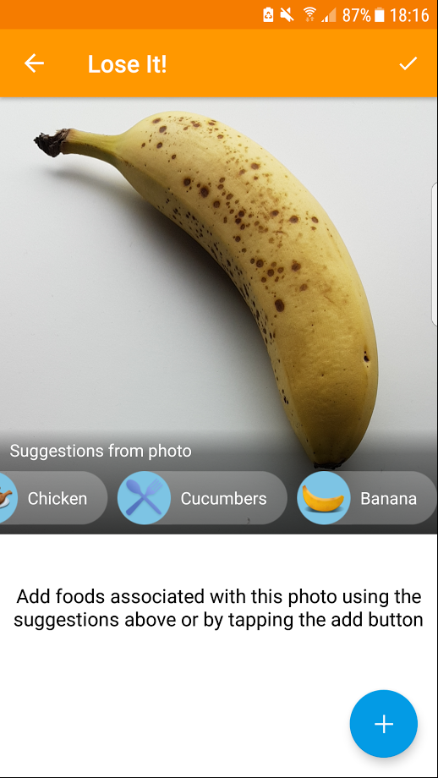Advantages

Figure 2.1 LoseIt! photo recognition API SnapIt!

* Throughout the week, the app was used consistently, mostly because it boasted an excellent barcode scanner. It was fast and returned results from the densely populated database quickly without much user intervention. On installation of the app, the database is downloaded and stored locally to the user’s phone. This facilitates fast data entry and calorie tracking. The app response times were excellent and far exceeded MyFitnessPal.
* A favourite feature in this app is the image recognition SnapIt! functionality. Even though the tool is still in Beta phase, the integrated photo app was quite accurate, recognising most foods and associating them with a database entry. The API was built by the same developer and used to create a feature within the app to promote quick and easy tracking.
* The reporting tools were summarised into a ‘MyDay’ screen that allowed the user to navigate using swipe between views, Calories, Macronutrients/ Micronutrients, and partake in recommended community challenges.
* The interface had a consistent look and feel utilising the same colour scheme throughout the app screens. The icons used relevant metaphor and the instruction buttons had good affordance, guiding the user in navigating and entering data.
* The app profile had some convenient customisation available, enabling the user to filter nutrient preferences and update the database.

Disadvantages

* Many of the customisable features are visible in the profile but are only available to premium users. This includes the weekly meal planner and Lose It! Meal Ideas. Ads were prevalent on some of the screens such as the Goal screen and made it difficult to interact with the free content around it.
* Fitbit and API integration are only available to premium users. This is a negative as MyFitnessPal exceeds expectations in this area by offering free integration.
* Some of the notification and reminders are irritating. Users can be put off by this feature and prefer that they are encouraged to interact through ease of use rather than reminders.
* The app would not have an appeal in the professional health & fitness market. It lacked the complexity and extensive features that MyFitnessPal boasts, the reporting tools were limited.

### MyPlate

MyPlate is a mobile health & fitness app published by health community-based web nutrition resource, Livestrong. The application was installed on Samsung Galaxy S7 Edge and tested for 1 week using the free version. The app promotes a healthy living lifestyle, fitness advice and goal-based tracking facilities. The website is primarily dedicated to science and nutrition-based articles and glossy Pinterest-esque images of recipes. The app is peppered with all the standard nutritional app components including calorie tracking, exercise, water intake, weight progress, reporting features and an in-app forum.

Advantages

* The app has a wealth of features available to the free user. Tracking, reports, goals and even the community forum is available to the freemium user.
* There is a barcode scanner. The information returned is comprehensive, allowing the user to add a serving size, meal choice and quantity. A small pie chart of macro values is a good visual aid to quickly view the amount of protein, fats and carbs contained in the food.
* There is a user database that enables the user to add their food entries. The added records contribute to a larger community-based database.
* The app supports meal saving. Users can create meals from foods regularly consumed together by adding the total calories and a list of ingredients.
* The reports were very conveniently saved to one graph. The user could switch views by selecting from the drop-down list at the top and adding filter criteria such as 1 week, 1 month up to 6 months data.
* The community page was quite impressive. Simple card views in recycler view list enabled users to post photos, short blogs and questions. Interaction was easy, and content could be added by clicking the FAB icon at the bottom of the page. Posts allowed up to 2000 characters and images from the device camera or gallery.

Disadvantages

* Apps are created to produce revenue, but the huge upgrade ad in the middle of the home screen takes precedence over the food diary and could be considered distracting and annoying.
* A frequent limitation with apps that allow users to add directly to the database is the amount of unverified data that can slip through undetected. It is difficult to rely on data sets that yield varying results.
* The lack of social media integration may be a deal breaker for some users. A choice is not offered to share updates to Facebook or similar. There is some integration with the health tracking platform Google Fit, but it would be good to see support for more popular devices such as Fitbit.

### Slimit

Slimit is a new and slightly poorer cousin to the previously mentioned apps. This app is suitable for users that like basic functionality and a no-nonsense user experience. It is hard to compare as it offers a slightly different service. It is designed to appeal to users who wish to track points that they can then rebrand as a unit of their choosing (usually from a commercial weight loss plans such as WW or Slimming World). The app is available only on Google Play for Android with a free version available but no option to upgrade.

The app was reviewed for 1 week and installed on Wieppo S6 Lite.

Advantages

* One of the benefits of the app is its simplicity. It could hold an appeal to some users who are not interested in tracking activity, viewing reports or social media engagement. There is low user commitment which is attractive to users with busy lifestyles or require the portability of tracking while multitasking.
* The swipe navigation is very user friendly. The user can move between days and view previous entries.
* Tracking in advance is an excellent feature. Users can plan foods for the following day, which is a helpful method to stay on track
* The points graphic in the middle of the screen is well placed and keeps the user focused on how many points they have used. It shades the used points in green and the remainder of the circle is white as an indicator of how many points are left from the daily allowance.

Disadvantage

* It is boring and somewhat uninspiring. There is no engagement for the user apart from adding points. Some apps encourage user participation by using techniques such as gamification. Not this one.
* It feels like the developer grew bored of it in the middle of development. Some aspects of it are very nicely designed offering a slick user experience. Other features are plain and unfinished looking such as the food list. The font is small and plain. The UI could have benefited from a card view to give focus to each new entry.
* Why name a list for tracked foods ‘*Activity’*? This is very confusing for the user who may wonder why they cannot track activities.
* There is a label that indicates that the user can select a food to edit. This action does not edit, it only deletes.

# Technical Research

The technical research covers the proposed technologies for the application, the current trends in global internet usage and the rationale for platform and software choices.

## BitBucket

BitBucket is the chosen source control for the FotoTrack project. This has been selected based on the following criteria:

* The repository supports a widely supported and known version control system GIT. Online support for GIT is extensive in terms of tutorials and documentation.
* It is a free, privately hosted repository, that is not accessible unless issued an invitation. Up to five contributors are supported at a time.
* The security is paramount and reduces the risk of malicious damage to source code or unsolicited cloning of the repository.

## Target Platform Choice

Analysing Mary Meeker’s Internet Trends Report (published by venture capitalist and tech incubation investor KCPB) a basis for mobile platform choice can be established.

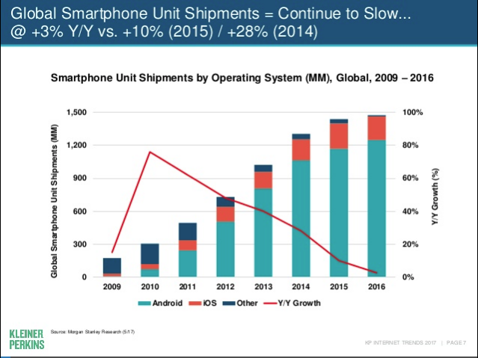

Figure . Smartphone Unit Shipments by OS (Meeker, 2016)

Mary Meeker’s 2017 report defines that whilst global smartphone unit shipments continue to slow, the largest proportion of the market share (85%) is still attributed to Android. Based on this research, Android has been selected as the target operating system.

### Android Version

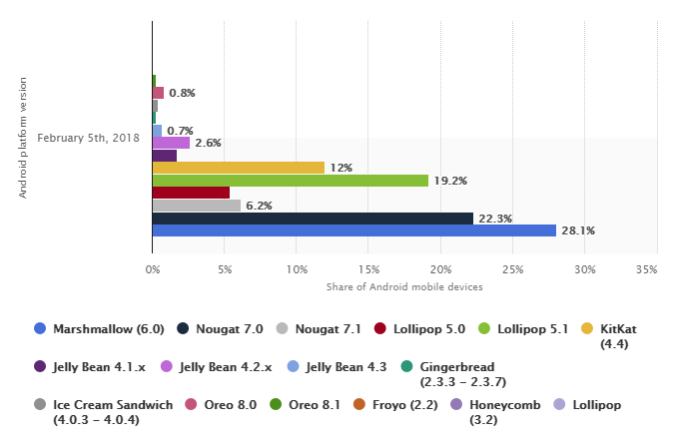

Figure . Android Version market share distribution (Statista, 2018)

Figure 3.2 captures the current most popular Android platform choices as of February 2018. The bar chart demonstrates the market share of Android versions for 2017-18 as captured by research portal Statista.

The application will specify an android version coverage as minimum API Level 16 (Jelly Bean 4.1) and a maximum API Level 27(Oreo 8.1.0). The target version will be API Level 24 (Nougat 7.0).

Screen size and resolution is also a key factor in assessing the specification for the mobile app. Since 2013, smartphone screen sizes have steadily been increasing into phablet-sized form factors. Figure 3.3 demonstrates the growth in the market share of devices with screen sizes of 5 – 5.5inches. The target screen size defined for the application will be 5.5 inches.

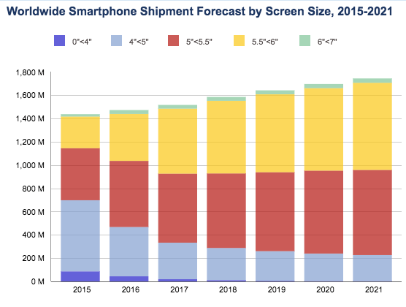

Figure . Smartphone screen size projection (International Data Corporation (IDC), 2017)

Android has a wider scope as a choice for the mobile application as the platform has a good relationship with numerous mobile phone manufacturers (such as Samsung, Sony and LG) and the app will have a better market reach than that of the proprietary (and limited) iOS / Apple platform.

## Android Studio

The focus of Sprint 1 will be the realisation of the mobile application. The development will be executed using Android Studio IDE. The rationale for this selection is based on several factors:

* The powerful debugging features available with the development environment
* The integration with source control
* The app encapsulates an array of essential development tools such as emulators, debuggers and testing integration with J-Unit.
* There are a wealth of tutorials and documentation to provide support and guidance

## JIRA

JIRA will be implemented as a sprint management tool and issue tracker. This will facilitate the development of each task using workflows or swim lanes, tracking progress and recording changes in task status.

Using the project requirements model and project timeline, the sprints will be planned using stories and tasks added to a Sprint Board. As each task progresses in development, it will move across the Sprint board until it is completed.

One of the major advantages of implementing JIRA as a tracking tool will be the ability to track issues and bugs that surface during development, ensuring that they don’t go unresolved or overlooked. Task interlinking will be a bonus, allowing an impact assessment of bugs and their effect on the related sprint tasks and ultimately the sprint scope.

Another part of the rationale for using JIRA is the product integration with my chosen source control, BitBucket. Both Atlassian product enable the seamless integration between source control commits and sprint tasks.

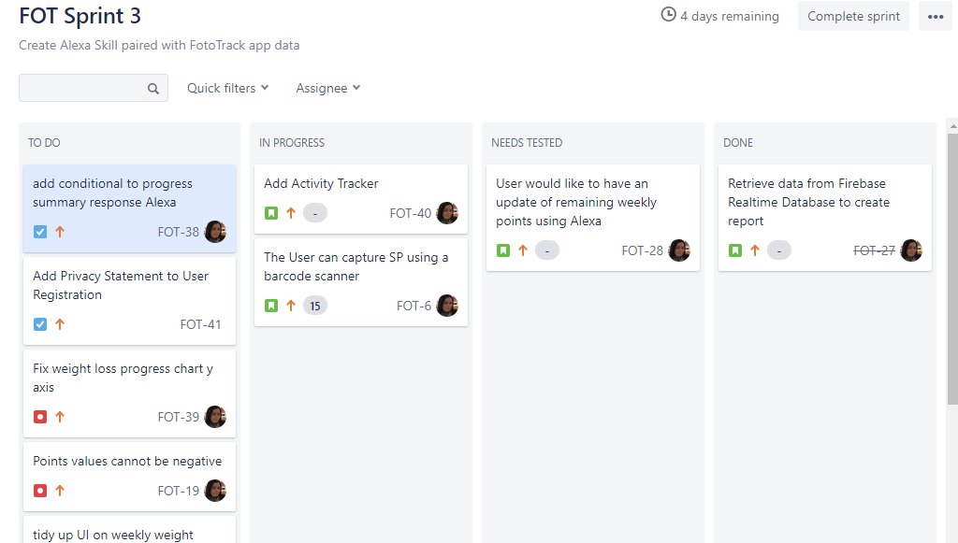

## Firebase

Firebase is a mobile and web application development platform that provides real-time integration services, chat functionality, data analytics, storage and authentication services. The project Risk Register demonstrates the potential of the scope in Sprint 1 stretch and leading to a re-evaluation of the project timeline. A decision has been made to simplify the integration aspect of the application and utilise a single middleware resource to provide the integration services.

Firebase has been selected based on the multi-functional services that it can provide and the vast array of services that the free account can offer.

The FotoTrack app will utilise the following Firebase services:

### Firebase AUTH

The Firebase authentication service can provide a secure authentication facility using client-side code in the paired android app. The service also provides an authentication UI that supports user onboarding and registration services. The sign in service also supports logins from social media accounts such as Facebook, Twitter and Google. The FotoTrack app will focus on a simple end to end identity solution using an email address. This minimises the personal data collected from the user that is not used as part of the application.

The Firebase authentication UI will also allow the user to recover and reset lost passwords using their email address.

### Firebase real-time database

The FRB is a cloud-based NoSQL database solution that lets the users sync data from the app in real time. It also allows the synchronisation of data by storing in a local cache when the user goes offline and then uploaded when they reconnect. By using the FRB, the users of FotoTrack can delete and reinstall the app or use on any device without losing the tracking data that they will build up over time.

The rationale for selecting Firebase as an integration solution is a combination of the following:

* It is a widely used and trusted integration method implemented by the largest commercial apps available such as, Shazam, Trivago and The New York Times.
* Firebase, as a project, provides a huge source of tutorials, sample applications and documentation to aid the implementation process.
* The Firebase management console (Figure 3.4) enables the user to manage all the selected Firebase apps in one space.

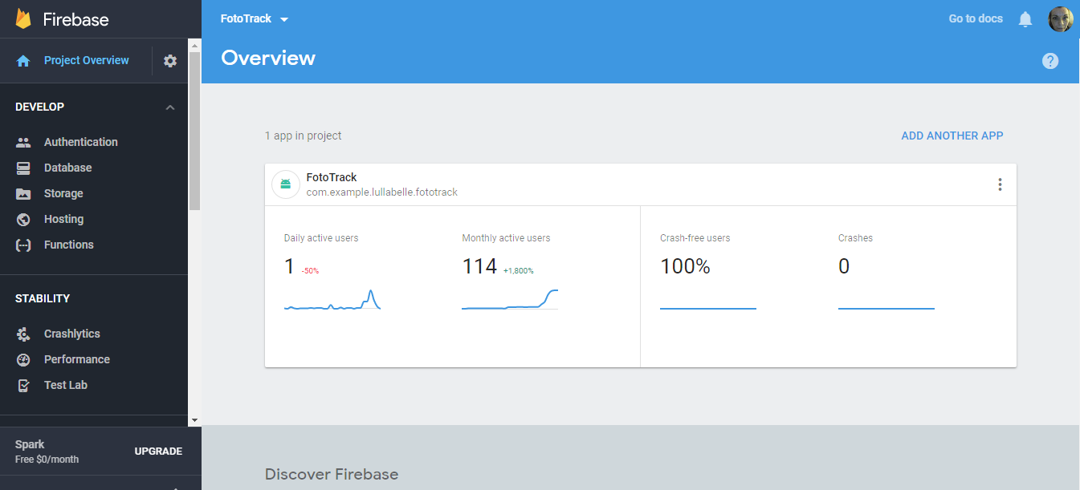

Figure . Firebase management Console

* The Firebase Spark Plan offers a generous developer focused package, that includes all the features required for the FotoTrack application such as realtime database, analytics, performance monitoring and authentication.
* Security
* Scalability- data hosting, authentication service will elevate the FotoTrack application from being just a mobile app to a multi user service

## Alexa

The inclusion of the Alexa Voice Service is an attractive one. The research for the FotoTrack app has revealed that encouraging people to engage with the nutrition apps will increase self-efficacy and change important motivational behaviours. The convenience offered by voice activated interfaces is one to be explored and harnessed. Figure 3.5 details the rise in popularity of the voice-based home platform and an increase in the number of Skills into the fourth quarter of 2017. This is expected to rise during 2018 and new promise for mHealth innovations in this area are becoming more prevalent (page 6).

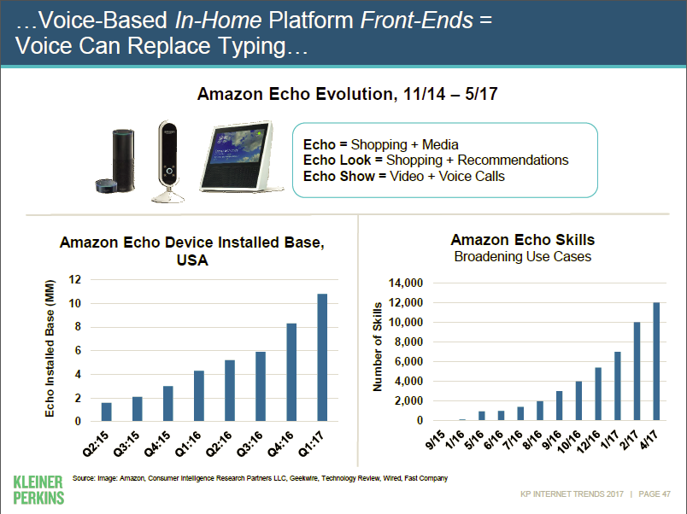

Figure . The evolution of Amazon Echo (Meeker, 2017)

The aim is to incorporate the Alexa Skill as a means of tracking and hearing reports on the user’s progress. Verbalising reports coupled with the accessibility of tracking using the voice interface should serve as motivation to the user.

### Alexa Skills Development Kit

The Alexa Skills Development kit is a free service provided by Amazon to create Skills for the Alexa Voice Service. The Skills are considered as ‘capabilities’ and the development process are about ‘*teaching Alexa new skills’* (Amazon Alexa, 2018)

The Skills can range in type such as:

**Custom** – requests for information, services or interactive voice games

**Smart Home Skill API** – management of IoT devices, smart home appliances such as lights, heating or TV controls.

**Video Skill API** – allows users to access cloud-based video services to play on smart TV.

**Flash Briefing Skill** – provides original customised content based on user preferences as a news report.

The Alexa Voice Services processes the voice input and creates a message request to send to the chosen service. AWS Lambda is the most commonly used processing service

### AWS Lambda Functions

AWS Lambda allows users to develop, test and run cloud-based code without the use of server management. The Lambda function processes the Alexa request and executes the associated code, data requests and responses.

The AWS console provides a development and test environment for creating Lambda functions. The developer can choose from existing templates or ‘blueprints’ and can select from various runtimes such as Node.js, C#, Java and Python. The most common function templates and tutorials are based on Node.js and this will serve as a basis for the FotoTrack Lambda function.

# Requirements

## Approach

The CMMI process area Requirements Development has been applied to analyse customer needs, develop functional, non-functional requirements and prioritise and validate requirements document.

* Develop Customer Requirements
  + Elicit Needs
  + Transform Stakeholder Needs into Customer Requirements
* Develop Product Requirements
  + Establish Product and Product Component Requirements
  + Allocate Product Component Requirements
  + Identify Interface Requirements
* Analyse and Validate Requirements
  + Establish Operational Concepts and Scenarios
  + Establish a Definition of Required Functionality and Quality Attributes
  + Analyse Requirements
  + Analyse Requirements to Achieve Balance
  + Validate Requirement

## Identify and Understand Stakeholder Needs

The key stakeholder for the mobile calorie tracker application is the Weight Watcher’s member and the WW group leader, Berni Walsh.

To identify and understand the needs of end user various methods were used to gather and analyse the information. This included talking with the members at the meetings, engaging in discussion with the group leader and using social media as a way of gathering opinion. The local Weight Watchers group uses a closed Facebook page as a forum for diet tips, suggestions and support. This was an opportunity to elicit information from the members regarding their tracking behaviour and how they would like to track their SmartPoints. It is important to recognise that the stakeholder’s needs will evolve throughout the development process, therefore elicitation should be an iterative process; harvested regularly throughout the lifecycle

Another method used to establish stakeholder needs was white board sessions in which ideas were brainstormed exploring the main expectations of the customer. This was an opportunity to begin breaking down generalised features into more granular application functionality.

Figure 4.1 illustrates the initial key features that the members had cited as important. From this a more comprehensive list of features and user stories was developed. The four main areas of functionality identified were:

* Capture Data
* Track Data
* Report Data
* Scale & Integrate

Figure 4.2 & Figure 4.3 demonstrate how the main categories were expanded to include a more detailed breakdown of expected functionality and the potential to make the app stand out from the current market competitors.

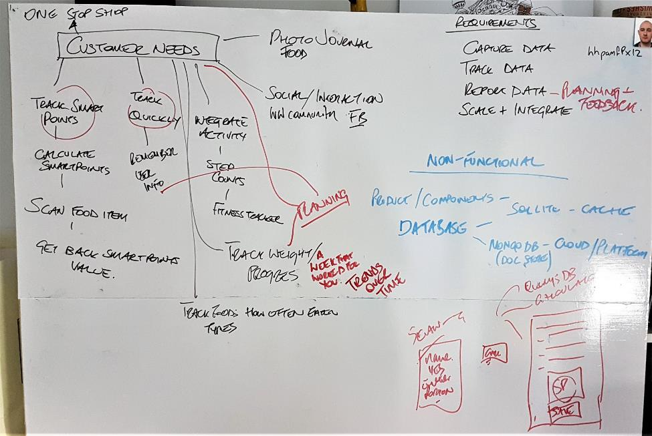

Figure . Elicitation of Customer Needs 1

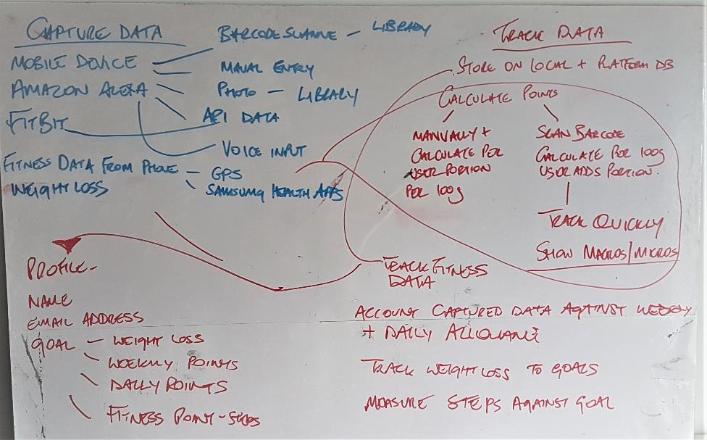

Figure . Elicitation of Customer Needs 2

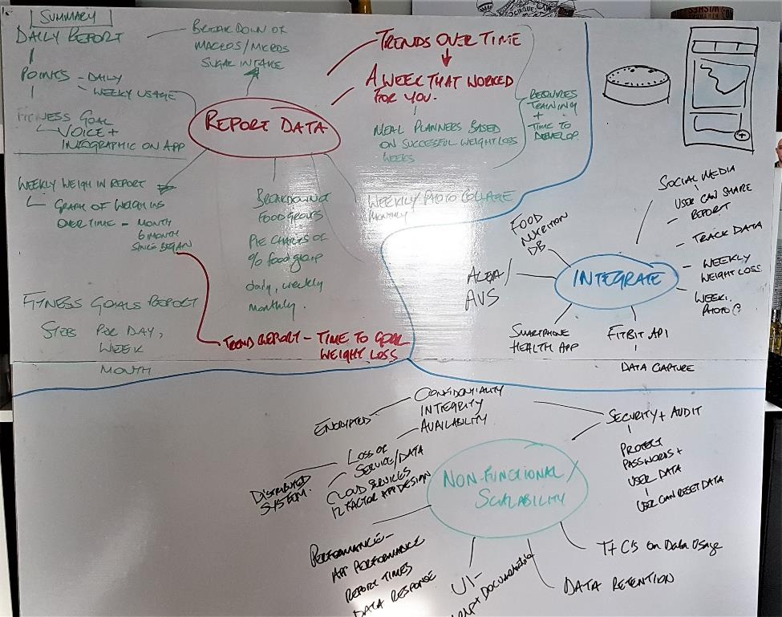

Figure . Elicitation of Customer Needs 3

## Transform Stakeholder Needs into Customer Requirements

Having established the stakeholder’s needs, a process of consolidation was implemented as defined by CMMI Requirements Development Specific Practice 1.2 to transform needs into a prioritised list of customer requirements.

The MoSCoW prioritisation model was introduced to establish a hierarchy of deliverable requirements. The categories can be described as:

* **MUST** – if the requirement was excluded, the project could not be delivered.
* **SHOULD** – the requirement is important to the success of the project, but an alternative work around would suffice.
* **COULD** – a desirable feature that has a lesser impact of the failure of the project if omitted.
* **WON’T** – a requirement that is rendered out of scope and undeliverable within the project time line or current skillset of the development team.

### Functional Requirements

#### Approach

The high-level requirements are based on the initial elicitation of customer needs.

|  |  |
| --- | --- |
| **Requirement Number** | A number allowing each requirement to be uniquely identified |
| **Requirement Topic / High Level Requirement** | A heading providing the sub categorisation of the requirements or the text of the requirements themselves |
| **M/S/C/W** | Prioritisation model indicating whether the requirement is Must, Should, Could or Won’t.  *Must* requirements support the customer needs. *Should* and *Could* requirements are nice to have but not considered essential to supporting the customer needs. *Won’t* requirements will not be achievable within the project time frame |

### Detailed Functional Requirements

|  |  |  |
| --- | --- | --- |
| No. | Requirement Topic / Detail | Prioritisation |
| 1.0 | **A. Capture Data** |  |
| 1.1 | Mobile Application to track & Report SmartPoints | M |
| 1.2 | Amazon Alexa Skill to track & Report SmartPoints | S |
| 1.3 | Add Fitbit data to tracker | C |
| 1.4 | Add and capture fitness from mobile device / application | W |
| 1.5 | Capture weekly weight loss statistics / data | M |
| 1.6 | Use a barcode scanner to capture nutritional data from packaged food | S |
| 1.7 | Use a form based manual entry system for food portions (unpackage) and recipes | M |
| 1.8 | Capture and build data from user-defined recipes | C |
| 1.9 | Capture photos from device camera of foods to be tracked and meals | S |
| 1.10 | Capture voice input data from Amazon Alexa | S |
| 1.11 | Capture GPS data from mobile device to support fitness tracking | W |
| 1.12 | Capture data from mobile device health app (Samsung Health) to support fitness tracking | W |
| 1.13 | Store data in local database on device (cache data) | M |
| 1.14 | Store larger volumes of data in platform database | S |
| 1.15 | Calculate SmartPoints values manually from user entered data and portion size | M |
| 1.16 | Calculate SmartPoints values from barcode scanned foods and user portion size | S |
| 1.17 | Capture Data as quickly as possible by using bar code scanned food nutritional values | S |
| 1.18 | Capture the date and time of each entry of fitness, photo and food data. | M |
| 1.19 | Update a SmartPoints record | M |
| 1.20 | Delete a SmartPoints Record | M |
| 1.21 | Track foods with 0-point values | M |
| 1.22 | User can capture known SmartPoints values directly in the app without calculating | S |
| **2.0** | **B. Track Data** |  |
| 2.1 | Create a user Profile to create Profile Name, email address, set Goals   * Weight loss Goal * Weekly SmartPoints Allowance * Daily SmartPoints Allowance * Fitness Goals such as Daily Steps Goal | M |
| 2.2 | The user can account for used SmartPoints against Daily SmartPoints Allowance | M |
| 2.3 | The user can account for used SmartPoints against Weekly SmartPoints Allowance | M |
| 2.4 | The user can account for daily calculated steps from Fitness API against fitness goal in profile | C |
| 2.5 | The user can account for weekly recorded weight loss against overall weigh loss goal in user profile | M |
| 2.6 | The user can view SmartPoints value of food before committing it to the tracker | M |
| 2.7 | User can record SmartPoints of foods in a daily allowance and weekly allowance record using the mobile app | M |
| 2.8 | User can view a record of weekly and daily SmartPoints values used at any time using the mobile application | M |
| 2.9 | User can view a record of weekly and daily SmartPoints values used at any time using Amazon Alexa Skill | S |
| 2.10 | User can obtain a ‘SmartPoints left’ record via the mobile application and Amazon Alexa | S |
| 2.11 | User can obtain the last weigh in record via the mobile application and Amazon Alexa | S |
|  |  |  |
| **3.0** | **C. Report Data** |  |
| 3.1 | The user can generate an end of day summary report contain details of SmartPoints used daily and weekly, Fitness goal and current weight loss. This will be available on the app as an infographic and as a flash briefing by Alexa. | S |
| 3.2 | The user can view a report of Daily/ Weekly/ Monthly micro/ macro nutrient breakdown of foods | C |
| 3.3 | The user can view a report of percentage of foods attributed to each food group, sugars, proteins, carbohydrates and fats. This will be available as a daily, weekly or monthly pie chart | C |
| 3.4 | The user can view a weekly weigh-in report on total weight loss during their time using the app. | S |
| 3.5 | The user can view a fitness goals (steps) report on a daily, weekly or monthly basis. | C |
| 3.6 | The user can generate a daily, weekly, monthly photo collage of all food / meal photos. | C |
| 3.7 | The user can view / generate a Time to Goal weight loss trend report based on data built up over a minimum of 3 weeks | W |
| 3.8 | The user can utilise a ‘Week that Worked for You’ meal planner (report) that will formulate a meal / activity planner based on the user’s most successful weeks weight loss. (Trends Over Time reporting) | W |
|  |  |  |
| 4.0 | **D. Integration Services** |  |
| 4.1 | Food Nutrition Database | S |
| 4.2 | Social Media APIs – user can share reports, tracked data, weekly weight loss progress, weekly photo collages | C |
| 4.3 | Fitbit API – record steps per day and Fitbit tracking data as part of fitness goals | S |
| 4.4 | Smartphone Health App integration such as Samsung Health | W |
| 4.5 | Amazon Alexa integration with Amazon Echo. Mobile application will be partnered with an Alexa Skill using AVS | S |
|  |  |  |

## Develop Product Requirements / product Component Requirements

A set of product and component requirements have been prepared, that expands upon the technical details of the customer requirements. This area predominantly describes, the non-functional requirements, timings and design patterns applied to the architecture of the app as per the guidelines in specific practice 2.1 of CMMI Requirements Development.

The measurable quality attributes for the requirements have been detailed and highlighted in terms of performance and the security of the application.

### Non-Functional Requirements

|  |  |  |
| --- | --- | --- |
| No. | Requirement Details | Prioritisation |
| 5.0 | **A. Scalability** |  |
| 5.1 | Add up to 1000 additional users without adding more resources and minimal code refactoring | C |
| 5.2 | Accommodate growth in user data sets without scaling up resources | C |
|  |  |  |
| 6.0 | **B. Performance** |  |
| 6.1 | Command action (button press), screen navigation and field navigation completed within 5 seconds, worst case scenario with 95% of actions taking under 3 seconds | C |
| 6.2 | Uploading a tracker record should not take more than 2 seconds under normal connectivity conditions | C |
| 6.3 | Searches – 95% of food database searches completed within 10secs | S |
| 6.4 | Complex reports and infographics presented within 2 minutes | S |
|  |  |  |
| 7.0 | **C. Security** |  |
| 7.1 | Security considerations applied using C.I.A principle   * Confidentiality – Encrypted data from mobile device to platform services. Data at rest in platform is secured. Protection of data from unauthorised access; user can only modify their password protected data * Integrity – information will be kept accurate and maintained unchanged in storage and during transfer * Availability – Using cloud services, data is available 24 x 7 x 365 except for planned downtime | M |
| 7.2 | The system shall provide appropriate functionality to maintain usernames and passwords including the ability to reset forgotten passwords | M |
|  |  |  |
| 8.0 | **D. Usability, Help and Documentation** |  |
| 8.1 | The system shall provide an intuitive user interface using current Android Design principles | S |
| 8.2 | The system shall provide context- sensitive Help – a Help facility that is relevant to the current user activity | S |
| 8.3 | The system will be documented with appropriate user guide documentation | S |
| 8.4 | The system will provide only for the English language | M |
|  |  |  |

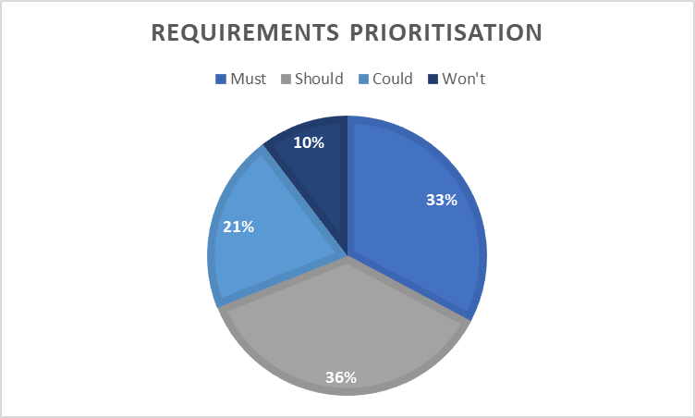

Figure . Requirements Prioritisation

The pie chart in in Figure 4.4 illustrates the percentages of requirements attributed to each prioritisation area. The highest percentage of prioritisation is ‘*Should’*, largely due to categorisation of the Alexa Skill services. The Alexa functionality would be a unique addition to the food tracker app, but it would not render the project a failure if it was not delivered. The users could still track, manage and view the tracker data without it, so therefore it has been prioritised as a ‘*Should Have’*.

Consideration has been given to the inclusion of advanced reporting features such as ‘Time to Goal’ and ‘A Week that Work Worked for You’ but a decision was taken to exclude them from the project requirements. They are excellent features and would be well received by members, but the time constraints imposed upon this iteration cycle would be too stringent to facilitate the production of complex and time-based reports. These are features that could be considered for implementation in future iterations of the application.

## Analyse & Validate Requirements

To support specific practice 3.1 – Establish Operational Concepts and Scenarios, use case diagrams were developed to illustrate the main functionality of the mobile application and the Alexa Skill.

The required functionality and quality attributes were defined by formulating activity diagrams to accompany the use cases. This describes what the product is intended to do in terms of actions, sequences, inputs and outputs. This established focused groups of requirements to support requirements analysis and validation.

As defined in specific practice 3.3 Analyse Requirements, an in-depth analysis of the requirements was conducted to confirm that they are necessary and sufficient to the user’s needs.

To ensure that the requirements are validated, a user survey was compiled that presented a summary of the proposed functionality and asked the users to evaluate based on its relevance to them. The focus group was comprised of Weight Watcher’s members and communication was via members only Facebook page. The questions were formulated to elicit a more meaningful response from the participants using a five-point Likert scale. Jared Spool indicates that a more useful response can be garnered if modelled around ‘delight and frustration’ rather than varying degrees between satisfied and dissatisfied (Spool, 2015). This approach helped extract what the user really wanted to use in app and what would exasperate them the most. The results of the survey can be viewed in the attached document

|  |  |
| --- | --- |
|  | Click the pdf icon to view the requirements survey response |

The Weight Watchers group members survey produced some interesting results. Most of the survey group were intrigued by the possibility of voice entered data using the Amazon Echo with 58% opting for highest rated answer in favour. Only 8% claimed that they would not be interested at all.

61% of participants opted for the most favourable answer for Fitbit and health app synchronisation, followed by 26% choosing the mid-scale favourable answer.

The highest rated (67%) response time for tracking one meal was between 0-3 minutes and just 13% of users said that they did not mind how long they spent tracking a meal.

Perhaps the most rated response was the interest registered for a feature that would scan barcodes of packaged food items and return the SmartPoints values. 83% of the surveyed members expressed the most favourable answer for this, with just 4% opting just to ‘try it’.

One of the most surprising answers was the response to the sharing of progress on social media. Considering the survey solicited responses using a Facebook forum, the highest number of participants (33%) opted for the answer least in favour of social media integration. The next highest answer was a neutral vote for sharing ‘sometimes’ on social media.

In one question, the group were asked to rank several of the proposed features in order of their importance to them. The highest-ranking feature was the ‘*Daily Summary image that collates all daily information such as points used, activity, food groups, weekly points’* followed by *a ‘Break down of foods eaten in categories of Carbs, Sugars, Fats and Proteins’.* The question harvested useful responses that would help prioritise the features for development and focus on what is most important to the client.

The participants were asked to provide details of their current tracking activities. 71% of the surveyed group stated that they used the paper-based Weight Watchers tracker. 13% reported using MyFitnessPal and a further 13% used a combination of note taking apps and other nutrition-based tracker apps.

Finally, the members were asked what they found to the most frustrating feature of commercial nutrition tracking apps. The highest scoring negative feature in apps was Adverts, followed by notifications. Using text-based analysis, a word cloud revealed the most frequently occurring comments. Figure 4.5 clearly demonstrates that Adverts and notifications surpass all other features in terms of their negative impact on user experience.

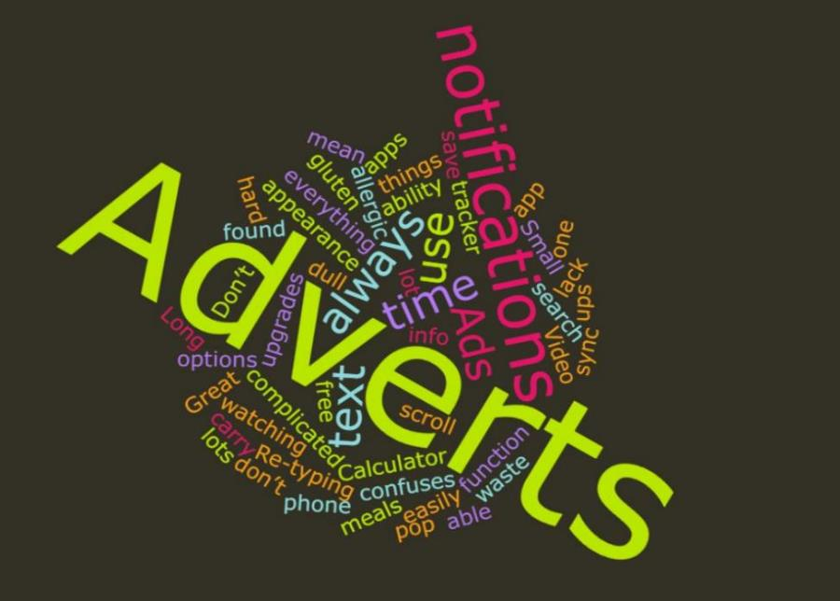

Figure . user survey feedback analysis

## Analyse to achieve balance

A Requirements Defects Report was created to establish whether the proposed requirements would meet the high-level objectives of the project and if they are feasible, achievable and complete.

The report uses modified criteria identified by Alshazly et al. to detect defects in the requirements specification using a combined reading technique (Amira A. Alshazly, 2014). This was achieved by answering a series of check list questions, designed to examine each section of the requirements specification based on expected defects that are prone to occur in similar requirements documents.

## Validate requirements

A requirements traceability matrix was formulated to facilitate the validation of the requirements throughout the development and testing processes. Requirements quality features specify that all requirements should be traceable and testable. Requirements validation can be achieved by insuring that the features described in each requirement are fully testable, explicit and the development and testing process are completely traceable to the original requirement.

The customer feedback from the survey, prioritisation model and the requirements defects report have been reviewed and considered to regenerate a validated list of requirements. The completed list is available to view in the Requirements Traceability Matrix (page 77).

# Design

## Data Structure

The application will use a local SQLite3 database (Figure 5.1) to read, update, create and delete data objects. The database objects will have corresponding Java objects in the application.

The User table will contain a record for a single user on each device. Consideration was given to the table containing multiple users, but it was deemed unlikely that more than one user would sign into the application on a single device. For this assumption, the user table does not contain foreign keys to any other table.

The User ID (string value) is saved from the Firebase authentication UID which will be passed into the user object on creation. The email address will be the same email that is used to authenticate the user on Firebase. This will also be passed into the user object as part of the create statement. The table contains basic profile information such as goal weight, start weight, daily points allowance, weekly points allowance and activity goal. This table will be updated when the user updates their profile information. If another user signs into the same device, the table record will be deleted, and the new user record created.

The Daily Tracker table will contain records of all trackers create by the user. This will be the basis for the Main Activity of the application. The tracker will contain a timestamp (auto generated by the database), daily SmartPoints remaining, weekly SmartPoints remaining and the week number as a foreign key. When a user creates a new tracked food entry the value of the SmartPoints is sent as an update statement to either the daily or weekly SmartPoints remaining field. This will maintain the most recent record of the users SmartPoints allowance. When a new week object is created the week number is recorded as foreign key in the Daily Tracker table to indicate which week the tracker belongs to. This facilitates resetting the users weekly points allowance.

The Week table contains the most recent week number, a timestamp of the week start-date and the current user weigh in value. The table contains the weekly weigh in records for the user that are added in a weekly alert displayed on the application. The week table will be queried to return a dataset used to populate the Weekly Weigh in Chart (see Appendix 2 – GitHub libraries).

The Food table contains records of all foods added to the database by the user. The primary key food ID is a unique integer value assigned to each new food object on creation. Each food has a name, SmartPoints value, calories, saturated fat, sugars, portion size and the user portion entered. The food table records are used to populate the search functionality in the application. A record is added each time the user enters the values and calculates the SmartPoints. The record is saved regardless of whether the user decides to add the food to the tracker. This maintains a personalised food database for the user that they can query using the search option (see Appendix 2 – GitHub libraries).

The TrackFood table contains the records that will populate each Daily Tracker entry. It has two foreign keys, Food ID and Tracker ID. The Tracker ID links the tracked food to the tracker it should be displayed against and the Food ID links the tracked item to the details of the food it is tracking. The additional fields are meal type, portion, quantity, dailyOrWeekly, a timestamp, SmartPoints value and an image URI. The SmartPoints value is stored as a float and returned in the application as whole integer. This assists the accurate calculation of foods tracked in multiple quantities. The image URI is the path recorded when an image is captured by the user and tracked against a food. The URI will be retrieved and rendered using Glide Image Loader Library (see Appendix 2 – GitHub libraries)

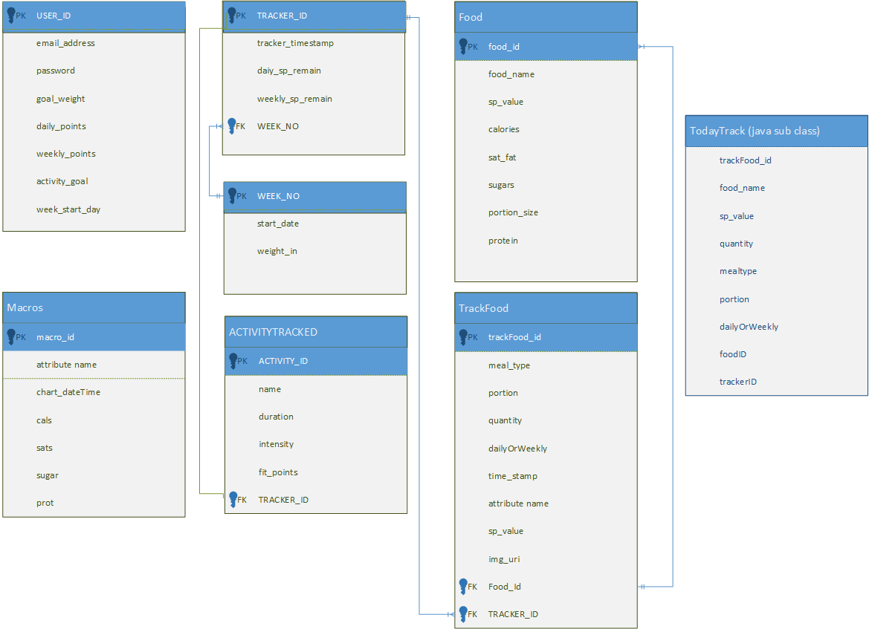

Figure . FoodDatabase_Local ER Diagram

The Activity table contains records of the user entered activity. It contains a unique primary key, name of activity, duration, intensity and FitPoints earned. The table contains a foreign key tracker ID which links the activity to the daily tracker it should be displayed on. The information from the activity table will be used to present a record of the user daily activity on a bar chart and the number of FitPoints earned.

The Macros table contains records that have been extracted from the foods tracked each day. For each tracked food, the calories, saturated fats, sugars and proteins are added to the table along with a timestamp. A sum of the individual field totals will be returned using a date parameter to populate a pie chart (see Appendix 2 – GitHub libraries) displaying the food macronutrients each day.

## UML Diagrams

The UML Use Case diagram (Figure 5.2) provides an overview of the proposed system functionality. The user should be able to login and logout of the application using a secure identifier. The basic functionality will include, tracking SmartPoints values, viewing current SmartPoints totals, view a Daily Summary and Reports, view the user profile, set and adjust goals. There are some additional ‘nice to have’ features included such as a barcode scanner to facilitate SmartPoints calculations and tracking, creating meals plans and API connectivity with social media and fitness tracking platforms.

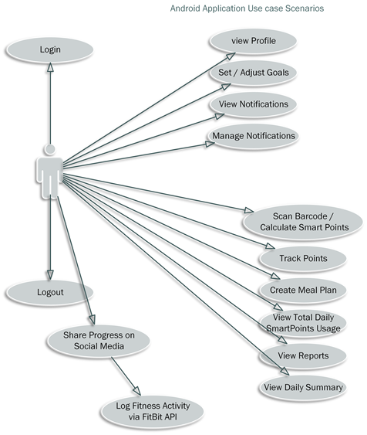

Figure . Android app use case diagram

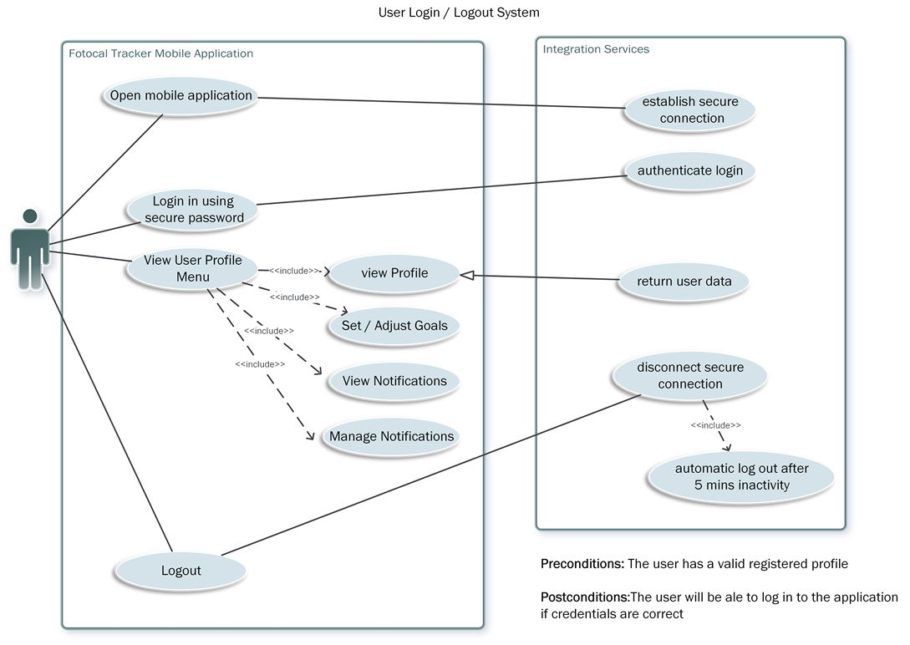

Figure . Activity Diagram - User Login/ Logout

In the activity diagram Figure 5.3 an actor is used to demonstrate the proposed login and authentication service. The user authenticates against a password stored in a secure cloud login service and an application session is created. During the session the user can use the mobile application functionality until logging out. The secure connection is then severed, and the session will end. Further functionality could be implemented by adding an automatic logout if the session becomes inactive after a period of time.

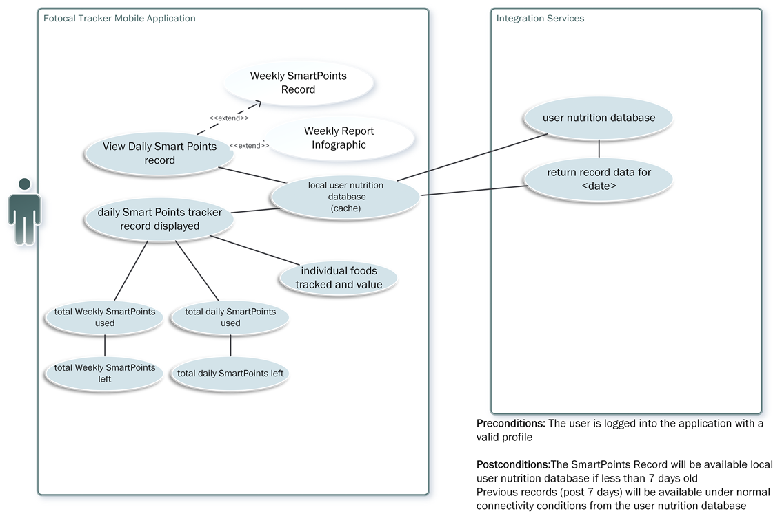

Figure . Activity Diagram - view tracked foods

The user should be able to view tracked foods on a Daily Tracker visible on the home screen of the mobile app. Figure 5.4 illustrates the actor viewing the Daily Tracker and the information types available to them as a result of the query. It is proposed that the records will be stored for short term use in the local database and larger volume records can be stored in the cloud database. The user should also be able to view the most recent totals of their daily and weekly SmartPoints balances.

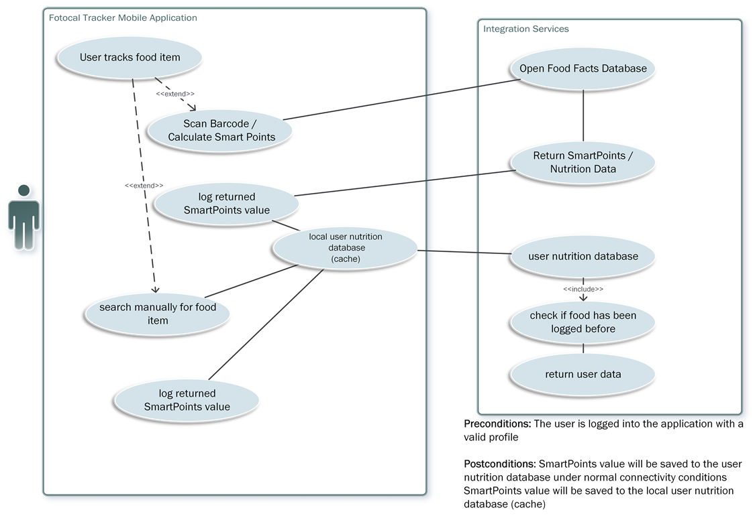

Figure . Activity Diagram - track new food item

Figure 5.5 illustrates the potential integration with an open source food database by using a barcode scanner to retrieve food records and then calculate SmartPoints using the values extracted from the record. The activity diagram also details that the user can search for food manually and log SmartPoints values in the local device database before saving to the cloud database. This will allow the user to track offline if a connection is not available.

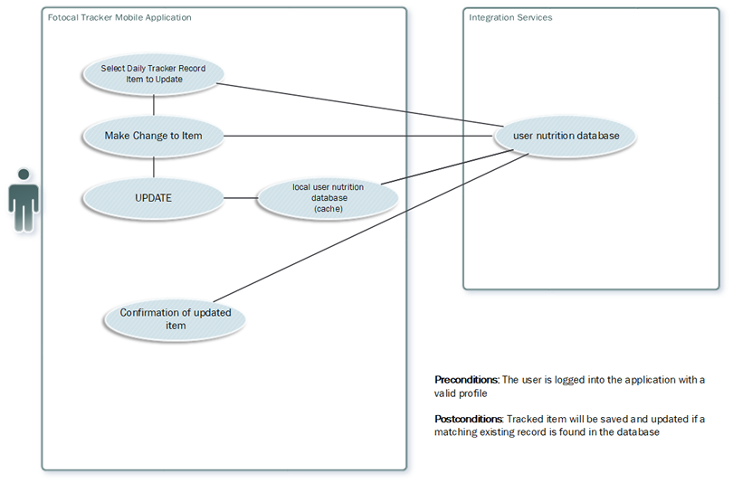

Figure . Activity diagram - update tracked food

One of the requirements is that the user can update and delete records. In Figure 5.6 the actor selects an item to update, makes a change and then the update is passed to the local device database. Once the update has executed locally, the synced record is uploaded to the cloud database. Similarly, in Figure 5.7 the actor selects and deletes an item which is deleted from the local database. This change is synced with the cloud database. A confirmation of both actions should be conveyed to the user.

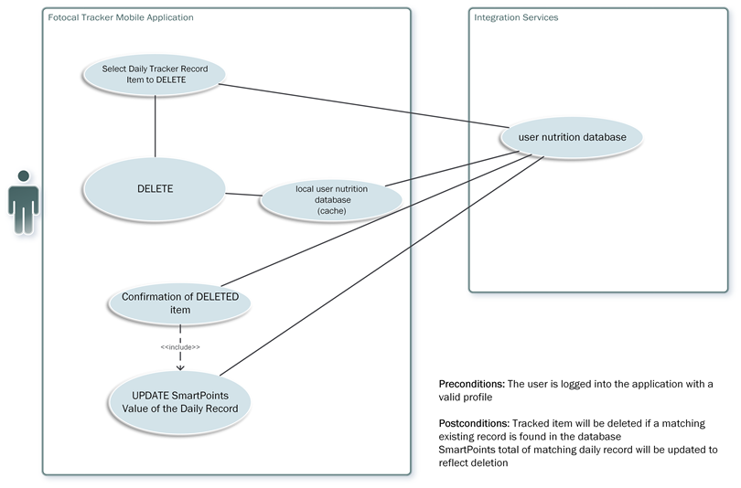

Figure . Activity diagram - delete tracked food

## UI Design

One of the most important aspects of the UI design for the mobile application is creating a unified look and feel that will promote consistency across the application experience. The FotoTrack logo is a representation of the app and its functionality. The emphasis should be on the message the app aims to convey and the purpose of the user engagement.

The colour scheme is an important aspect in consistency and a palette (Table 5.1) has been selected to sustain throughout the app icons and features.

|  |  |  |
| --- | --- | --- |
| Colour | Hex | RGB |
|  | #0872ba | 8,114, 186 |
|  | #7e287e | 126, 40, 126 |
|  | #4d4d4e | 77, 77, 78 |

Table . FotoTrack Colour Palette

### Logo

The logo icon will be used in two places, as a launcher icon, accessed via device OS menus and as an action bar icon at the top of each feature activity in the app.

The 3-D mock-ups illustrate the proposed logo designs. Each design reflects the specified colour palette. The colours were selected to convey inclusivity for all gender types including the stereotypical male and female tones blue and pink and a neutral shade grey.

The logo illustrated in Figure 5.8 uses a combination of the location icon and a wrapped arrow to impart the association of fitness tracking (GPS activity tracking) and the constraint of the arrow to symbolise a measuring tape. The location icon is transformed to look like scales which reveals some of the apps purpose in its design.



Figure . FotoTrack Logo Design 1

Figure 5.9 demonstrates a text-based approach to the logo and conveys the location icon with an indented motif. The motif is representative of a track or road, combined with location, this illustrates a journey towards fitness or walking and running activities.

Figure 5.10 illustrates a logo that has a combination of many of the apps features. This includes the mobile phone (the tracking device), the location icon that has a wrapping cinch to represent slimming. The incorporation of the Wi-Fi symbol demonstrates the connectivity to the cloud database.

Figure 5.10 is the selection for the launcher and action bar icons for the FotoTrack app. It was considered on the basis that it conveyed the most aspects of the apps functionality.

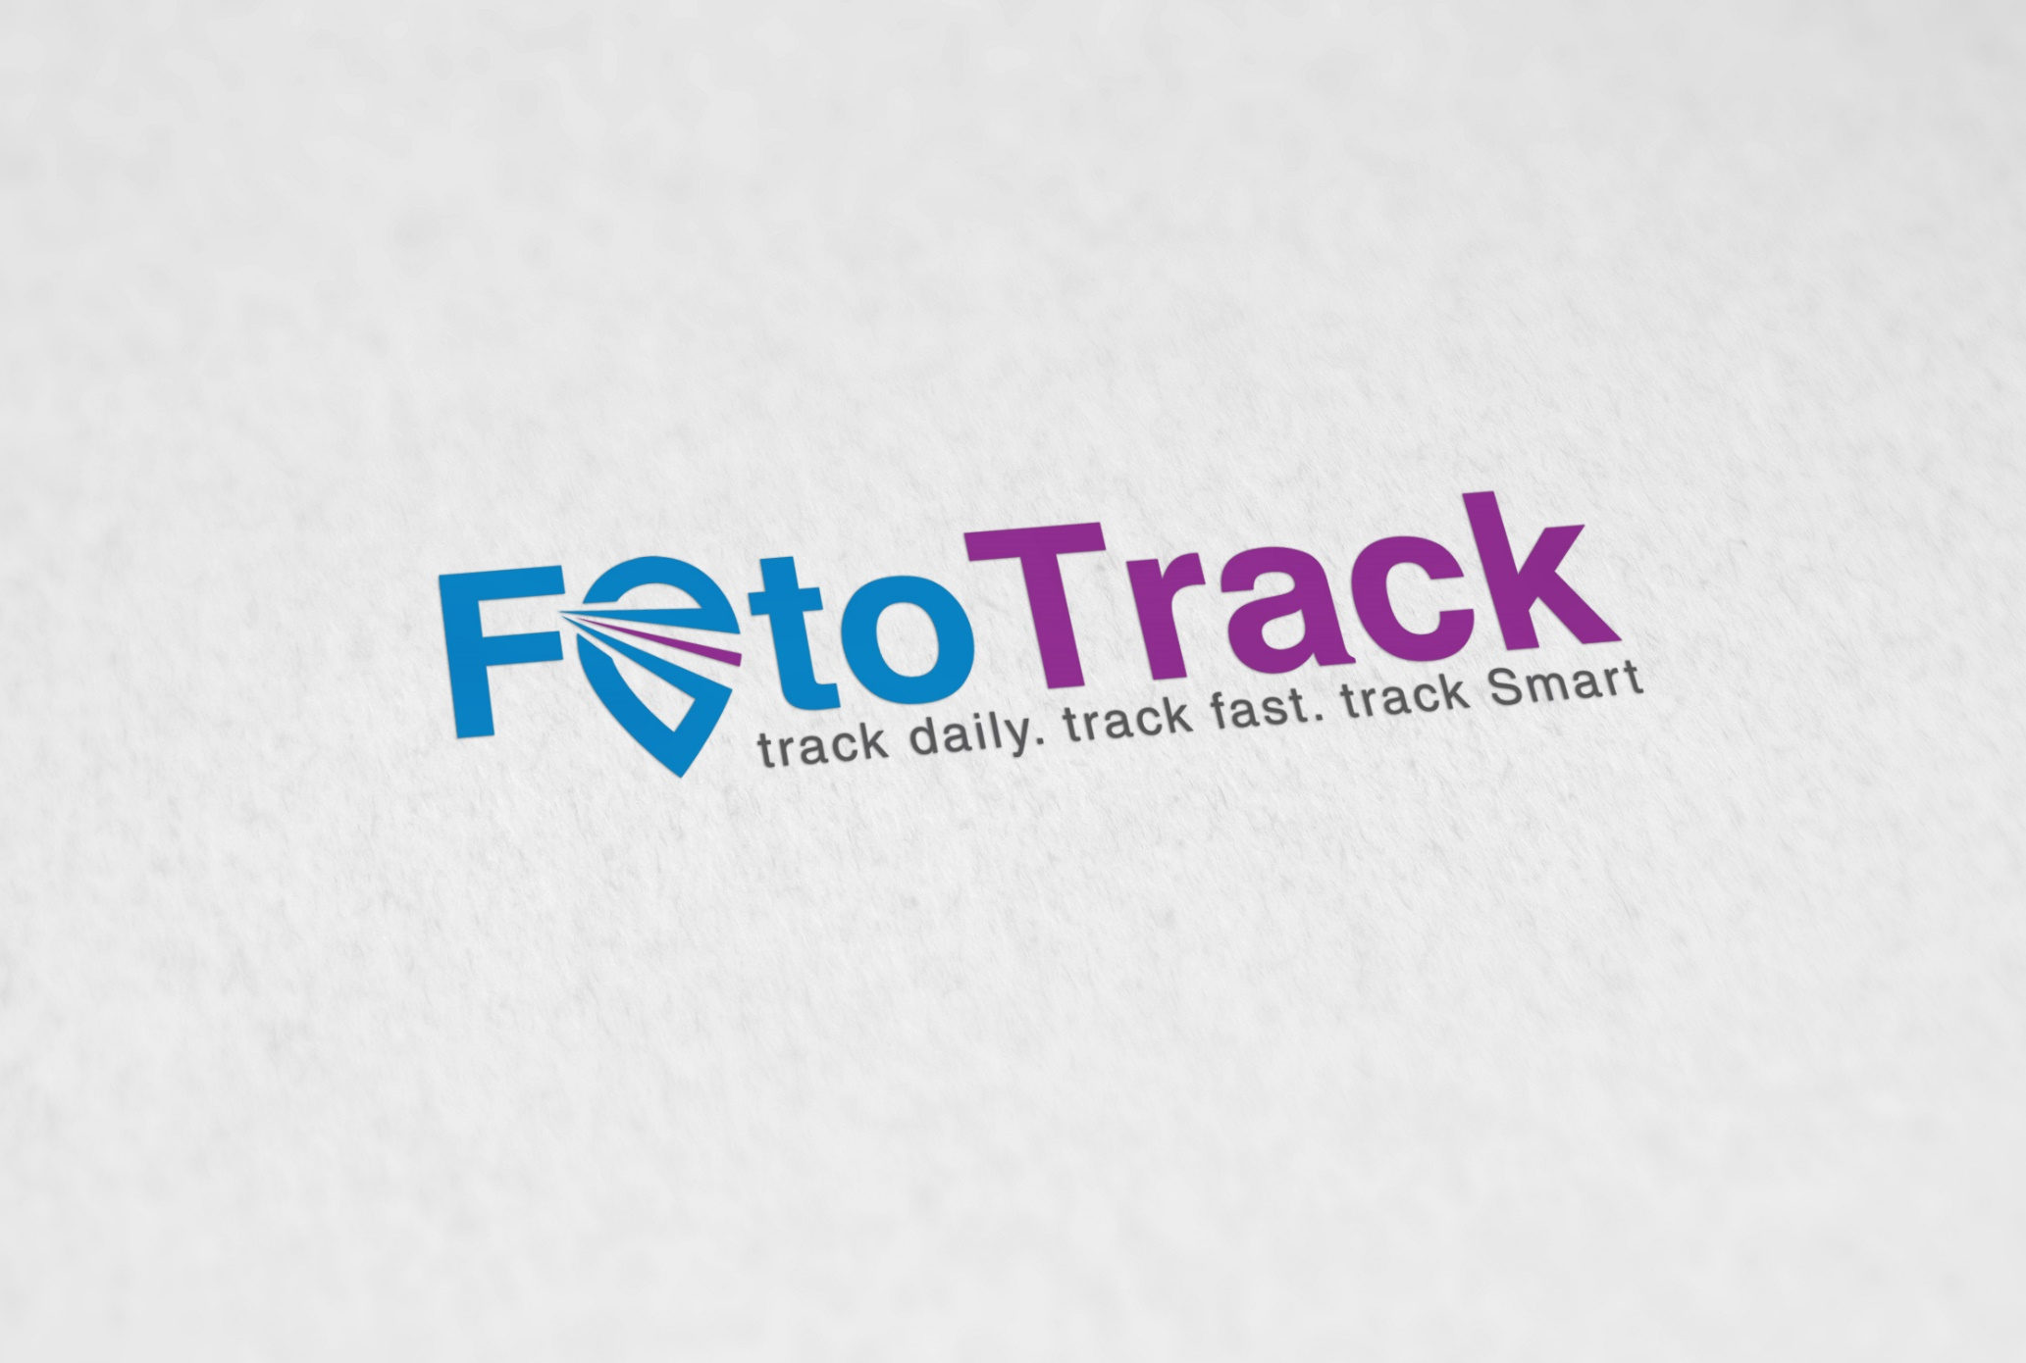

Figure . FotoTrack Logo Design 2



Figure . FotoTrack Logo Design 3

### Activity Screens

The app will use AppCompat theme to provide Material Design support for pre-API Level 21 devices.

The parent theme is Theme.AppCompat.Light.DarkActionBar and the primary colour palette has been modified to reflect the FotoTrack colour palette (Table 5.1).

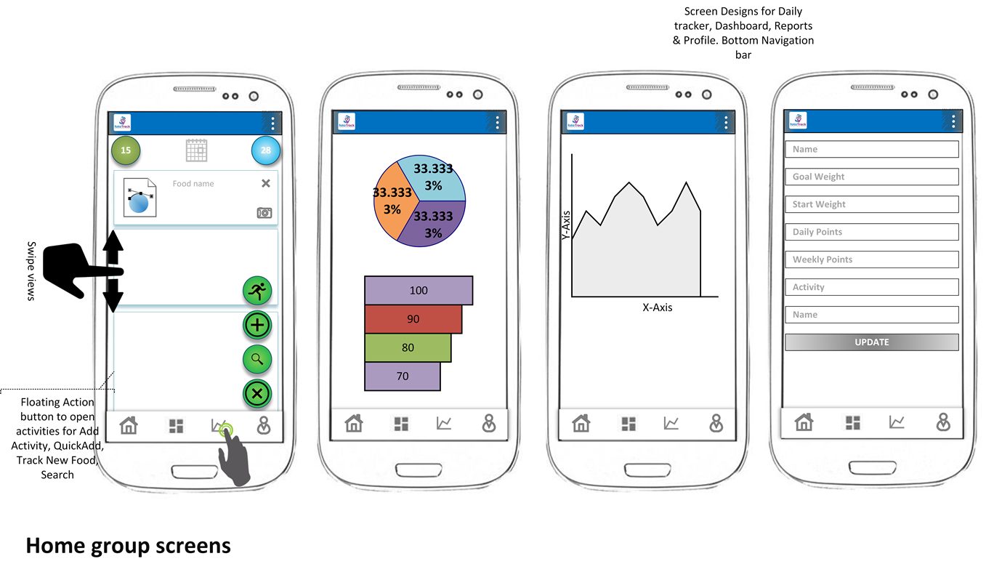

Figure . Home Pages Activities - Screen Designs

Figure 5.11 illustrates the four main home pages of the application. The Main Activity is the Daily Tracker view and will contain a list of the tracked entries that the user adds. A scrollable recycler view will be used to display individual card views. This is in keeping with the Android Material theme. There are two types of navigation, the bottom navigation bar and the floating action buttons.

The bottom navigation bar will contain links to the four main screens and will appear on each of these activities. The FAB will only be used on the Main Activity – Daily Tracker and will provide links to specific tracking functionalities such as tracking new foods, quick add and tracking activities.

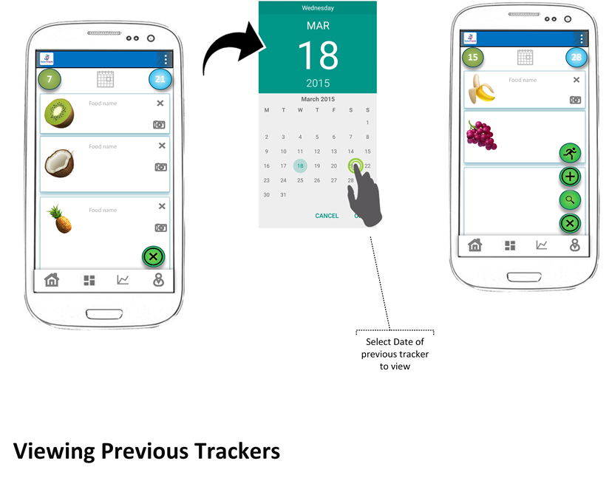

Figure . Screen Designs - viewing previous trackers

Figure 5.12 demonstrates the use of the calendar picker to select a tracker date to display on the Main Activity. A click event on the date at the top of the activity will launch the calendar dialog. The user can then select a date and view that activity. The selected list will be returned from the database using the date parameter and populate the recycler view list.

Figure 5.13 details the designs for the activity tracking. The user can select the icon in the FAB and an alert dialog will open. The dialog will be customised with edit Text fields and a number picker. The collected activity data will be displayed in a bar chart on the Dashboard activity.

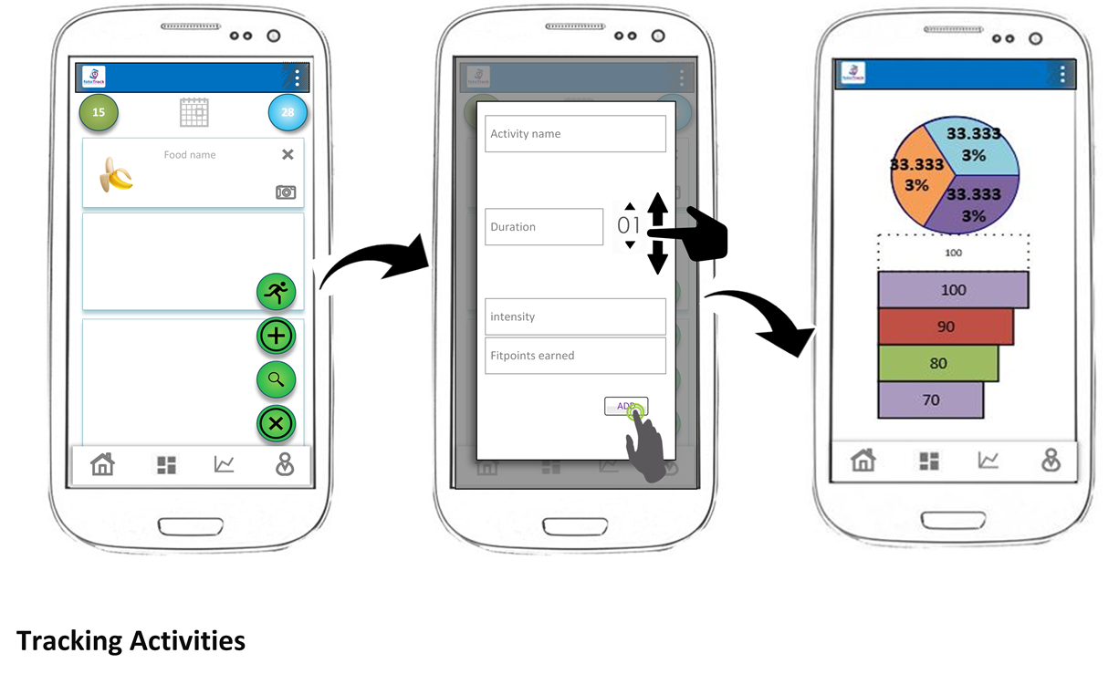

Figure . Screen Designs - record activity

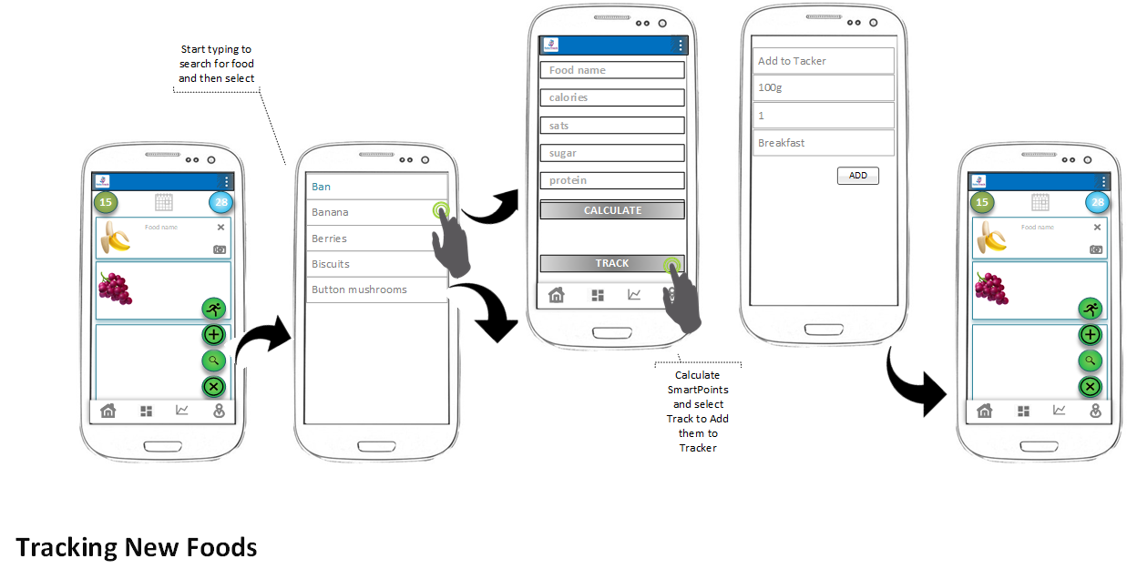

Figure . Screen Designs - Track new foods

Figure 5.14 details the user journeys in tracking a new food. The user can launch the food tracking form by using the action button or selecting the search action button to find the existing food first.

### Navigation

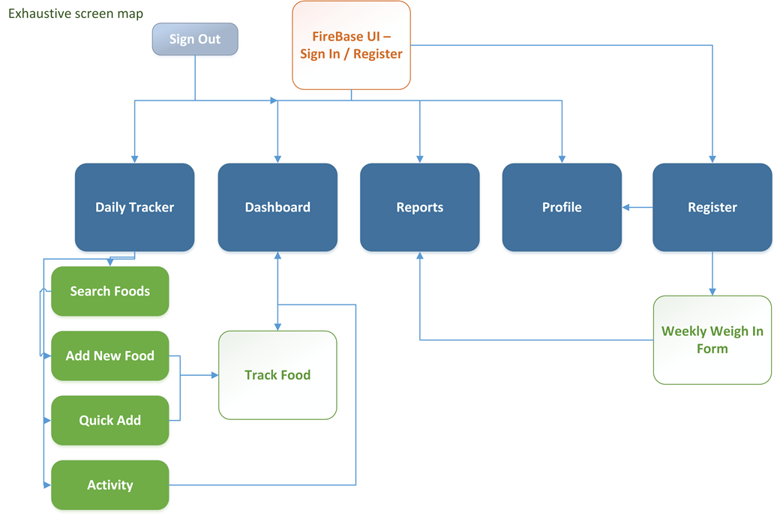

Figure . FotoTrack mobile application screen map

Figure 5.15 & Figure 5.16 illustrate the UI navigation of the FotoTrack application in combination with the Firebase UI authentication.

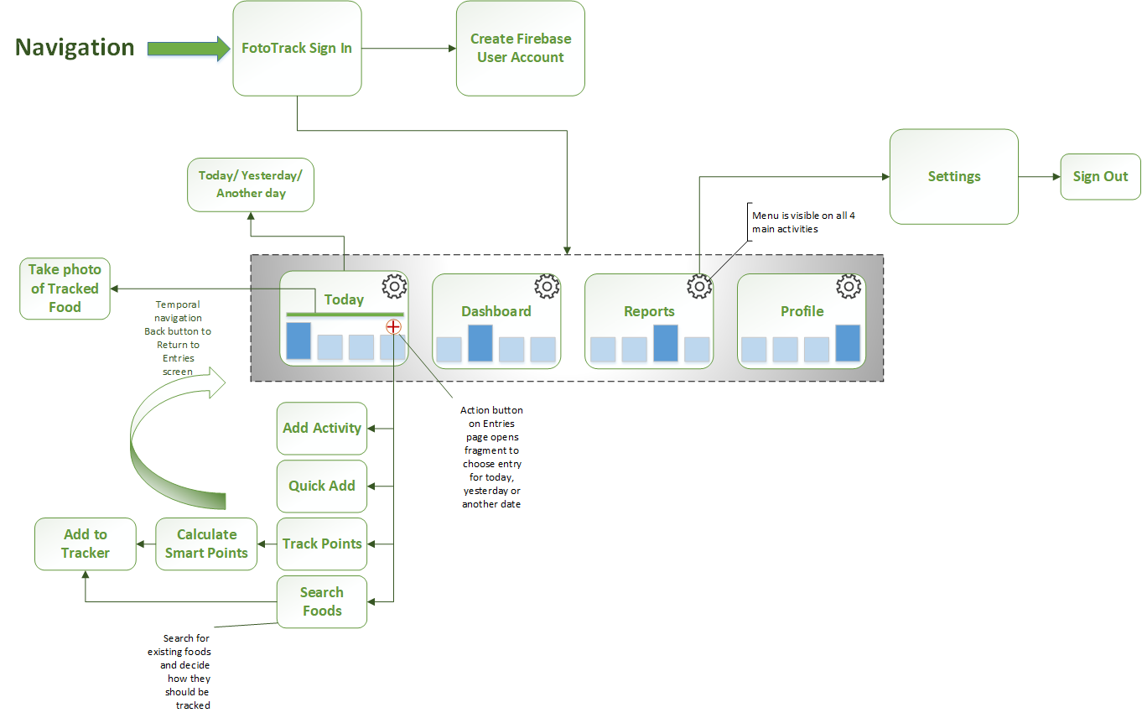

Figure . FotoTrack Navigation

## Firebase Database Structure

The Firebase Realtime database will be used to upload User profile information, daily trackers, food lists and record of current balances. The FRD supports a NoSQL structure which will support regular uploads of changing data types. The service supports always-on functionality and will accept uploads in realtime as the user adds data via the application. The most important aspect of the NoSQL database is the scalability. The application has been designed to support a growing number of users, which will eventually lead to powerful querying capabilities to build user recommendations such as meal-plans and ‘Time to Goal’ predictions.

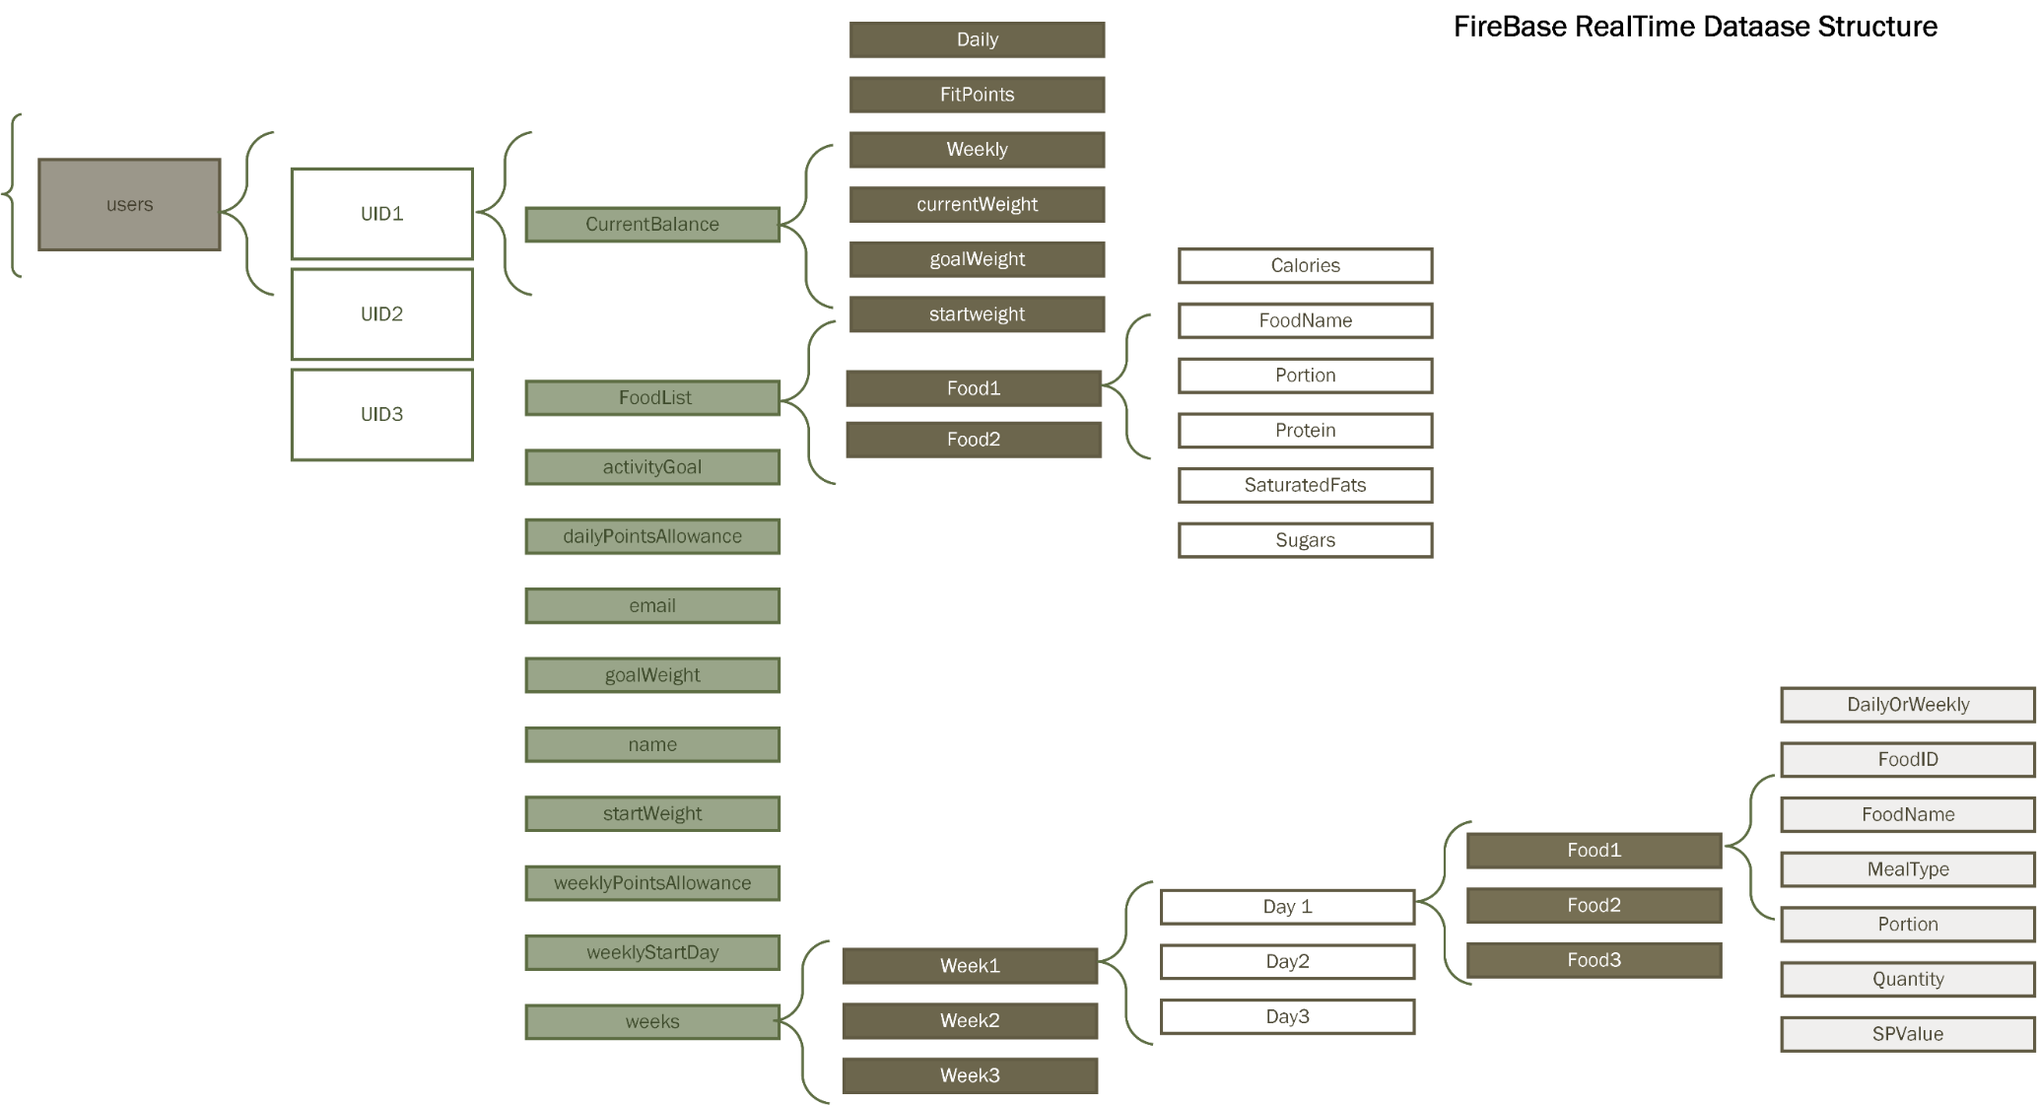

Figure . Firebase NoSQL Database structure

The deep querying levels are limited in FRD; hence the data has been organised in a shallow structure to ease the load on returning DataSnapshots. The DataSnapshot will return full subtrees in a query so it was considered beneficial to extract the current data node away from the main user node so that data for the Alexa service could be returned more efficiently.

The diagram in Figure 5.17 details the proposed structure for the FRD using a top-level node, Users. Each unique UID will form the start of each user tree and accept data on a realtime basis as it is synced from the local device database.

The FoodList has been maintained separately for each user to allow them to download it again should the app require reinstallation. It is proposed that this will be downloaded each time the user re-registers on a device and used to populate the local database food table.

## Alexa Skill & Firebase Realtime Database

Figure 5.18 illustrates the integration of the Alexa Skill with the FRD. The user will be able to send queries using the Alexa Skill to return current updates about their progress. The voice stream request will be passed from the Echo device to the Alexa Voice Service. Using the custom Skill identifier or *Invocation*, the AVS analyses the request and converts to text. The text request will then be passed to the Alexa Skill to process launch requests and build the intents. The intents will be passed to the AWS Lambda function to process and send a request via REST API to the FRD. The response is received back from the database, processed by the Lambda function and the text response returned to the Alexa Voice Service. The text is converted back to speech and streamed to the users Echo Device.

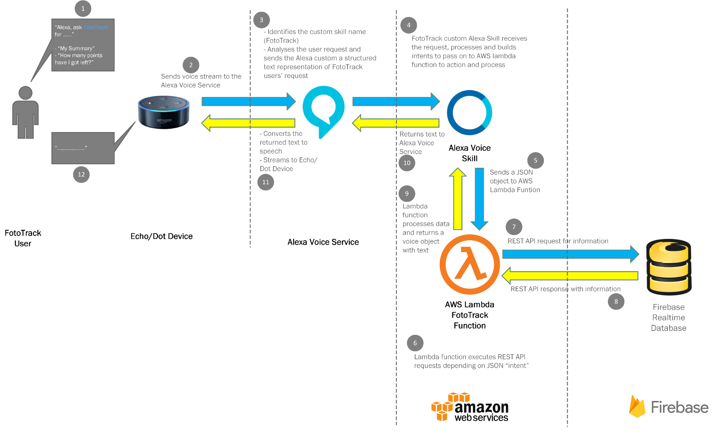

Figure . Alexa Skill & Firebase Integration

# Legal, Ethics & Security of Personal Data

The General Data Protection Regulation is coming into effect in May 2018 and rarely before has there been such focus and mainstream attention around the role of data and its use. Not only from the implementation of a new and updated protection in law but also by the revelations of how some of the largest technology and data platforms on the internet have been found to be using and processing user data with motivations which are highly questionable. Many have demonstrated less than ethical conduct in how it is gathered, for what purpose, and how it is subsequently processed, stored and shared.

The 6 principles of GDPR have been used as guidance to shape and inform the appropriate data required to gather and then process within FotoTrack (the data controller).

Under GDPR, the data protection principles set out the main responsibilities for organisations which are as follows:

a) processed lawfully, fairly and in a transparent manner in relation to individuals;

b) collected for specified, explicit and legitimate purposes and not further processed in a manner that is incompatible with those purposes; further processing for archiving purposes in the public interest, scientific or historical research purposes or statistical purposes shall not be considered to be incompatible with the initial purposes;

c) adequate, relevant and limited to what is necessary in relation to the purposes for which they are processed;

d) accurate and, where necessary, kept up to date; every reasonable step must be taken to ensure that personal data that are inaccurate, having regard to the purposes for which they are processed, are erased or rectified without delay;

e) kept in a form which permits identification of data subjects for no longer than is necessary for the purposes for which the personal data are processed; personal data may be stored for longer periods insofar as the personal data will be processed solely for archiving purposes in the public interest, scientific or historical research purposes or statistical purposes subject to implementation of the appropriate technical and organisational measures required by the GDPR in order to safeguard the rights and freedoms of individuals; and

f) processed in a manner that ensures appropriate security of the personal data, including protection against unauthorised or unlawful processing and against accidental loss, destruction or damage, using appropriate technical or organisational measures.” (ICO, 2018)

A privacy policy has been included with the FotoTrack app outlining the data collected and informing the registering user in simple terms how their data is collected and stored. The policy also outlines that by using the service the user is agreeing to their data being processed and they are giving their consent for this purpose. When a FotoTrack user first installs the app, at the end of the initial profile setup process users are prompted to read and accept the privacy policy(Figure 6.1). This must be accepted by ticking the checkbox before the users' account is created. The full FotoTrack privacy policy can be reviewed on the host [Iubenda](https://www.iubenda.com/privacy-policy/64546909) website.

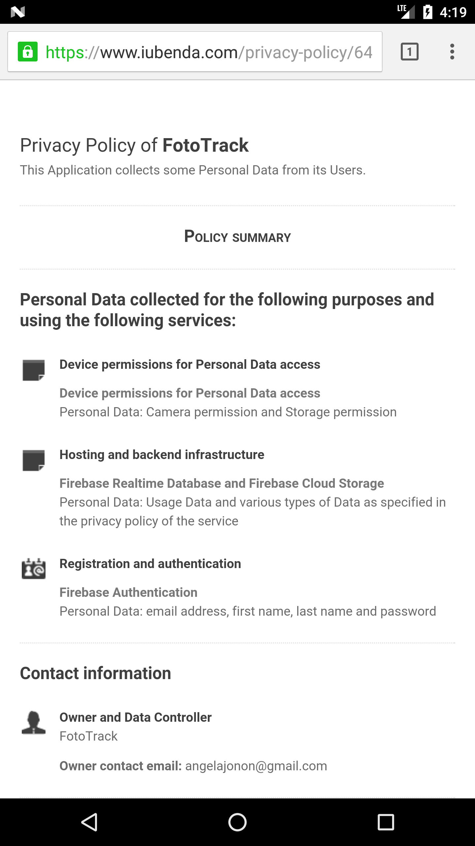

Figure . FotoTrack Privacy policy accessed via Registration activity

As outlined in the privacy policy, FotoTrack only collects and processes data that is relevant to the application and its stated purpose. This, however represents a wider dilemma for application developers as it is the collection processing and subsequent monetisation of data through targeted advertising of products and services that make many applications economically viable. With smartphones it is extremely easy to enable access to a very broad spectrum of data which can be collected and processed. Although unnecessary for the core purpose of the app, it can broaden the appeal of the application to connect with users in a highly selective effort to sell goods and services.

Although not implemented in the app it would be possible to include a "forget me" option which would erase all profile and tracking data associated with a user. For convenience and to support a user either moving to a new device or restarting their weight loss journey, the ability for existing\previous users to download previous tracked foods to populate their local food database has been included to improve convenience and efficiency. As a data management exercise, it would be possible adopt a process whereby user accounts and user level data nodes that have not been updated after a suitable period of time (e.g. 1 year) are automatically deleted. To support the accuracy and currency of the data it would also be possible to prompt the user to confirm that the key FotoTrack data is accurate.

The security of the data transferred to the supporting Firebase services are secured using SSL which is used to provide an encrypted link between the user smartphone device and Firebase server.

The user data can only be updated or modified if they have an authenticated user session.

The top-level data objects are referenced using a unique user ID (UID) which is a string of 28 randomly generated upper and lower-case alpha-numeric characters.

Access to the Firebase REST API, as utilised by the Amazon Lambda function to support the Alexa Voice skill is on a read-only basis for current balance information. No user identifiable information is communicated via the REST response.

In addition, access to the Amazon Lambda function endpoint, which reads data from the Firebase REST API, has been limited to the custom FotoTrack Alexa Voice Skill which provides an authenticated requesting application ID when submitting requests to the function.

# Implementation

## Overview of FotoTrack Architecture

The diagram in Figure 7.1 illustrates the architecture of the FotoTrack application and the various services that integrate.

The overview demonstrates the layers of service from a high-level perspective.

The user interface layer incorporates the end devices such as fitness trackers, Amazon Alexa and FotoTrack Android app.

The user devices communicate with the back-end cloud services of the FotoTrack application platform, providing user authentication and long-term data storage. The FotoTrack app is built on a highly scalable data platform that has the potential to support a significant number of users. The cloud database solution is a flexible document -based No-SQL technology built to support a large volume of loosely correlated data that enables the regular modification of data structure hierarchy.

The data layer is accessible to additional services and opens the possibility to integrate and make the data available to queries or updates by other user channels than just the FotoTrack app. The example detailed in the diagram is the integration of the Alexa Voice Services, Alexa Skill and the AWS Lambda function to achieve this.

The application is not dependent on the back-end cloud services being available to be functionally usable. The data can be updated asynchronously, when network connectivity is restored.

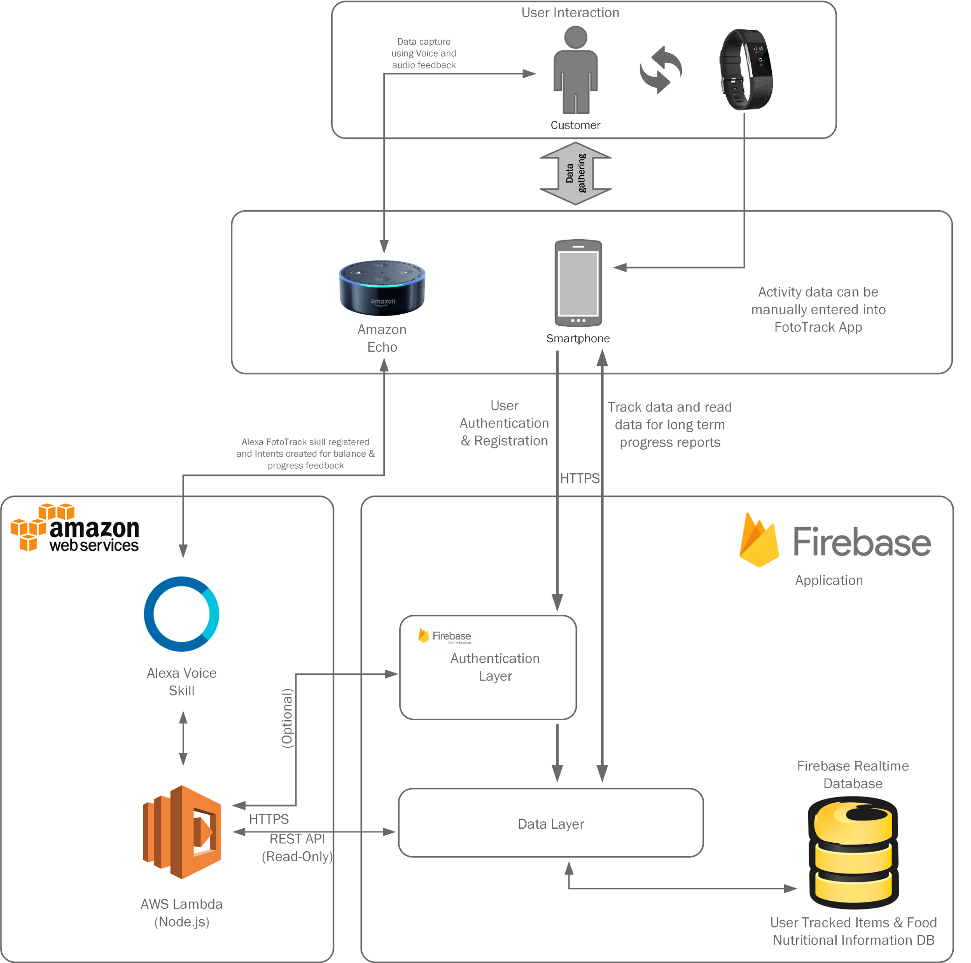

Figure 7.1 FotoTrack Services Architecture

## Sprint 1

|  |  |
| --- | --- |
|  | Click on the PDF icon to view a Sprint Report for Sprint 1 |

Sprint 1 began on 13th December 2016 and was originally forecast for just 11.5 days development time. This was due to unexpected complexity in some of the mobile application components and the extra time needed to address the learning curve.

Risk No. 5 on the Project Risk Register (see Appendix ­_) outlines this risk and the proposed mitigation tasks to reduce the impact of the risk. One of the methods implemented was the introduction of JIRA Project Management software to create Sprint boards and manage backlog tasks. Sprint Report 1 outlines some of the user stories extracted from the requirements and added to the sprint. Each sprint board also includes tasks that derived from incidents that occurred during the sprint.

Much of the complexity in the opening sprint could be attributed to the verbose business rules that surrounded the construction of a new Daily Tracker. This was the foundation on which the mobile application was built, and the planning and relationship of data structures was more time consuming than originally outlined in the project plan.

The main thread of the application centres around the creation of a new tracker day to which the user could add new food tracked entries. The tracked food entries are entered by the user and then returned from the local SQLite DB (*FoodDataBase_Local*) as a list to be displayed within a Recycler / Card view on the home screen. The following sections detail the application flow, user interaction and events that create the data to be displayed.

### Daily Tracker

Figure 7.2 illustrates the Daily Tracker view that creates the Home page of the application.

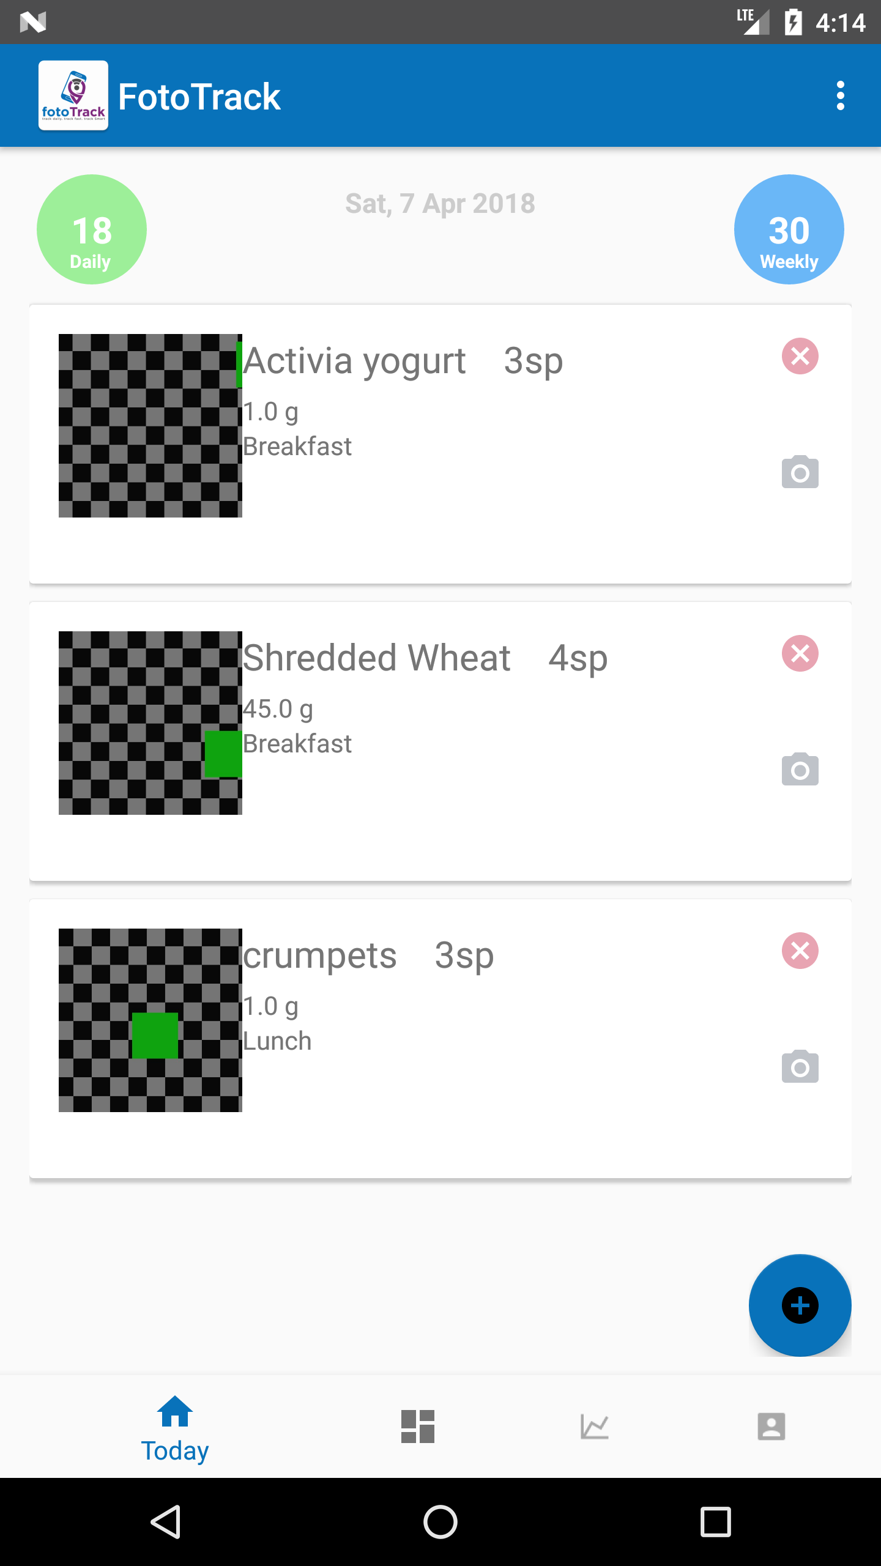

Figure . Daily Tracker screenshot

The Main Activity contains the main food tracker view of the application. A new tracker is created for each calendar day when the user starts the app.

|  |  |
| --- | --- |
|  | Double click on the PDF to see the full detail of the code sample. |

Figure 7.3 outlines the code used to evaluate the various conditions that influence the creation of a new tracked day for the FotoTrack application.

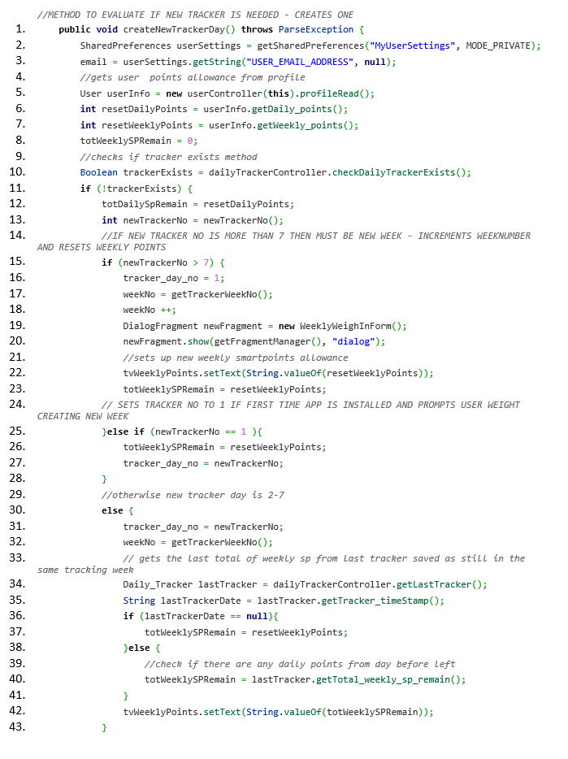

Figure .New Tracker Day conditions

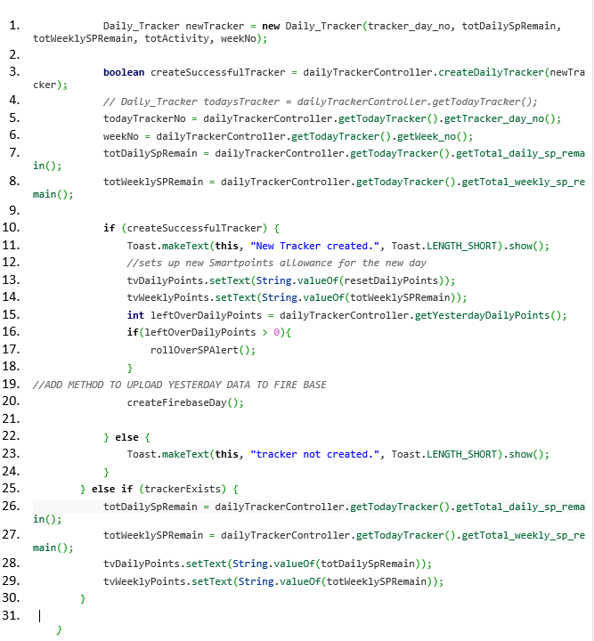

Figure . New tracker successfully created - confirmation

Figure 7.4 demonstrates the creation of a new tracker object and its insertion into the DailyTracker table in the FoodDataBase_Local. The function createDailyTracker() returns a Boolean createSuccessfulTracker as True if the object has been successfully added to the database and a user Toast message is displayed to confirm that the new tracking day has begun.

As the MainActivity is refreshed several times during the application use, it also executes an else condition to reload the same tracker and the associated SmartPoints balances if the tracking date remains the same.

The activity diagram in Figure 7.5 demonstrates the decision tree and method calls implemented during the creation of the new tracker object.

|  |  |
| --- | --- |
|  | Double click on the PDF link to view a copy of the diagram. |

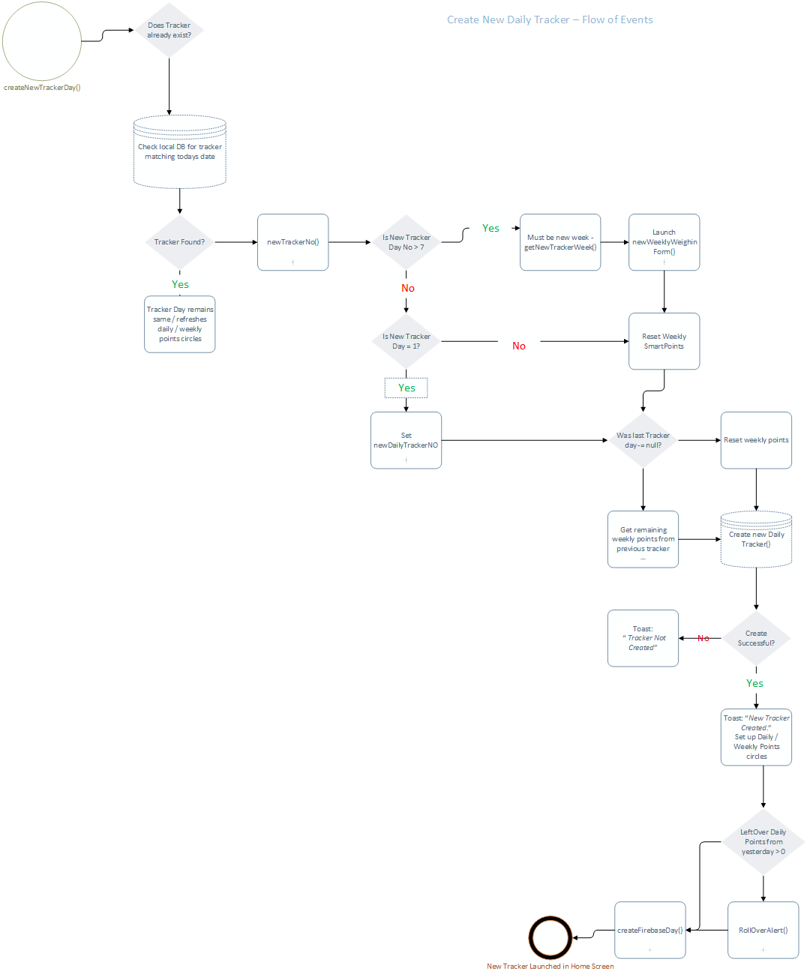

Figure . Activity Diagram - Create New Tracker

#### newTrackerNo()

The function newTrackerNo() Figure 7.6 is called from the createNewTrackerDay() method. This was implemented during initial testing on observing that if the user missed a day tracking, the tracking week did not progress to the tracker number of the next daily tracker created. For example, if the user tracked on Day 1 but did not track on Day 2, then no physical tracking object would be created for that day. Should the user resume tracking on Day 3, the tracker day number would have only incremented to Day 2. This method gets the actual tracking day in the week cycle, whether the user participates in tracking daily or not.

The function first queries the database to retrieve the last tracker day number and time stamp.

If the query returns a null for the last tracker, the new tracker number will be set to 1. This facilitates the user when first installing the app.

The last tracker date is then reformatted to remove the timestamp and a variable is set with today’s date.

The difference in the two dates is calculated to return the number of days that have elapsed since the last recorded tracker date. This total is then added to the last tracker number to obtain the new tracker day number.

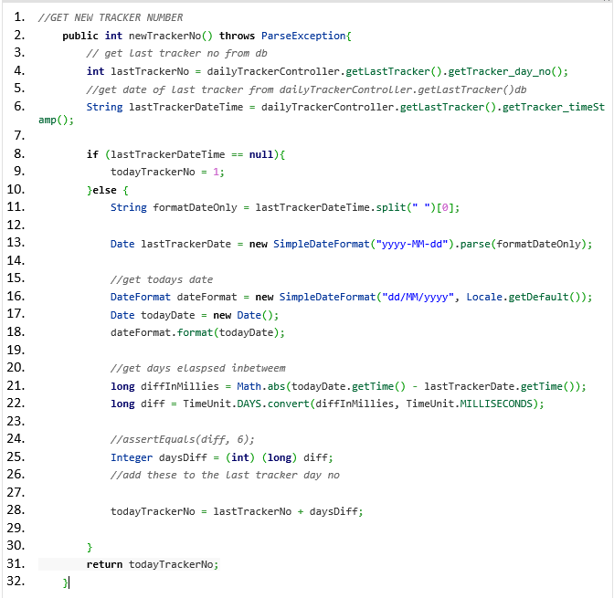

Figure . Code - New Tracker Number

### Recycler View & Card View

The MainActivity tracker interface is created by displaying a list of tracked food entries within a recycler view containing a card view of individual items. A scroll view was added to the XML, allowing the user to scroll through the full list of entries returned. The data is collected using initialiseTrackerData() and then passed to the RecyclerView Adapter using initialiseViewAdapter() .

The tracker data is queried from the database from two tables:

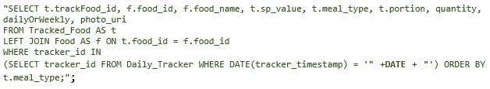

To return the tracked food entry as one object, a subclass of Tracked Food named TodayTrack was created. Figure 7.7 demonstrates how the TodayTrack objects were queried from the database and returned as list of objects.

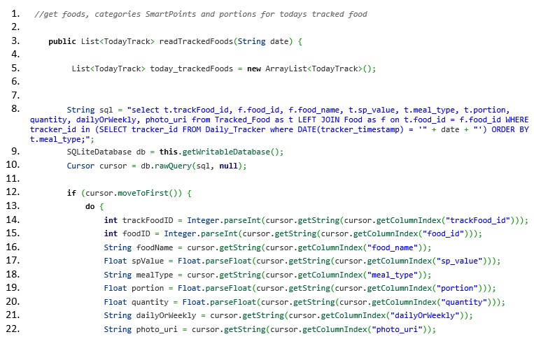

Figure . readTrackedFoods from Database

A new TodayTrack object (Figure 7.8) is created with the returned value from the joined tables and added to the list of tracker items to be displayed on the Daily Tracker.

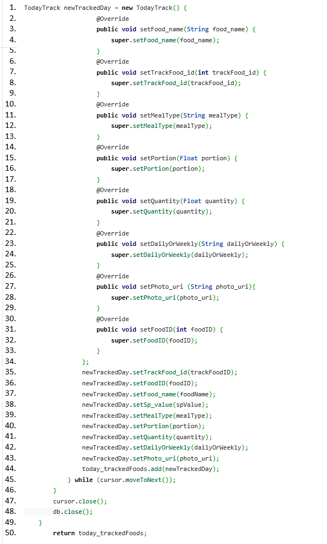

Figure . TodayTrack object created and added to list

The List entries were returned based on the date passed from the Daily Tracker. See initialiseTracker() in Figure 7.9 for implementation detail. The flow diagram in Figure 7.10 details the data flow of the method.

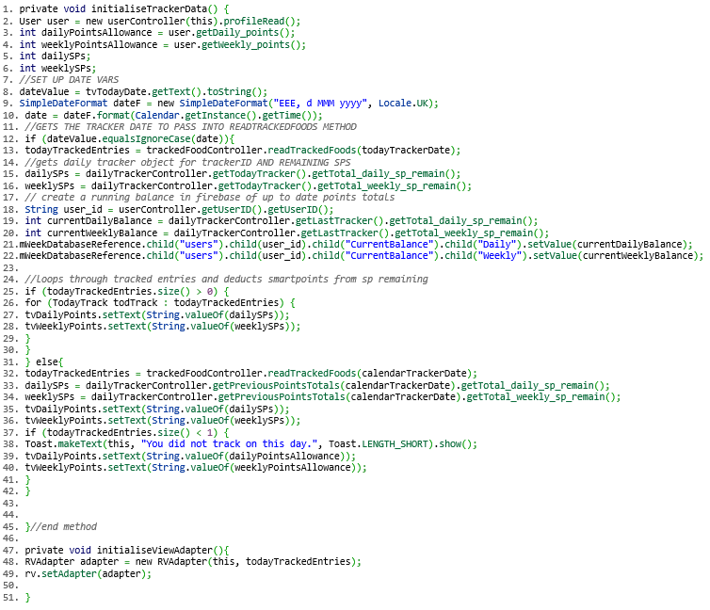

Figure . Code Initialise Tracker method



Figure . Activity Diagram - Initialise Tracker

#### Recycler View Adapter

|  |  |
| --- | --- |
|  | Click on the pdf to view a complete code listing for RecyclerViewAdapter |

The list of tracked food entries for the selected data is then passed to the RecyclerView Adapter. RecyclerView conforms to the Material design guidelines and simplifies the rendering of list data. It is difficult to anticipate how many tracked entries a user will add each day. This could present performance issues as lists can be resource intensive if scrolling is implemented. Recycler view does not create new views for each scroll event but recycles them for reuse if required. I have paired this with a linear Layout Manager to present the view as a vertical scrolling list.

The RecyclerView.Adapter provides the views that represent each tracked food item in the returned data set.

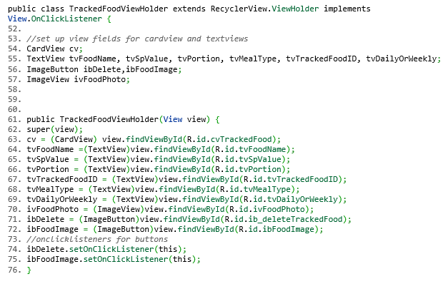

Figure . Code - View Holder

The ViewHolder in Figure 7.11 is used by the RecyclerView as an alternative to view creation. The ViewHolder contains the inflated views and can be cached for reuse.

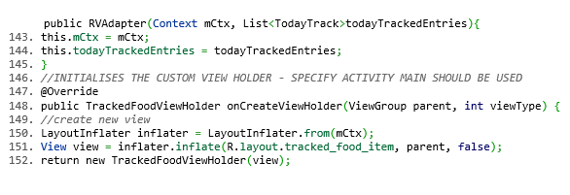

In Figure 7.12 the Layout inflator inflates the created xml view in the card views and the list of todayTrackedEntries are initialised.

Figure . Code - Layout Inflater

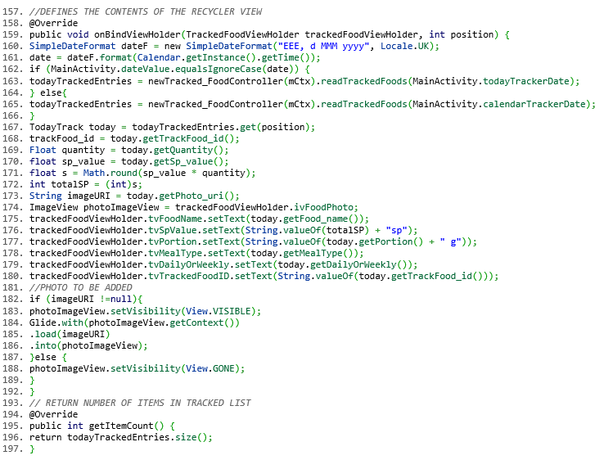 The onBindViewHolder, Figure 7.13 takes in the custom view holder above as a parameter and binds the data from todayTrackedEntries List to the child views. The Count() method below returns the size of the returned dataset and sets the size limit of the list. Additional methods have been added to format the SmartPoints values and process the image URIs of tracked foods with captured photos.

Figure . Code - OnBindViewHolder

To facilitate the image capture and to delete tracked food entries, OnClick(Figure 7.14) events have been added to trigger the associated functions for each child item in the View Adapter.

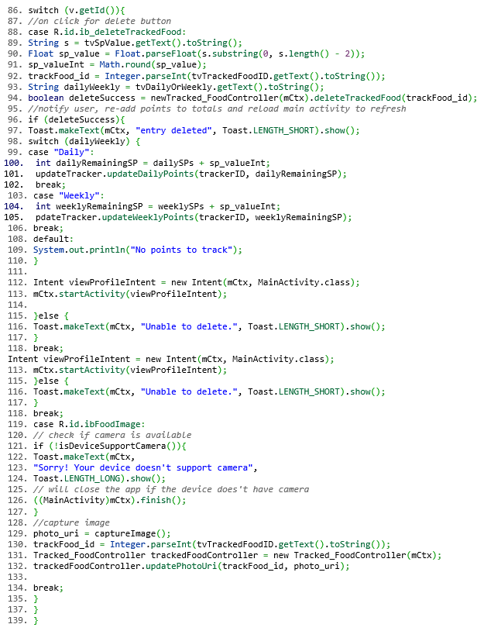

Figure . OnClick() - Switch Case

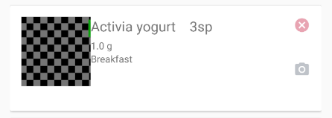

Figure . Individual CardView with image

The event flow diagram in Figure 7.16 illustrates the decision tree for each card view (Figure 7.15) Camera click and Delete click function. On completion the functions, the Main Activity is then loaded to refresh the Daily Tracker data and reflect the changes.



Figure . Activity Diagram - Take Picture

### New Weekly Weigh in Form

The New Weekly Weigh In form is an alert dialog that performs two functions:

* Adds a new Week object to the Week table in the local database.
* Allows the user to record their weekly weigh in statistics

It is accessed via the Main Activity() when the createNewTrackerDay() method assesses that the tracker must enter a new week and when the user registers on the app for the first time.

|  |  |
| --- | --- |
|  | Click on the PDF link to view the code for the newWeeklyWeighIn Dialog Alert |

The screen shot in Figure 7.17 demonstrates the alert dialog used for the Weekly Weigh In form when the user completes the registration process.

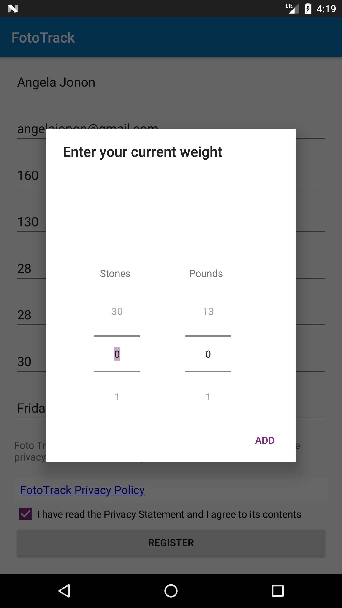

Figure . Weekly Weigh in form

The number pickers present a more user intuitive input method and allow the dialog to be displayed fully without the keyboard popping into view. The activity diagram in Figure 7.18 illustrates the flow of events that surround the weekly weight entry and the data objects generated as a result.

During the feedback sessions from some of the end users, it was proposed that the weight units were entered in stones and pounds as this is the unit system most commonly used within the local Weight Watchers groups. To facilitate this, stones and pounds were used as a method of input for the user and converted back to pounds for saving to the database.



Figure . Activity Diagram - New Weekly Weigh In

### Add New Food & Add to Tracker

As part of the daily tracker, users can also calculate SmartPoints of a given food by entering the following information:

* Calories
* Saturated Fats
* Sugars
* Proteins
* Portion
* Your portion consumed

This is then processed using the SmartPoints function:

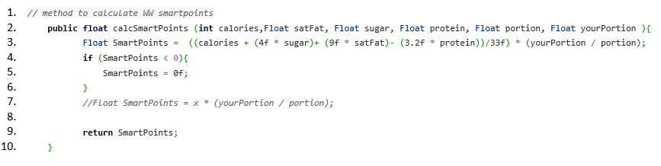

The AddNewFoodForm() is an activity that is launched from an OnClick() event using the MainActivity FAB (floating action button). Figure 7.19 illustrates the AddNewFoodForm when it is launched. The Save To Tracker button will remain disabled until the user has calculated points.

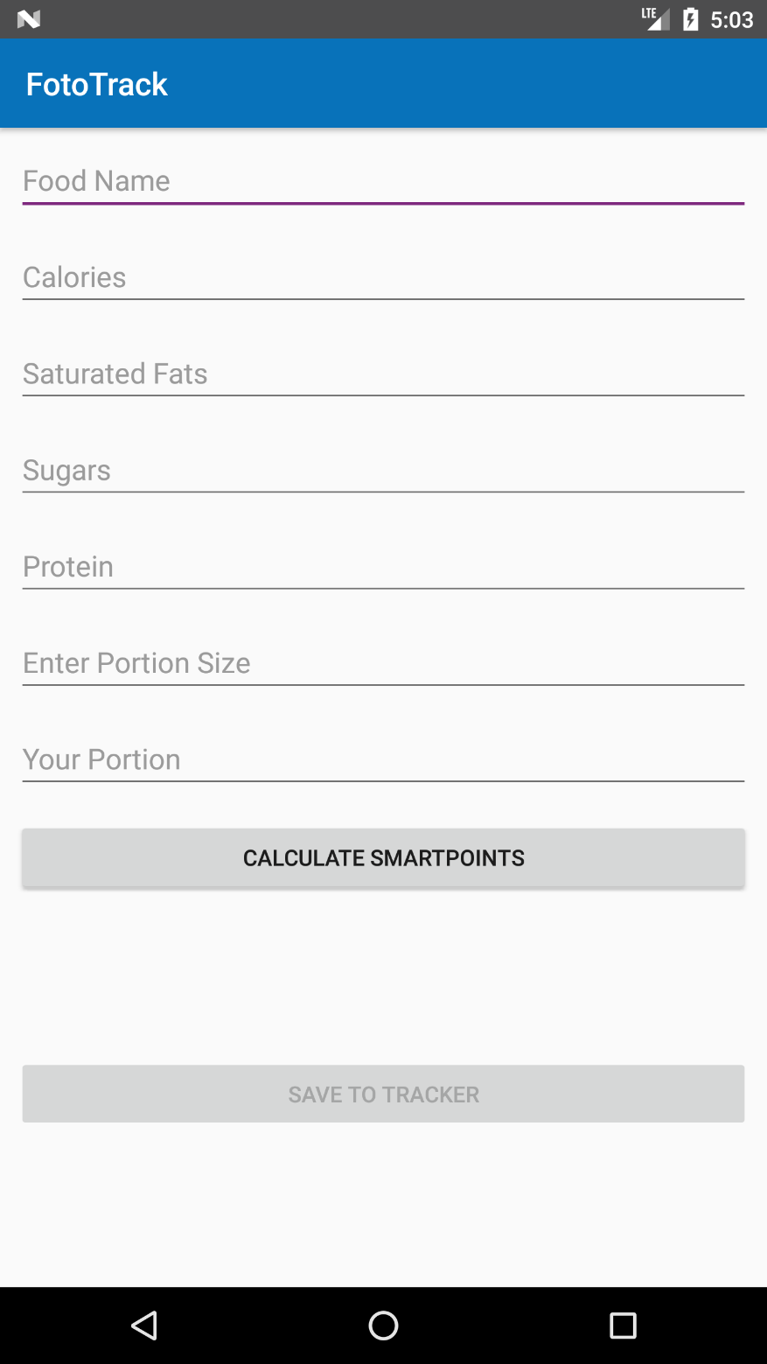

Figure . Add New Food Form - launched

|  |  |
| --- | --- |
| Figure 7.20 Add New Food Form - food already saved toast | Figure 7.21 Add New Food Form - Food Save toast |

Once the user has calculated the SmartPoints, the value will appear in the text view and the Save To Tracker button will be enabled, allowing the user to commit the food to the tracker.

Foods calculated on this form are saved to the database Food table Figure 7.21 they are not added to the Daily Tracker until the user decides to use them by clicking Save To Tracker.

Another feature that has been implemented is checking to see if the food already exists in the database. On the implementation of the food search spinner in Figure 7.22, a method was introduced to check the food table and display a user toast if found Figure 7.20. This prevents duplicate food items appearing in the search spinner.

|  |  |
| --- | --- |
| Figure .- Food Search Spinner | Figure . - Track Food Form |

When the user decides to commit the entered food to the tracker, a custom dialog will appear to collect further information about the tracked food.

On this dialog, the user can decide whether to use their daily or weekly SmartPoints balance to deduct the calculated value from. Figure 7.23 demonstrates the trackNewFoodForm.

Once the food has been added here, the food is saved to the daily tracker and the Main Activity reloads containing the new tracked entry.

|  |  |
| --- | --- |
|  | Click on the PDF to view the full code for the Add New Food form |

### Database – SQLite3

The user maintains a small SQLite3 database on their device. This contains tracking data and user profile information that facilitates the user in tracking their daily food and activity entries. The main benefit the local database is that the user can use the tracker without relying on network connectivity.

The connection to the Firebase Realtime Database ensures that the user data is then synced to cloud storage when network connectivity becomes available.

The FoodDatabase_Local is a relational database that contains the tables relative to the data represented by the application objects. The ER diagram is detailed in Figure 5.1

The schema for the database is defined in the DatabaseConnection contract class. A series of constants (Figure 7.24) have been defined representing the database name, tables and column names. The create statements are also listed here (Figure 7.25), defining the table structure, foreign keys and relationships.

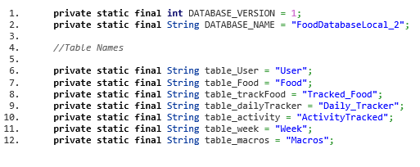

Figure . Database Connection constants

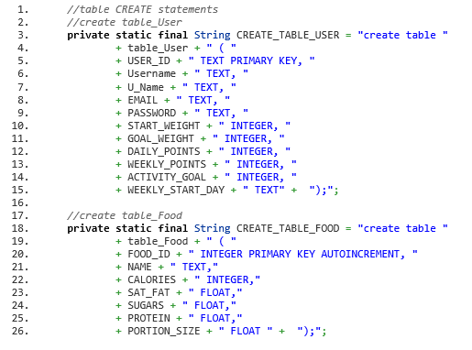

Figure . Database Connection - create statements

The DatabaseConnection class extends SQLiteOpenHelper that provides a set of APIs to manage database functions. Figure 7.26 demonstrates the OnCreate method that will execute the prepared SQL create statements for the database. The Upgrade method can be called when making changes to the schema, dropping the existing tables and creating a new version of the database.

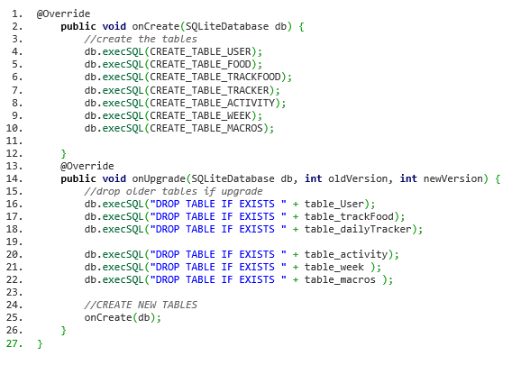

Figure . Database Connection Create table and Upgrade

|  |  |
| --- | --- |
|  | Click on the pdf link to view a complete listing of the DatabaseConnection class |

A series of database interfaces or controllers have been implemented to create a layer of abstraction between the database and the application code. The SQL database calls are categorised into a controller class of object type and can be accessed throughout the application by calling a new instance of the controller and the method. An example of an application database interface class is the Daily_TrackerController. Each interface extends DatabaseConnection to avail of the SQLiteOpenHelper APIs such as getWriteableDatabase() . This method is called each time the SQL methods are implemented via each controller class. It opens the database and allows a read or write function to execute. The method close() is then called to close the connection to the database.



Figure . Application local SQLite database architecture

Figure 7.27 illustrates the relationship between the application layers and how they interact with the SQLite database. The database methods have been abstracted away from the activity classes to allow accessibility from all classes, facilitate modification and debugging.

Figure 7.28 details the create new daily tracker object method in the controller class for Daily Tracker. The method takes in the newly constructed Daily Tracker object (from the MainActivity) as a parameter and uses the ContentValues() object to pass to the database insert method. A Boolean is returned as *true* if the insert statement is successful.

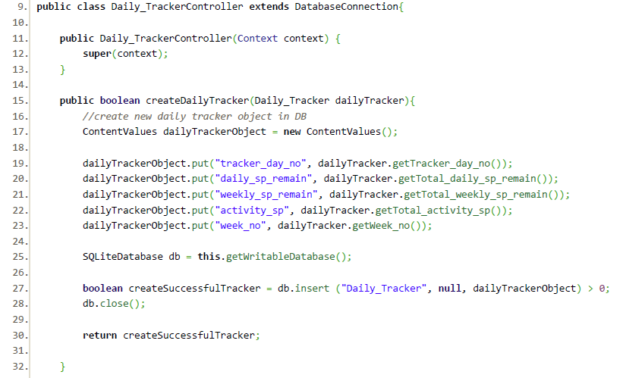

Figure . DailyTrackerController - createDailyTracker()

Figure 7.29 demonstrates a read method in which a cursor object is used to iterate through records of the DailyTracker table that match the *where* condition in the SQL query and return them as a DailyTracker object. This method has been used several times in the MainActivity, RvAdapter.ViewHolder, QuickAddFoods, WeeklyWeighIn, TrackNewFoods and TrackNewActivity.

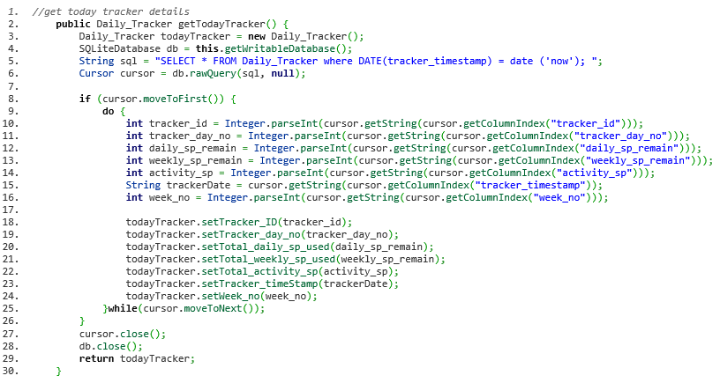

Figure . DailyTrackerController - getTodayTracker()

Figure 7.30 details the update method executed to update the new Daily Points balances to the Daily Tracker table. The method uses ContentValues to ‘put’ the new values in the table and a where condition passed in via db.update.

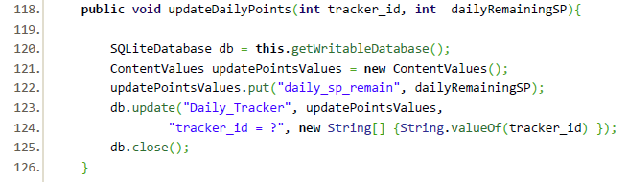

Figure . DailyTrackerController - Update Daily Points

Figure 7.31 demonstrates a delete method that is called once during the createNewTracker function. To minimise growing datasets on the end user device, all tracker data, including macros, activities and tracked foods will be deleted after a retention period of 4 weeks.

The user tracking data is uploaded to the Firebase database and can be restored at the user’s request.

It is important to note that the tracking in the Firebase realtime database will also be subject to a retention period and will not be indefinitely available. The user personal food list will be retained for a long period of time until the user requests the deletion of their account.

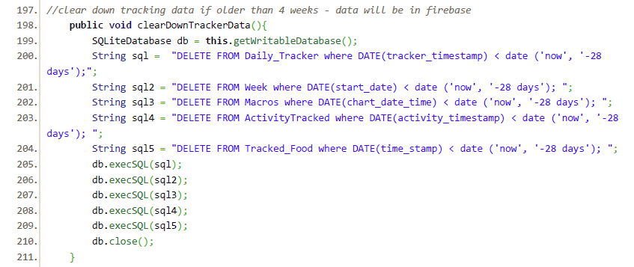

Figure . DailyTrackerController – Clear Tracker Data

## Sprint 2

Sprint 2 began 5th March and ran until 3rd April 2018. This was later than anticipated in the original Project plan and was due to the under estimated complexity in Sprint 1.

The Project Risk register contains details of a potential risk to the project timeline if the integration service present challenges in terms of compatibly or high complexity. On reviewing the project time line, the contingency plan for this risk was implemented to reduce the impact on the project delivery date and integrate the cloud services successfully.

The services used for the application integration were Firebase Realtime Database, Firebase UI and Firebase Authentication.

|  |  |
| --- | --- |
|  | Click on the PDF link to view a Sprint Report for Sprint 2 |

### Firebase Authentication & UI

To create a secure authentication and onboarding process, FotoTrack implements Firebase Authentication and UI.

The Firebase UI library is built on Firebase Authentication SDK and provides a UI onboarding process for the FotoTrack mobile application. The UI will support signing flows from multiple providers for example, Google Sign, Facebook and Twitter. The app uses an email registration (Figure 7.34) and sign in UI (Figure 7.32).

|  |  |
| --- | --- |
| Figure 7.32Firebase UI - Sign In with email |  |

|  |  |
| --- | --- |
| Figure 7.33 Firebase UI - Forgotten Password | Figure 7.34 Firebase UI - New User Registration |

The user can also retrieve forgotten passwords (provided they have supplied a valid email address) and create a new user registration.

The app is connected to Firebase by adding the google-services-plugin to the build.gradle file, adding the app package name to the Firebase console. This generates a google-services.json file to add to the project app folder and a secure Web API key.

In the Authentication web console, email/password authentication type was enabled.

On registration, each user is assigned a UID which has been saved in the Firebase console and in the FoodDatabase_Local to uniquely identify each user. This facilitates the upload and structure of the json formatted user data to the Firebase Realtime Database.

In the app.gradle the following dependencies have been added:

compile 'com.google.firebase:firebase-core:11.8.0'

compile 'com.google.firebase:firebase-database:11.8.0'

compile 'com.google.firebase:firebase-auth:11.8.0'

compile 'com.firebaseui:firebase-ui-auth:3.2.1'

Firebase core provides Google Analytics for the Firebase Console.

The activity diagram in Figure 7.35 demonstrates the Firebase AUTH UI sign-in and registration process.

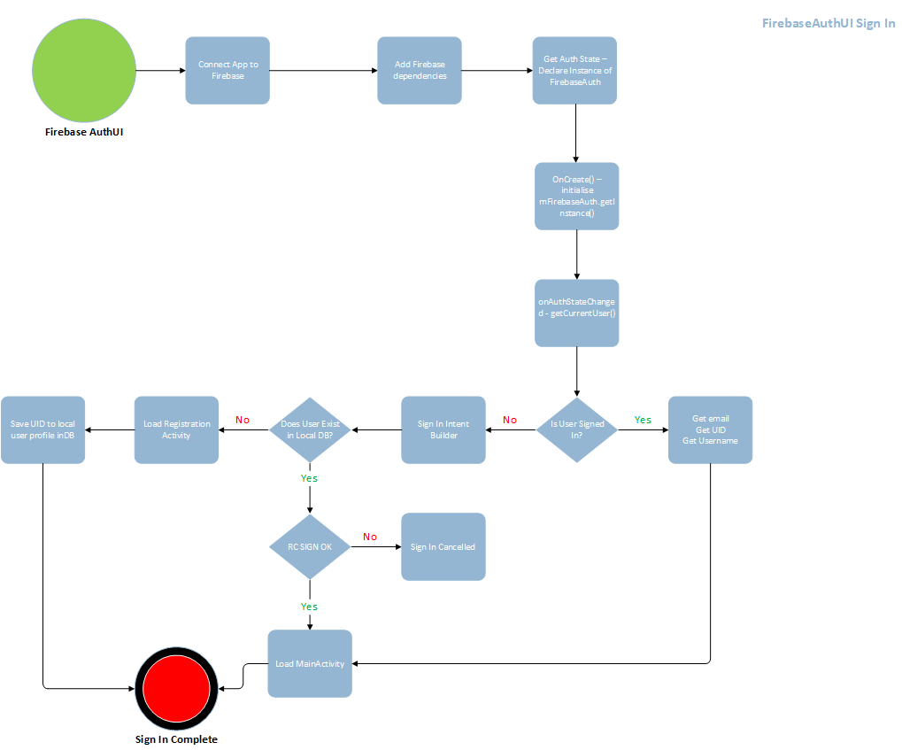

Figure . Firebase AuthUI

### Firebase Realtime Database

The app uses cloud storage to minimise data stored on the end user device. The Firebase Realtime Database (FRD). At strategic intervals during the app processes, data is uploaded to the user’s profile in the secure FRD database. The data is synced in real time providing the user with the most current statistics about their weight loss and food tracking journey.

The most important aspect of having the real time data available is the integration compatibility with AWS Lambda functions/ Alexa Voice Skill using a read only REST API to extract the current SmartPoints and weight loss data for each specific user. The app does not depend on network connectivity to function and local data changes are synchronized when the app reconnects.

The structure of the data in FRB differs from the standard relational structure of the local SQLite database. The FRB utilises a NoSQL json tree that adds the data objects as nodes or key value pairs.

The data structure was planned to avoid a deeply nested structure which are subject to performance implications when retrieving data snapshots. Deeply nested structures return large volumes of data when retrieval takes place as all the associated child nodes are retrieved at the same time.

For each class that uploads or retrieves data from the Firebase database, an instance of a database reference must be obtained (Figure 7.36)

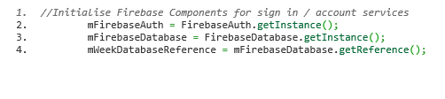

Figure . Firebase database reference

### Uploading User Profile

When the user registers on the app, the profile information is uploaded to the FRD using the assigned UID. The method createFirebaseUser() (see Figure 7.37)is called in the OnClick() function of the Register Button The data is populated into the child nodes with the User UID as the parent node.

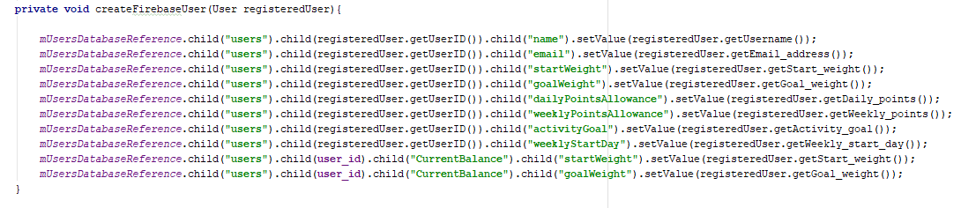

Figure 7.37 Firebase Upload User Profile

The child *Current Balance* is used to maintain a realtime snapshot of the daily points allowances. This has added higher in the json tree structure (see Figure 7.38 ) as this data will be frequently accessed by the Alexa Skill using a REST API. This will limit the unnecessary retrieval of unused child node data.

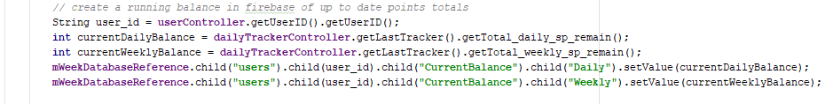

Figure 7.38 Firebase Maintain Current SmartPoints Balance

### Uploading DailyTracker Data

The Daily Tracker data for the previous day will be uploaded when a new one is created. The firebase function (Figure 7.39) is called at the end of the successful creation of a new tracker day. A list of the tracked items from the day before is retrieved from the local database. A check is performed to ensure that this list is populated and then iterated through, uploading the tracked objects and mapping them to the child nodes.

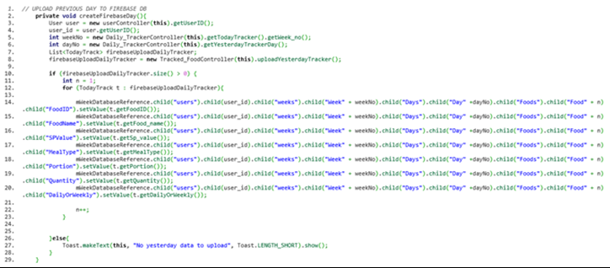

Figure . Firebase - Upload daily tracker data

The FoodDatabase_Local is purged daily, checking for tracker, food, week, macro and activity objects that have passed a defined data retention period of 28 days (Figure 7.40). Items such as macros and activity data are retained for shorter periods of time as they are only required for a daily chart. The limited retention periods have been implemented to promote good housekeeping and to remove personal data when no longer required

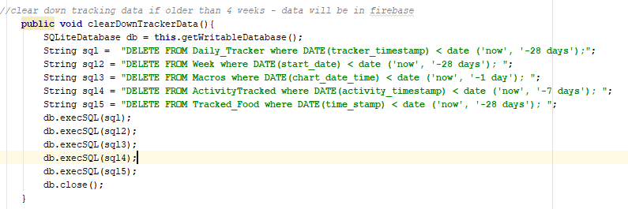

Figure . Local database purging function

### Uploading Weekly Weigh In

Figure 7.41 Firebase Upload Weekly Weigh In

After each weekly weigh in and a new week object is created in the local database, the user entered weigh in data is uploaded to firebase under the child object week (Figure 7.41). The current weight is also added to the CurrentBalance node to be accessed by the Alexa Skill report service.

### Uploading User Created Foodist

The users create and populate a local food database, which contains a list of all food data that the user has tracked since they installed the app. The food list is used to populate a search spinner (Figure 7.22) that facilitates faster tracking times.

The foods are added to the FoodDatabase_Local each time a SmartPoints value is calculated using the AddNewFoodsForm (Add New Food & Add to Tracker). The foods are uploaded to firebase as they are created, populating a FoodList node in the user’s FRD profile.

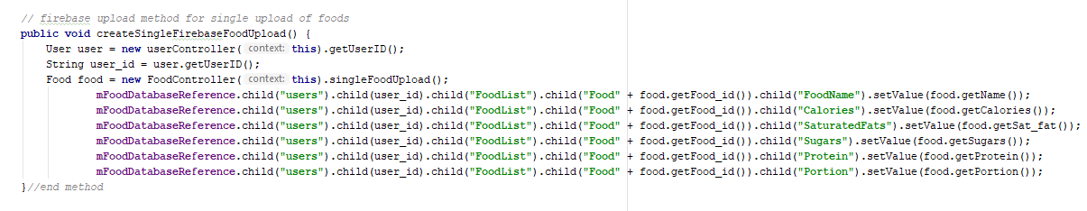

Figure 7.42 Firebase Upload User Food List

### Retrieving User Created Foodist

The food list facilitates the searching and tracking of commonly used foods quickly within the app. If the user reinstalls the app on to another device, they can re-register their profile information again using the same authentication credentials. On completion of the registration, if the user has an existing food list stored in the FRB, it will be retrieved and used to populate the user’s local database food table and therefore populate the search spinner.

|  |  |
| --- | --- |
|  | Click on the pdf icon to view the full code listing for retrieving a food list from Firebase |

## Sprint 3

Sprint 3 began on 3rd April and completed on 13th April. The sprint timeline had been impacted by the late finish of Sprint 1 and consequently, Sprint 2.

|  |  |
| --- | --- |
|  | Click on the PDF link to view a Sprint Report for Sprint 2 |

On review of the Project Risk Register, risk No.9 outlines the potential impact on the project delivery if the Alexa Voice Service technology presented a learning curve that was too steep. A review of the original requirements was conducted, and a decision was taken to exercise the contingency plan for this technology and simplify the requirements. The Alexa Skill was implemented as read-only report service.

|  |  |  |
| --- | --- | --- |
| Requirement No. | Requirement Description | Priority |
| Requirements Not Fulfilled: | | |
| 1.2 | Amazon Alexa Skill to track & Report SmartPoints | S |
| 1.10 | Capture voice input data from Amazon Alexa | S |
| Requirements Fulfilled: | | |
| 2.9 | User can hear a record of weekly and daily SmartPoints values used at any time using Amazon Alexa Skill | S |
| 2.10 | User can obtain a ‘SmartPoints left’ record via the mobile application and Amazon Alexa | S |
| 2.11 | User can obtain the last weigh in record via the mobile application and Amazon Alexa | S |
| 3.1 | The user can generate an end of day summary report contain details of SmartPoints used daily and weekly, Fitness goal and current weight loss. This will be available on the app as an infographic and as a flash briefing by Alexa. | S |
| 4.5 | Amazon Alexa integration with Amazon Echo. Mobile application will be partnered with an Alexa Skill using AVS | S |

Table . Alexa Skill Requirements

### Preparing the data

To make data accessible to Alexa, regular uploads of datasets were added to the CurrentBalance (7.3.3) child node for each user in the Firebase Realtime database.

The data is then accessed by the AWS Lambda Function for the FotoTrack app using REST API requests.

|  |  |
| --- | --- |
|  | Click on the PDF link to view a full code listing for the AWS Lambda function |

The end user device (Amazon Echo or Dot device) sends the user voice stream to the Alexa Voice Service. A Skill with a matching name to the user invocation is registered on the Alexa Skills Kit Developer console (Figure 7.43).

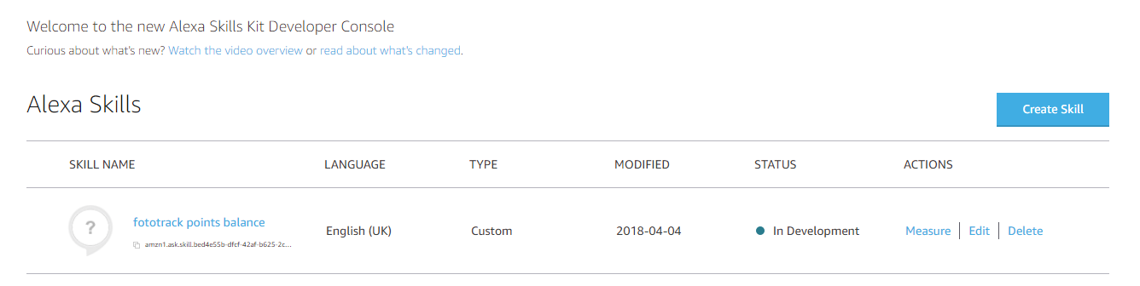

Figure . Alexa Skills Kit Developer Console

The AVS analyses the user’s request and sends a structured text response of the speech request to the custom skill. The Skill processes the requests and builds intents to send to the Amazon Web Service Lambda function, that will execute the request logic and process a response. The Lambda function posts a REST API request for information to the Firebase Realtime database and receives a json object as a response.

The function then processes the returned json as a SpeechletResponse text object. This is them passed back to the Alexa Voice Service to convert the text to speech. The completed speech response is streamed to the Echo or Dot device.

Figure 7.44 presents a detailed illustration of the FotoTrack Skill and the information request intents used to process the daily summary report.



Figure . Alexa Skill Launch & Intents 1

The invocation name ‘FotoTrack’ or (phonetically “*photo track*”) identifies the Skill when the user starts the conversation with Alexa device. A json file represents a series of sample utterances or key phrases that the users can use and will be used to map the speech requests to the intents (or actions that the Skill will perform).

|  |  |
| --- | --- |
|  | Click on the pdf link to view a copy of the FotoTrack custom intents |

The custom Skill is assigned a skill ID and is used in the configuration of the skill with the AWS Lambda function. An ARN (Amazon Resource Name) is used to specify the AWS Lambda Function. Figure 7.46 demonstrates how the Lambda function handles the request type from the Alexa Skill. A switch statement is used to identify the request type for example case “Launch Request” is a simple request that will invoke the following response from Alexa

“Welcome to FotoTrack Smart Points Tracker, what would you like to do?”

The user can then use a series of sample utterances to invoke the intents such as the Points Summary, Daily Points Summary, WeeklyPointsSummary and the Progress Briefing.

An endpoint is defined to collect the data from the Firebase Realtime Database (Figure 7.45). For the FotoTrack application, this is the child node CurrentBalance in a specified user tree.

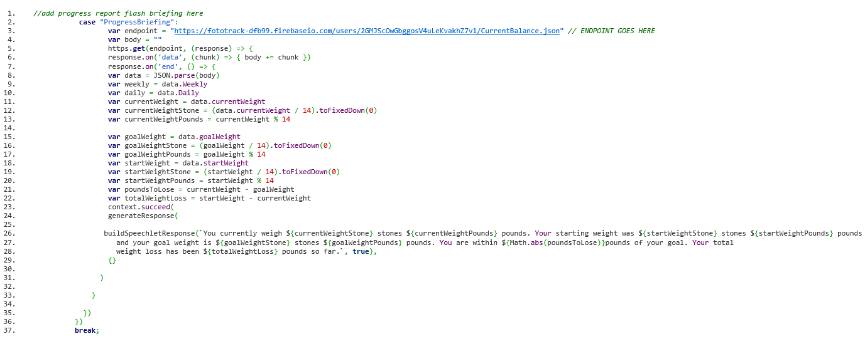

Figure . Progress Briefing Node.js request

The data is returned as a json object and then parsed to extract the required information and build a speechlet response.



Figure . Alexa Skill Launch & Intents 2

# Testing

During the development and testing phase of the product lifecycle, various testing techniques were deployed to ensure that the product met the proposed requirements and that the end product could fulfil its intended use.

The Project Test Plan outlines the testing types implemented throughout the development and testing periods of the project timeline.

|  |  |
| --- | --- |
|  | Click on the icon to view a copy of the Project Test Plan |

## Validation

Using the CMMI maturity level 3 process area Validation, the FotoTrack prototype and development lifecycle was analysed to establish whether the end-product could fulfil its purpose within the end user environment. By conducting a thorough validation process of the product and its components, the suitability of the product could be established and if the product would fulfil its original intent.

The FotoTrack application is referred to as the ‘product’ and components include features, functionality such as the Alexa Voice Skill and the integration services. The ‘work products’ refer to the Project Traceability Matrix, Requirements and Requirements Defects list. In section 4.7 a detailed validation of the proposed requirements was conducted, and the results analysed and compared in the Requirements defects list.

The validation environment represents the setting in which the user operates the application. This is a smartphone device with standard mobile data or Wi-Fi connectivity (preferable, not essential) and the ability to be portable in various domestic and commercial environments.

Validation and Verification process areas share similar characteristics, but they examine the product from different perspectives. Verification establishes if ‘*the product built has been built right*’ and Validation confirms if ‘*the right thing has been built*’. (Mary Beth Chrissis, 2011).

In the project plan the application scope defined the aim of the project:

To produce a working mobile application in conjunction with an Amazon Alexa skill that promotes the efficient tracking of nutritional content in food. The software aims to make the user commitment to tasks low whilst providing comprehensive and rich reporting features that the end user can utilise to promote the achievement and maintenance of goals.

The aim of the validation process is to prove that the application meets this projection and that the associated work products and components help fulfil this ambition.

CMMI Validation process area defines the specific goals and practices as follows:

* **SG1 Prepare for Validation**
  + SP1.1 Select Products for Validation
  + SP1.2 Establish the Validation Environment
  + SP1.3 Establish Validation Procedures
* **SG2 Validate Product of Product Components**
  + SP2.1 Perform Validation
  + SP2.2 Analyse Validation Results

(Mary Beth Chrissis, 2011)

Specific Goal 1 identifies the products, environment and criteria for validation.

### SP1.1 Select Products for Validation

The products selected for validation are assessed in terms of their value to the end user needs. In section 4.5 the original requirements were validated by conducting a user survey (using Survey Monkey) to gain an understanding of what the end user would expect to experience using the product. The work products extracted from this process were the Survey Results, Requirements Defects List and the Traceability Matrix.

During the prototype phase of the development, an original screen design was presented to a selection of users via a closed social media forum operated by the project stakeholder and Weight Watchers group leader Bernie Walsh. The scope of the validation for this component was to gain feedback on the user interface design.

The selected software for validation includes Firebase Realtime database and the Alexa Skill. The scope of the validation included operational behaviour, training and maintenance.

Hardware validation identified the end user devices such as smartphones (Wieppo S6 Lite, Samsung Galaxy S7 edge and HTC Desire 626). This involved reviewing the operational behaviour and user interface.

Finally, a short user manual or Readme was selected for validation. The scope of the validation included training and maintenance.

Validation methods demonstrate how the product will satisfy the outlined intended use and the end user need. The methods defined were:

* End user feedback solicitation.
* Demos of the product in alpha phase.
* Use of the product in alpha phase (by developer).
* Review of the user manual by end user.
* Acceptance testing by end users.
* The product was rolled out incrementally to a select group of users (and the developer) to perform early testing and identify bugs.
* Emulator testing for a range of devices to test the scope of the UI.

|  |  |  |  |
| --- | --- | --- | --- |
| Product/ Product Component | Validation Method | Requirements for Validation | Validation Constraints |
| UI Design / Prototype | End user feedback / demo | Feedback forum, design prototype | UI Design not clear or misinterpreted by end user |
| Firebase Realtime Database | User of product alpha phase | Admin access account to Firebase, network connectivity | Unavailability of FRD admin account, costs for FRD plan |
| Alexa Skill | Demo/ use of product | Amazon Echo device or similar | Unavailability of device or product |
| Smartphone devices | End user feedback / use of product | Android Smart phone target API 7 (min API 4.1 | Product not suitable for installation of application |
| User Manual | Use of product by end user | Application installed an copy of ReadMe | User manual not understood or not enough detail |

Table . Products selected for validation

### SP1.2 Establish the Validation Environment

The validation environments were selected on their ability to emulate the real end user environment or similar. The environments selected for the validation process must provide the user or the developer with the ability to use the application in normal operational circumstances.

The environment requirements were:

* Cost effective – they must not incur mounting service charges e.g. use free accounts in Firebase and set a limit on AWS cloud service usage ( Figure 8.1)

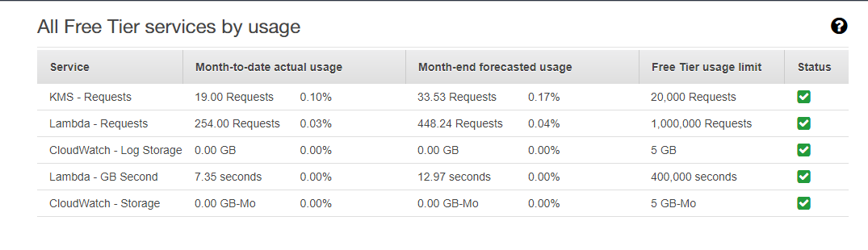

Figure . AWS environment cost management for FotoTrack Alexa Skill

* Prepared device emulators using Android studio for Nexus 5 API 21, HTC Desire 626 API24 and Samsung Galaxy Edge API24
* The validation environment can be subject to control and monitoring to analyse results and repeat tests

The identified environments were:

* End user devices HTC Desire and Nexus 5, application to be installed via Android Studio and tested in own user environment.
* End user device Wieppo S6 device to be supplied to user with the application pre-installed.
* Android Virtual Device manager to operate a range of devices.

### SP1.3 Establish Validation Procedures

To establish if the product has behaved in an acceptable way in its intended environment a series of validation procedures were defined. To provide a template for this, the original objectives from the project plan were reviewed.

**Customer Acceptance Criteria**

* The product should be accepted (express an interest to continue using the app) by at least 70% of the test user group.
* The product should be used at least 3 times daily by the test user group.
* The standard tracking time for a meal should be 1 minute or less using 4 interactive motions on the device.
* The product should not impede or impinge on the performance of any other app installed on the user device

**Testing & Evaluation**

* The application should receive 70% positive review after user acceptance testing.
* The application should have a defect rate of less than 2% after Functional End to End Testing.

**Environment & Performance**

* The product should experience no crash time during user acceptance testing
* The product should not experience loss or breach of user data.
* Lack of network connectivity should not affect the user’s ability to create tracked entries

**Risks to the Validation process**

**The validation process has the potential to be subject to risk imposed by the end user, performance of the application or the hardware and environment. Potential risks to validation include:**

* **Users may not commit fully to the acceptance testing period, leaving test data incomplete and difficult to analyse.**
* **Users may experience hardware performance issues and not be able to resolve them, rendering the test environment unstable.**
* **The user may reject the software at the start of the acceptance testing and not finish the testing period.**

### **SP2.1 Perform Validation**

The initial part of the Validation process was performed by asking users to submit feedback on UI prototype screen shots. This was conducted by posting the screen design to the closed Facebook forum for the local Weight Watchers group and gathering a response from the participants.

|  |  |  |
| --- | --- | --- |
| Figure 8.2 User Feedback Validation |  |  |

The feedback received indicated the users were interested in the overall appearance of the app and the capabilities of the on-device camera as a tool for facilitating their weight loss. Another suggestion was to add a ‘Fav list’ so that the user would not have to re-enter the SmartPoints values of a specific food more than once. This relates to one of the original objectives of the project:

To decrease user-tracking time for one standard meal to 1 minute or less and within 4 interactive motions by streamlining the data capture processes and applying proven UI methodologies.

The requirements were reviewed at this point to analyse which requirements could help fulfil this function. The original requirement *1.6 – The user can use a barcode scanner to capture nutritional data from packaged food if listed in the OpenFoodFacts database* had been demoted in terms of its priority. Due to complexity issues, the requirement was not fulfilled. On reviewing this a decision was taken to include a feature that could reduce the overall tracking time for the user and contribute to fulfilling the outlined objective. A predictive search spinner was introduced, that would retrieve a list of foods and associated values contained in the user’s local database.

Consideration was also given to the user suggestion for additional colour to the home screen. Rather than alter the subtle elevation of the card design (as per Material design guidelines) a colour was added to the delete icon and a lighter shade introduced for the camera icon (Figure 8.3).

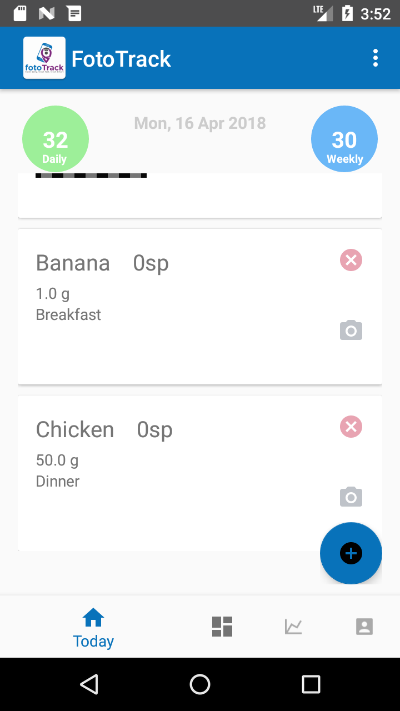

Figure . Colour added to UI as a result of user feedback

The User Acceptance Testing plan is outlined in the Test Plan, detailing the number of users, environment and length of the testing period. To facilitate the acceptance testing, a user survey was prepared that would anticipate responses to the users experience of using the app within the scope of the original project objectives and requirements. The acceptance testing contributed to most of the validation process.

|  |  |
| --- | --- |
|  | Click on the PDF link to view a copy of the UAT FotoTrack Survey |

### SP2.2 Analyse Validation Results

The acceptance testing involved the users registering on the app, completing profile information, adopting the tracking method for one week, adding foods to the local database and using the weekly weigh and activity forms.

From the Firebase console, it is evident that some of the tracking has been sporadic and inconsistent. None of the users managed to upload a full week of data. 100% of the users completed the onboarding process and completed the initial profile and provided feedback on their experience.

The User Acceptance results survey can be viewed in Chapter 9 Results.

## Verification

The CMMI Verification Process Area defines that the selected products and product components should meet their project related requirements. The process area covers specific goals and practices to carry out the Verification process.

Verification is an incremental method and was implemented from the evolution of the requirements document and tracked using the Project Traceability Matrix. Key areas involved the initial unit and integration testing of the prototype product features in development, bug tracking and corrective actions. The CMMI Verification Specific Goals and Practices are:

* **SG1 Prepare for Verification**
  + SP1.1 Select Work Products for Verification
  + SP1.2 Establish the Verification Environment
  + SP1.3 Establish Verification Procedures and Criteria
* **SG2 Perform Peer Reviews**
  + SP2.1 Prepare for Peer Reviews
  + SP2.2 Conduct Peer Reviews
  + SP2.3 Analyse Peer Review Data
* **SG3 Verify Select Work Products**
  + SP3.1 Perform Verification
  + SP3.2 Analyse Verification Results

(Mary Beth Chrissis, 2011)

Specific Goal 1 defines the importance of the preparation for verification, establishing requirements and criteria to carry out the associated tasks.

### SP1.1 Select Work Products for Verification

The work products selected for the FotoTrack application were of significant risk to the project timeline, that directly correlated to the requirements and the project objectives.

The alpha phase prototype application was selected for verification because this would allow early unit and integration testing to begin using the Traceability Matrix as a template for areas to be tested.

The Integration Services design was also considered as this presented one of the biggest project risks. There was a risk to the delivery timeline if the design of the services became too complex to complete.

The Alexa Skill was selected for similar risk reasons. The Skill product component was defined in the Project Risk Register as having a potential impact on the delivery timeline because of possible difficulties in implementation.

The verification methods selected for this specific practice were:

* Integration services evaluation
* Test case reuse for end to end Functional tests.
* Stress testing of UI gestures and performance of service architecture.
* Incremental unit, integration and exploratory testing to identify bugs in individual application components and their interaction with overall application functionality.

One of the work products associated with the Verification process is the project Requirements Traceability Matrix. This identifies the individual requirements, related test cases, components, prioritisation and customer needs. The matrix was used to establish a linear path from requirements conception to product delivery ensuring traceability at every step.

|  |  |
| --- | --- |
|  | Click on the excel icon to view the Requirements Traceability Matrix |

### SP1.2 Establish the Verification Environment

The verification environments varied according to the methods used. The integration services evaluation was conducted as a peer review process involving the input of a project mentor and white board session to brainstorm ideas.

The product test environment began initially using Android Studio virtual device manager to emulate different specifications of Android device. This progressed to hardware devices Samsung Galaxy S7 and Wieppo S6 as the product grew in stability.

Service integration included Firebase Realtime database and tutorial documentation, Alexa Skill Development Kit Console and AWS Lambda Management console.

### SP1.3 Establish Verification Procedures and Criteria

The procedures for the Verification were defined using the criteria:

**Work Products**

* Alpha phase prototype application.
* Alexa Voice Skill.

**Testing & Evaluation**

* Integration and unit tests to be carried out incrementally from the start of development to ensure that product components meet the specified requirements and function as expected.
* System and Functional end to end testing to be carried ensuring that the user can complete whole routines from start to finish that match their intended requirement. These will be recorded in test cases corresponding to their requirement on the Traceability Matrix. The test cases will be recorded in a reusable test matrix with detailed step instructions and expected results.
* The product component will be considered verified when it passes the related test cases.
* All product and product component requirements will be tracked and recorded in the Traceability Matrix.

### SP2.1 Prepare for Peer Reviews

A project mentor was engaged to peer review the early stages of the development that included the following areas:

**Development & Code**

Business Rules for the Daily Tracker

Database Objects

Event timings e.g. alert dialogues, Firebase data upload

Testing SmartPoints calculations

Testing Macro calculations

Code Quality Inspection

**Infrastructure**

Integration services architecture review

The main aim of the peer review was to analyse the code functionality, find defects and ensure that the corrective action was taken. A review of the proposed service architecture was also scheduled to anticipate potential deviations from the project timeline.

A peer review checklist outlined common areas for defects in the code and the project schedule, detailed any defects found and any corrective action that should be taken to rectify them.

### SP2.2 Conduct Peer Reviews & SP2.3 Analyse Peer Review Data

The peer review checklist details the recommendations from the reviewer after a code review at the end of Sprint 1.

Sprint 1 was longer than the initial project plan had suggested, due to the complexity of some of the tasks in coding the mobile application and producing a working prototype. Incremental unit and integration tests were conducted to identify defects early in the development stage. The reviewer made a recommendation to use JIRA as an incident tracker, recording bugs as they were found in the code. This kept track of issues and highlighted them for actioning before the end of the sprint.

|  |  |
| --- | --- |
|  | Click on the excel icon to view the Peer Review Checklist |

In a review of the proposed integration services, it was suggested by the reviewer to reconsider the use of Microsoft Azure to configure custom microservices to handle cloud data and response queries. The services required for FotoTrack were not considered extensive enough to warrant a custom-built service. In Chapter 5, the design of the proposed services was reviewed and a new proposal to use Firebase was introduced.

### SP3.1 Perform Verification & SP3.2 Analyse Verification Results

In identifying the work products for verification, the process could begin early in Sprint 1 when the first features of the mobile application were developed. The unit and integration tests were applied to small incremental functions such as the tracker data lists returning from the databases and the SmartPoints calculation. To ensure that any defects were fixed, the bugs were added to JIRA to track their progress in the Sprint.

The Traceability matrix listed in 8.8.1 provides details of the Functional end to end tests mapped to the relevant requirement ensuring complete verification coverage in testing. Chapter 9 analyses the results returned from the integration and unit tests, Functional end to end testing and the User Acceptance testing.

# Results

The purpose of the test results and evaluation is to demonstrate evidence of the validation and verification of the FotoTrack mobile application and Alexa Skill.

The documentation in Table 9.1 provides details of the test cases, expected results and actual results of the FotoTrack project testing phase.

Scope

The testing scope includes all unit and integration tests that have been executed to verify component and individual method functionality. System test scope verified the integration with background OS (Android) functions such as receiving calls, messaging, app performance and its effect on host system. The Functional end to end testing validated each requirement, from start to finish, covering all aspects of the mobile application, Firebase Realtime Database and the Alexa Skill. Acceptance testing scope incorporated the behaviour of the system in its intended environment and the response from the end user.

|  |  |  |
| --- | --- | --- |
| Document | Title | Testing Area |
|  | JIRA Bug Report | Unit & Integration |
|  | System Testing Cases & Results | System |
|  | Functional End to End | Functional |
| Link to [Survey Monkey Results](https://www.surveymonkey.com/results/SM-CZZ6DL3LL/) online | UAT Survey Results | Acceptance |

Table . List of Test Documents

## Unit & Integration

The unit and integration tests were performed incrementally as the development proceeded through Sprint 1 & 2. The test environment was Android Studio AVD emulator Samsung Galaxy S7 edge API27. The purpose of the test run was to identify bugs in individual methods and components in the early stages of development.

Test Coverage

Add New Food Form – Calculate SmartPoints values

Manual and unit tests were conducted to test the input values using the application SmartPoints calculator. The values were compared using the official Weight Watcher online calculator (*available at* [Weight Watcher Online calculator](http://www.weightwatchers.ie/lifestyle/smartpoints-plan/smartpoints-calculator/)) . The unit tests demonstrated the SmartPoints values were calculated correctly and no issues were reported with this method.

Macro chart date

Manual tests were conducted to evaluate that the macro values for the Macro Nutrient chart data were calculated correctly. This involved repeatedly adding new tracked foods and ensuring that all values for Calories, Saturated Fats, Sugars and Proteins were recorded. Verification of the data involved using the ADB (Android Debug Bridge) shell SQLite database access to query the Macros table for the values recorded and stepping through the pie chart data function. The expected outcome for the tests was the correct data display for each added food on the Macro nutrient chart

Issues

During the testing, it was noted that the macro chart data did not reflect accurately the nutrient values entered. A defect was logged on the JIRA incident tracker and then investigated. The inspection revealed that the values for each nutrient were not calculated per user portion of food entered but added for each whole portion. The issue was resolved and then tested again using the same methods.

Weight loss chart / dialog

The weekly weight loss chart was tested by continuously adding update statements to the SQLite database to force the tracker to enter a new week. Each test was monitored to evaluate if the weekly weight tracker dialog appeared and if the data entered a new week object in the Week table and recorded the user’s current weight and a timestamp.

Issues

Initially the testing failed as the weekly weight dialog was called after the first week had completed. This left the first seven tracker days without a week object as a foreign key. A fix was applied to start the first week when the user completes the in-app registration profile.

Other components that were tested included the update of the SmartPoints values in the Daily Tracker display circles. This was tested by verifying the daily tracker table in the database was updating the daily points remaining and weekly points remaining columns.

One of the issues that was discovered in the integration testing was the addition of the food image to the card view. Initially the image was being captured and adding only to the last card in the recycler list view. Each time an image was captured this would overwrite the previous image. It was discovered during the testing that the food ID for the related food in the card view was not being captured and the image URI could not be saved to the correct entry in the database.

User input validation presented challenges in terms of error handling. The Add New Foods form and the Registration form were causing system crashes if the user left a field blank. This was remedied by adding TextUtils.isEmpty condition to each input field to check that the field contained data before adding it to the object saving to the database.

The initial alert dialog to save the users roll over points into the weekly points total contained errors. The alert dialog displayed when the user had not tracked the previous day, automatically rolling over 4 daily SmartPoints when the user had not earned them. The dialog box now presents an option to the user to choose to roll over.

|  |  |
| --- | --- |
| Number of logged defects: | 13 |
| Percentage Resolved | 85% |
| Percentage Remaining | 15% |

## System

The system tests examined the behaviour of the application in relation to other system apps and the host Android OS.

The test coverage observed system functions such as telephone calls, SMS messaging, connectivity and performance.

The application loading time was observed was tested against an expected result of loading in under 2 seconds. The application was testing using the Android Studio Activity Manager -Logcat to record the start-up time of the Main Activity. The average load time was +992ms.

Manual testing of the system behaviour when a call was received to the device we conducted using the emulator and Samsung Galaxy Edge S& API Level 24. Calls were sent to the android device when the app was running to monitor the application behaviour when receiving the calls. The expected behaviour for this test was that the app should retreat to the background and allow the call to take precedence. The tests successfully proved that the calls were given priority by displaying an incoming call notification. The user could then select the notification to answer the call in full screen.

A similar test was performed to monitor whether the user could receive and respond to an SMS message when using the app. This was conducted using the emulator and the app behaviour was assessed to establish if the message was received, notifying the user and allowing a response. The SMS was displayed as snapshot notification of the text, allowing the user to respond directly in the notification.

The application resume state was analysed by performing a routine task such as adding a new Daily Tracker entry and then shutting down the phone before completing the task. The objective of the test was to establish if the application resume state if the system shut down unexpectedly. The test completed, and the application resumed without incurring any data loss.

The app Authentication UI was tested by initiating an onboarding process in which a new user registered on the app. The test verified that the user could not bypass the registration or sign in by leaving data fields blank. The authentication UI issued warnings to notify of blank fields or incorrect input types.

When the user registered using the Firebase Authentication UI, the app was observed to verify that it directed the user to the in-app profile registration. The validation was tested by leaving blank fields and attempting to register the user in the local database without passing in completed details. The test verified that the input validation prevented a registration error and the user could not bypass the registration with adding the required details.

|  |  |
| --- | --- |
| Number of System tests | 12 |
| Percentage Passed | 100% |
| Percentage Failed | 0% |

## Functional

The functional end to end tests used complete application coverage, covering all aspects of the data input, display, UI interaction, reports, data upload to Firebase and the Alexa Skill. The scope was to test the performance of the app as the user completed whole tasks from start to finish. The end to end tests were conducted after the end of the third sprint, before the UAT period began. Each test was mapped to a related requirement and recorded in the Requirements Traceability Matrix. Test pre-conditions and post conditions defined the system state before and after the testing period.

The initial tests explored the ability of the application to capture and display data. The areas tested involved:

Add New Food Form

The form was tested to accept user input, the accuracy of the SmartPoints value returned, the button state for Save to Tracker (this should be disabled until user calculates points), the alert dialog for the Add to Tracker launch, the population of the drop-down lists and the reload of the Main Activity at the end of the task. This test presented no issues and the user could save SmartPoints t the tracker successfully.

Add New Foods Form / Quick Add Foods

This action tested the capability of the application to save new foods to the database via the Add New Foods Form and add foods quickly if the SmartPoints were already known. The test verified that the data was captured as expected by analysing the entries in the SQLite DB. The foods from the Add New Food Form were added to the database with a full list of macro nutrient data that the user supplied in the form. The Quick Add foods saved only the Food Name, SmartPoints values and portion. Both entry methods recorded a timestamp against each food saved that facilitated querying and uploads to the Firebase Realtime Database.

The tests passed with no deviations from the expected results.

Alexa Skill

The test examined the ability of the Alexa Skill to return an accurate summary of the user’s realtime weight loss statistics by retrieving the data from the Firebase Realtime Database. The users SmartPoints, goal weight, start weight and current weight are uploaded to the cloud database using the most recent tracked data. On invocation, Alexa was asked to return the daily progress summary for the user. The expected result was a flash briefing containing the user’s current weight, their goal weight and start weight. Alexa will then provide a report of the user’s total weight loss and their progress towards goal. The skill was also tested for accuracy in returning the user’s current SmartPoints totals.

The tests were executed with no issues or defects recorded.

Daily Tracker

The Daily Tracker was tested for various functionality including the accurate display of all the returned tracker entries for the selected day, the correct updates to the daily and weekly points circles (when foods were added and deleted). The delete functionality was also tested, verifying that the user could remove selected entries from the tracker and see the value reflected in the points totals.

Observations were noted on the rendering of the card views and some minor issues were recorded regarding the display of long food names overlapping the delete icon or cutting off SmartPoints values. Most of the issues found were minor UI problems that were rectified with some adjustments to the layout XML.

Daily Tracker Image capture

The Daily Tracker Image capture initially failed integration testing as the images were not recorded against the correct food entry. A fix was actioned and completed for this and the images were tracked in the right card view as a result. There were some minor rendering issues picked up in testing that observed the image pushing the card text behind the delete icon. Initially the recycler view scroll had obscured the last card view image capture control behind the floating action button. This was corrected by adding a bottom margin to the xml of the recycler view.

Firebase RD

The test examined the data passed between the app and the FRD. The initial test, observed a simple user registration using the Firebase Authentication UI. The test then verified that the user was registered in the Firebase console and assigned an UID. The user was then directed to the in-app registration and completed the required questions to create a new user in the Local database. This was verified by querying the user table in the SQLite database and confirming that the Firebase UID was saved as the ID for that user. The test then established the user profile information was uploaded to the FRD and confirmed the json tree structure.

Other test activity included creating new local database entries for the food table and viewing them as they are uploaded to the FRD. Finally, the user deleted the app and data from the phone. They completed the in- app registration process and then verified that the food list from their FRD profile was downloaded and used to populate the food table in the newly created local database. This was confirmed by viewing the search spinner results accessed via the FAB on the home page.

Profile Activity

The user can update their profile by accessing the activity from the bottom navigation bar. The test involved the user making changes to the profile text fields and clicking update. The changes were verified by:

* The UI - navigating to another activity and then returning to verify that the recent changes have persisted.
* The SQLite database – querying the user table to establish that the updates have been committed.
* Viewing the user node in the FRD to confirm that the changes have replicated to the cloud database.

Initially the changes had not been committed to the FRD and on further investigation it was noted that the firebase upload code was not added to the Profile Update function. This was rectified and then retested to confirm the functionality had been added successfully.

Reports & Charts

The Weekly weight loss and macro nutrient charts were observed by adding various datasets to establish if the chart data was correct. The weekly weight loss chart was examined by adding test data to the week table and then reviewing the results on the chart.

The Macro nutrient chart has presented some issues which were difficult to detect at first. The nutrient values were being added as whole values initially and not as portioned values. This presented invalid data to the user. This was rectified but an issue persists. When a tracked object is deleted, the portioned value is not removed from the chart and the data displayed is inaccurate.

|  |  |
| --- | --- |
| Number of Functional E2E tests | 27 |
| Percentage Passed | 93% |
| Percentage Failed | 7% |

## UAT

The UAT testing period began 10th April and ran until 17th April. The users were selected from a local Weight Watchers group and the weight watcher group leader Berni Walsh. Each user was asked to substitute their routine tracking method for the FotoTrack app. The users were expected to complete the onboarding and registration process and record their current weight, daily tracking entries and activity. At the end of the acceptance testing period, the users completed a short survey (via SurveyMonkey). Prior to the testing period, a short ReadMe (see Appendix A) document was circulated, detailing some of the apps features.

The aim of the UAT phase was to establish the potential adoption of the app post production and to gain feedback on any improvements that could be made.

Preparation tasks for UAT included publishing a signed APK file to distribute to the members. A pre-installed version of the app on Wieppo S6 Lite was supplied to Weight Watchers Leader Berni Walsh.

The users were asked to rate the app onboarding and registration process. 60% of the users select ‘It was good, easy to follow’ and 40% selected ‘*Yes, very fast and efficient’*. One user had commented that the felt the weight entry on the in-app registration page should be recorded in stones and pounds and not pounds.

100% of the users reported that they found the home page / tracker to be satisfactory (using the second highest weighted answer, ‘*Overall I was happy with it but would make some adjustments*’. There were some comments that indicated that the rendering on the card views varied on different phones and that some of the text was obscured by the icons. One user suggested that a timestamp on each recorded entry would be useful to be aware of when they last tracked their foods.

80% of the users recorded the average meal tracking time as 4-6 mins. This was longer than the proposed time. A user mentioned that they found initial tracking times longer but then it became faster when they had built up their local database to search for items.

The users were happy with the experience of tracking foods, 60% indicated that they thought it ‘*Good, I was very happy with it’* and 40% considered the experience to be ‘*Excellent, fast and very reliable*’.

The social media potential of the app seemed to prove unpopular. Although this feature was not implemented because in the requirements analysis this was not considered to be a favourable function, it was important to ascertain if the users felt it was something ‘missing’ from the app. Privacy concerns seemed to create apprehension but one user did indicate they would share the progress online with other Weight Watchers members.

During the acceptance testing, users were asked to rank their most preferred feature of the app. The highest scoring feature was the search functionality and ‘*being able to calculate and track all in one place*’ featuring 2nd. The least popular features were the activity chart and the weekly weigh in chart.

The most surprising statistic extracted from the survey was that 100% of the members said that they would choose FotoTrack as their preferred method of tracking over the Weight Watchers paper tracker or MyFitnessPal. One user remarked that ‘Once it was set up, it is simple and quick’. The members were asked if they would continue using the app and 100% said that they would.

The users provided feedback comments that indicated that they liked the Quick Add feature but would find it useful if they could use the camera to photograph items they would like to track later. One of the members suggested that being able to delete or edit items from the food list database would be beneficial (minimising redundant entries).

As improvements, a user recommended adding a reminder to track foods, although this was not considered a popular feature during the requirements gathering. Edits to the daily points tracking were also put forward such as being able to add FitPoints to the weekly total or start using the weekly points once the daily points had reached 0.

## Results Summary

The Traceability Matrix presents 67% of the requirements were completed and 33% remain incomplete. Of the 67% completed requirements, 6% could not be verified and 1% could not be validated.

The Functional end to end tests yielded a 93% pass rate with 7% fail.

The UAT testing returned the post implementation user adoption interest as 100%.

## Objectives Fulfilled

OBJ001

To deliver a working mobile application and Amazon Alexa skill nutrition tracker within the project timeline of 30 weeks by applying and maintaining a project management and development framework that will be upheld throughout all phases of the project.

The first objective was fulfilled in that a working product and functioning Alexa Skill was delivered within the delivery timeline of 30 weeks. There were some deviations and adjustments made to the timeline, but these were in the interest of fulfilling the delivery deadline. The project management and development framework CMMI was used as specified in the project plan throughout all lifecycle stages.

OBJ002

To deliver a mobile health and fitness tracker that is adopted by at least 70% of the target test group and used routinely (3 + times daily) during a 1-week Beta testing period. I will achieve this by researching the project background in terms of technologies and the current market for the software, to understand the limitations of the current market and enhance user interface activity by applying Android Design principles.

This objective exceeded the original expectation of a 70% adoption interest rate from the target test group. 100% of the test group said that they would continue to use the app. The user experience of the UI was 100% at the higher end of the satisfaction scale.

OBJ003

To achieve 70% user adoption post -testing from the Beta test group by using user-centric research techniques and dedicated CMMI led requirements development and management processes.

The CMMI requirements analysis and management process areas helped deliver a set of valid and user focused requirements as a foundation for delivering a successful mobile diet tracker application. The success of this is measured in the 100% adoption interest registered by the acceptance test users.

## Objectives Not Met

OBJ004

To decrease user-tracking time for one standard meal to 1 minute or less and within 4 interactive motions by streamlining the data capture processes and applying proven UI methodologies.

On reflection and using the experience of the project development, this projection was unrealistic. The largest proportion of users recorded tracking time of between 4-6 mins. It is possible, with the implementation of further features such as the barcode scanner, that this would reduce tracking times. The search feature was not in the original requirements but was added as work around feature to accelerate tracking times. Without this feature, it is unlikely that the users would have been encouraged to track regularly.

OBJ006

To ensure a defect rate of less than 2% after user acceptance testing by conducting thorough system test runs and code fixes after each development sprint.

For a development project, this defect rate was idealistic. In alpha phase, it is unlikely that an application could achieve a pass rate of this percentage. It is possible that further iterations, test and fix cycles that this defect rate could be reduced.

# Conclusion

The aim of the project was to produce a working mobile application in conjunction with an Amazon Alexa Skill. It was hoped that the application would promote an innovative and efficient way of nutrition tracking, primarily aimed at users following the Weight Watchers plan. One of the software goals was to make user commitment to the tasks low but provide a platform service that could support multiple users, reporting features and an all-in-one facility for tracking and weight maintenance.

The initial research considered the use of mobile apps as a basis of changing user behaviours and attitudes towards nutrition. One of the fundamentals of the Weight Watchers program is this change in perspective and how it can contribute to long term goal maintenance. Apps have become a ubiquitous part of life and by merging nutritional tracking with this portability, users can access and maintain their nutrition data efficiently and at their convenience. The introduction of the Alexa Skill was to provide an innovative feature and one that would encourage interaction with their data. Users are creatures of convenience and by providing information that can be accessed by using a few simple utterances is highly attractive.

The project lifecycle began by conducting a business analysis of the current applications that are available on the health & fitness market. From this, a list of desirable functionality could be established and a list of features to avoid. Current trends in the mHealth market created a backdrop for much of the research and influenced the direction of trying to encourage people to engage with the app.

The requirements gathering was conducted under the guidance of the CMMI process area Requirements Development. User input was vital, and a survey was conducted to establish what the end users would consider important in a nutrition tracking app. A validation process of the requirements was conducted, and the result was a user-centric list of functional and non-functional requirements that would form the foundation of the design, implementation and testing phases.

Th development phase was initially organised into four sprints but was reviewed as some of the project risks had started to present symptoms. This was mainly due to the unforeseen complexity in Sprint 1 that stretched the mobile app development until 5th March.

Sprint 2 focused on completing the integration services. Changes were made to the original design to reduce the complexity of the services by opting for the prebuilt platform, Firebase. The decision reflected on the unnecessary intricacy of the original design and revaluated the need for custom services. Firebase was deemed more suitable as a solution as it offered authentication UI, user management and the Firebase realtime database in one collective service.

Another proposition for mitigating some of the risks to the project timeline (and subsequent delivery) was the decision revisit the prioritisation model and remove some of the requirements that were non-essential to the production of a minimum viable product. One of the requirements reconsidered was integration with social media and fitness APIs. During the original requirements gathering process many of the WW members surveyed felt that they would not like to share progress via social media. As this would not compromise the main functionality of the app, it was decided to remove it from the Sprint backlog.

Regular reviews of the requirements and project timeline proved an effective way of resolving issues regarding the delivery of project.

Complexity was anticipated in the Alexa Skill development and a decision was made to review the user tracking functionality. It was considered beneficial to the fulfilment of the task to remove the tracking from the Skill development and focus on creating a daily report from Alexa that would support the user in reviewing their achievements and progress.

One of the most surprising and rewarding aspects of the project was how the app was received by the UAT group. The group were selected from past and present WW members and the local group leader, project stakeholder, Berni Walsh. The response was 100% positive in that all the users affirmed that they would like to continue using the app. The feedback was excellent and extremely useful for the project’s next steps. Some of the users mentioned that they would like to be able to use the image capture to quickly track food and complete the details later. They also mentioned that they would like to be able to edit the food list to correct typos or remove foods they no longer use.

All suggestions provided potential new features for future iterations of the project. Many of the original requirements that did not make it into the first development phase are still possibilities for improving the app. The response to the search feature for the user food database was very positive and this would be greatly improved by the addition of the barcode scanner. This was not completed in Sprint 1 because of technical difficulties converting the image URI to a bitmap. With extra development time, this feature could become a reality and a welcome addition to the app.

The Alexa service was not tested in UAT due to hardware limitations, but the functional tests conducted post sprint revealed the potential of expanding the service. The Alexa voice summary of the user progress was found to be uplifting as many WW members don’t often think of their total weight loss so far but usually focus on the goal ahead of them. This was a good motivational tool to reiterate how far the user has come on their weight loss journey.

Overall, the least successful aspect of the project was the time management. A working mobile application and Alexa Skill has been delivered within the project timeline as defined in the objectives, but shortcomings do exist. The elimination of the last sprint, estimates that did not account for the complexity in some of the development and the requirements that were removed all serve as deficiencies in the project’s success.

However, lessons learned were valuable and will be applied to future iterations of this project and others. The Risk Management strategy was a redeeming feature in many of the projects faults and the mitigation and contingency plans were outlined to deal with them, ensuring that project was delivered beyond a minimum viable product.

# Bibliography

MARKET RESEARCH STORE, 2017. *Global mHealth Devices and Services Market will Reach $50.0 Bn by 2020.* [Online]   
Available at: http://www.medgadget.com/2017/02/mhealth-devices-and-services-market.html  
[Accessed 18 March 2017].

Alisha Pradhan, K. M. L. F., 2018. *Accessibility Came by Accident”: Use of Voice-Controlled Intelligent Personal Assistants by People with Disabilities.* [Online]   
Available at: http://faculty.washington.edu/leahkf/publications.html  
[Accessed April 2018].

Amazon Alexa, 2018. *Build Skills with the Alexa Skills Kit.* [Online]   
Available at: https://developer.amazon.com/docs/ask-overviews/build-skills-with-the-alexa-skills-kit.html  
[Accessed March 2018].

Amira A. Alshazly, A. M. E. M. S. A., 2014. Detecting defects in software requirements specification. *Alexandria Engineering Journal,* 53(3), pp. 513-527.

AnTuTu, 2016. *Top 10 Global Popular Phones and User Preferences, Q3 2016.* [Online]   
Available at: http://www.antutu.com/en/doc/107641.htm  
[Accessed Feb 2017].

Bower, G., 2016. *Which calorie-tracking app should you count on?.* [Online]   
Available at: https://www.cultofmac.com/441940/calorie-tracking-app-reviews-diet-apps/  
[Accessed 12 October 2017].

Breton ER, F. B. A. L., 2011. Weight loss-there is an app for that! But does it adhere to evidence-informed practices?. *Transl Behav Med.,* 1(4), pp. 523-529.

Columbus, L., 2016. *Gartner’s Top Strategic Predictions for 2017 and Beyond.* [Online]   
Available at: https://www.forbes.com/sites/louiscolumbus/2016/10/19/gartners-top-10-predictions-for-it-organizations-in-2017-and-beyond/#2158faf159fd  
[Accessed March 2017].

De Cock N, V. J. L. C. e. a., 2017. Use of Fitness and Nutrition Apps: Associations With Body Mass Index, Snacking, and Drinking Habits in Adolescents. *JMIR mHealth and uHealth.,* 5(4).

Dietrich, E., 2015. *Creating Your Code Review Checklist.* [Online]   
Available at: https://blog.smartbear.com/development/creating-your-code-review-checklist/  
[Accessed 17 March 2018].

Google Developers, 2018. *Choose a Database: Cloud Firestore or Realtime Database.* [Online]   
Available at: https://firebase.google.com/docs/database/rtdb-vs-firestore  
[Accessed April 2018].

Google Developers, 2018. *Firebase Authentication - Firebase.* [Online]   
Available at: https://firebase.google.com/docs/auth/  
[Accessed 24 February 2018].

Google Developers, 2018. *Structure Your Database | Firebase RealTime Database.* [Online]   
Available at: https://firebase.google.com/docs/database/android/structure-data  
[Accessed March 2018].

ICO, 2018. *Principles | ICO.* [Online]   
Available at: https://ico.org.uk/for-organisations/guide-to-the-general-data-protection-regulation-gdpr/principles/  
[Accessed April 2018].

International Data Corporation (IDC), 2017. *Coming Off a Slow 2016, Smartphone Shipment Volume Expected to Recover in 2017 and Gain Momentum into 2018, According to IDC.* [Online]   
Available at: https://www.idc.com/getdoc.jsp?containerId=prUS42628117  
[Accessed March 2018].

Jones, N., 2016. *Top 10 IoT Technologies for 2017 and 2018 - top 10 Technologies - All regions.pdf.* [Online]   
Available at: http://docs.media.bitpipe.com/io_13x/io_132925/item_1384507/top%2010%20Technologies%20-%20All%20regions.pdf  
[Accessed 19 Feb 2017].

Martin CK, G. L. A. J. M. C. T. D. R. L., 2016. Smartloss: A Personalized Mobile Health Intervention for Weight Management and Health Promotion. *JMIR Mhealth Uhealth,* 4(1).

Mary Beth Chrissis, M. K. S. S., 2011. *CMMI for Development.* Third ed. New York: Pearson Education, Inc..

Meeker, M., 2016. *2016 Internet Trends Report.* [Online]   
Available at: https://www.slideshare.net/kleinerperkins/2016-internet-trends-report/12-KPCB_INTERNET_TRENDS_2016_PAGE  
[Accessed February 2017].

Meeker, M., 2017. *Internet Trends 2017,* Menlo Park: KPCB.

Say, M., 2017. *Hampshire plans Alexa trials for social care - UKA local digital.* [Online]   
Available at: http://www.ukauthority.com/UKA-Local-Digital/entry/7449/hampshire-plans-alexa-trials-for-social-care#  
[Accessed March 2018].

Spool, J., 2015. *Is Design Metrically Opposed?.* [Online]   
Available at: https://www.uie.com/jared-live/transcripts/Is_Design_Metrically_Opposed.html  
[Accessed November 2017].

Statista, 2018. *Andriod Versions Market Share 2018.* [Online]   
Available at: https://www.statista.com/statistics/271774/share-of-android-platforms-on-mobile-devices-with-android-os/  
[Accessed February 2018].

The Project Management Institute, Inc., 2013. *A Guide to the Project management Body of Knowledge (PMBOK Guide).* 5th ed. Pennsylvania: Project Management Institute, Inc.

Turner-McGrievy GM, B. M. M. J. K. A. B.-A. D. T. D., 2013. Comparison of traditional versus mobile app self-monitoring of physical activity and dietary intake among overweight adults participating in an mHealth weight loss program.. *Journal of the American Medical Informatics Association,* 20(3), pp. 513-518.

West, J. H. et al., 2017. Controlling Your “App”etite: How Diet and Nutrition-Related Mobile Apps Lead to Behavior Change. *JMIR mHealth and uHealth. ,* Volume 5.

# List of Figures

Figure 2.1 LoseIt! photo recognition API SnapIt! 8

Figure 3.1 Smartphone Unit Shipments by OS (Meeker, 2016) 11

Figure 3.2 Android Version market share distribution (Statista, 2018) 12

Figure 3.3 Smartphone screen size projection (International Data Corporation (IDC), 2017) 13

Figure 3.4 Firebase management Console 15

Figure 3.5 The evolution of Amazon Echo (Meeker, 2017) 16

Figure 4.1 Elicitation of Customer Needs 1 19

Figure 4.2 Elicitation of Customer Needs 2 19

Figure 4.3 Elicitation of Customer Needs 3 20

Figure 4.4 Requirements Prioritisation 24

Figure 4.5 user survey feedback analysis 26

Figure 5.1 FoodDatabase_Local ER Diagram 29

Figure 5.2 Android app use case diagram 30

Figure 5.3 Activity Diagram - User Login/ Logout 31

Figure 5.4 Activity Diagram - view tracked foods 32

Figure 5.5 Activity Diagram - track new food item 33

Figure 5.6 Activity diagram - update tracked food 34

Figure 5.7 Activity diagram - delete tracked food 35

Figure 5.8 FotoTrack Logo Design 1 37

Figure 5.9 FotoTrack Logo Design 2 38

Figure 5.10 FotoTrack Logo Design 3 38

Figure 5.11 Home Pages Activities - Screen Designs 39

Figure 5.12 Screen Designs - viewing previous trackers 40

Figure 5.13 Screen Designs - record activity 41

Figure 5.14 Screen Designs - Track new foods 41

Figure 5.15 FotoTrack mobile application screen map 42

Figure 5.16 FotoTrack Navigation 42

Figure 5.17 Firebase NoSQL Database structure 43

Figure 5.18 Alexa Skill & Firebase Integration 44

Figure 6.1 FotoTrack Privacy policy accessed via Registration activity 46

Figure 7.1 FotoTrack Services Architecture 49

Figure 7.2 Daily Tracker screenshot 51

Figure 7.3New Tracker Day conditions 52

Figure 7.4 New tracker successfully created - confirmation 53

Figure 7.5 Activity Diagram - Create New Tracker 54

Figure 7.6 Code - New Tracker Number 55

Figure 7.7 readTrackedFoods from Database 56

Figure 7.8 TodayTrack object created and added to list 57

Figure 7.9 Code Initialise Tracker method 58

Figure 7.10 Activity Diagram - Initialise Tracker 59

Figure 7.11 Code - View Holder 60

Figure 7.12 Code - Layout Inflater 61

Figure 7.13 Code - OnBindViewHolder 63

Figure 7.14 OnClick() - Switch Case 64

Figure 7.15 Individual CardView with image 65

Figure 7.16 Activity Diagram - Take Picture 65

Figure 7.17 Weekly Weigh in form 66

Figure 7.18 Activity Diagram - New Weekly Weigh In 67

Figure 7.19 Add New Food Form - launched 68

Figure 7.20 Add New Food Form - food already saved toast 69

Figure 7.21 Add New Food Form - Food Save toast 69

Figure 7.22- Food Search Spinner 70

Figure 7.23 - Track Food Form 70

Figure 7.24 Database Connection constants 71

Figure 7.25 Database Connection - create statements 71

Figure 7.26 Database Connection Create table and Upgrade 72

Figure 7.27 Application local SQLite database architecture 73

Figure 7.28 DailyTrackerController - createDailyTracker() 74

Figure 7.29 DailyTrackerController - getTodayTracker() 74

Figure 7.30 DailyTrackerController - Update Daily Points 75

Figure 7.31 DailyTrackerController – Clear Tracker Data 75

Figure 7.32Firebase UI - Sign In with email 76

Figure 7.33 Firebase UI - Forgotten Password 77

Figure 7.34 Firebase UI - New User Registration 77

Figure 7.35 Firebase AuthUI 78

Figure 7.36 Firebase database reference 79

Figure 7.37 Firebase Upload User Profile 79

Figure 7.38 Firebase Maintain Current SmartPoints Balance 79

Figure 7.39 Firebase - Upload daily tracker data 80

Figure 7.40 Local database purging function 80

Figure 7.41 Firebase Upload Weekly Weigh In 81

Figure 7.42 Firebase Upload User Food List 81

Figure 7.43 Alexa Skills Kit Developer Console 83

Figure 7.44 Alexa Skill Launch & Intents 1 84

Figure 7.45 Progress Briefing Node.js request 85

Figure 7.46 Alexa Skill Launch & Intents 2 86

Figure 8.1 AWS environment cost management for FotoTrack Alexa Skill 89

Figure 8.2 User Feedback Validation 91

Figure 8.3 Colour added to UI as a result of user feedback 92

Figure 14.1 Original Integration Services 114

Figure 14.2 Firebase Tracker Upload design 114

Figure 14.3 Alexa Skill Diagrams 115

Figure 14.4 Roll Over Points Alert Design 116

# List of Tables

Table 5.1 FotoTrack Colour Palette 35

Table 7.1 Alexa Skill Requirements 81

Table 8.1 Products selected for validation 88

Table 9.1 List of Test Documents 96

# Appendix A

List of Supporting Material

|  |  |
| --- | --- |
|  | Project Risk Register |
|  | Jira Issues Report |
|  | FotoTrack User ReadMe |
|  | Project Plan |
|  | Work Break Down Structure |

# Appendix B– GitHub libraries

The following GitHub libraries were used to provide functionality in the mobile application:

codepath/android_guides (Glide)

<https://github.com/codepath/android_guides/wiki/Displaying-Images-with-the-Glide-Library>

PhilJay/MPAndroidChart

<https://github.com/PhilJay/MPAndroidChart>

MdFarhanRaja/SearchableSpinner

<https://github.com/MdFarhanRaja/SearchableSpinner>

The following BitBucket repositories contain the full code listing and commits for the FotoTrack project. They have been granted public access for the purpose of review.

FotoTrack Bitbucket

<https://bitbucket.org/joannec/finalyear2018/overview>

Alexa Skill BitBucket

<https://bitbucket.org/joannec/alexaskill>

# Appendix C – Whiteboard Sessions

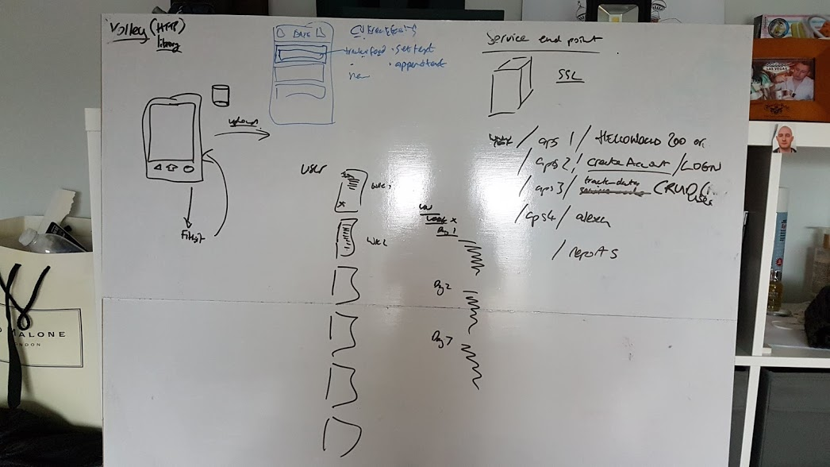

Figure . Original Integration Services

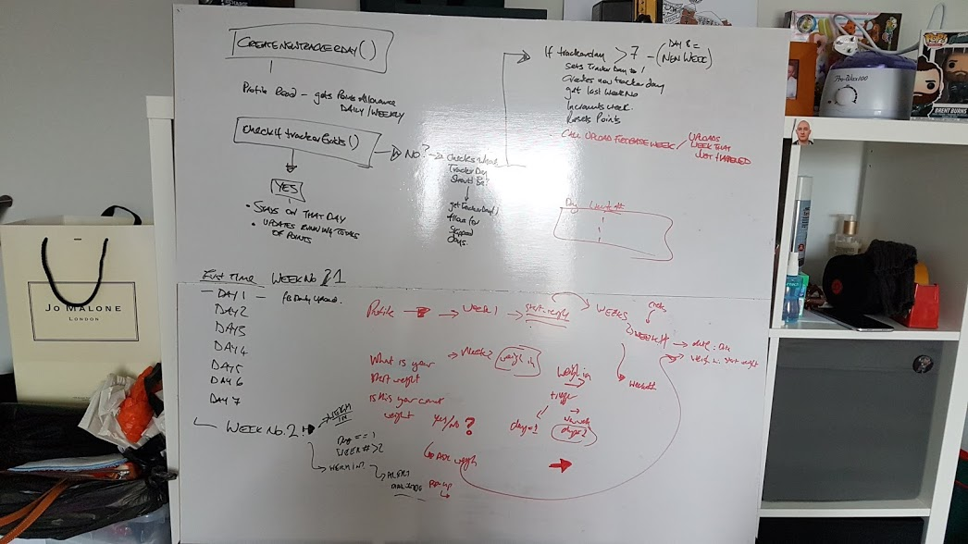

Figure . Firebase Tracker Upload design

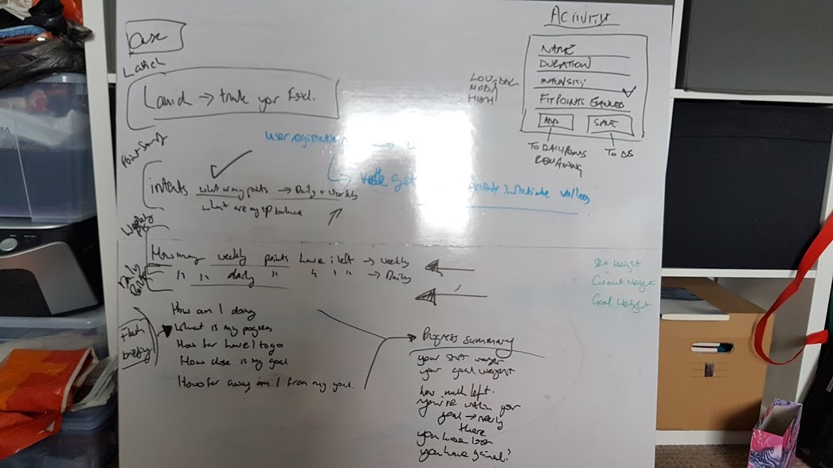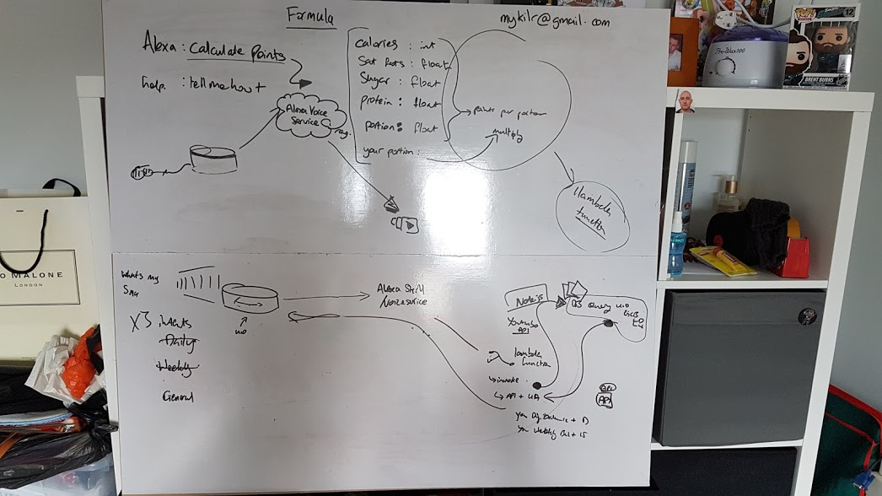

Figure . Alexa Skill Diagrams

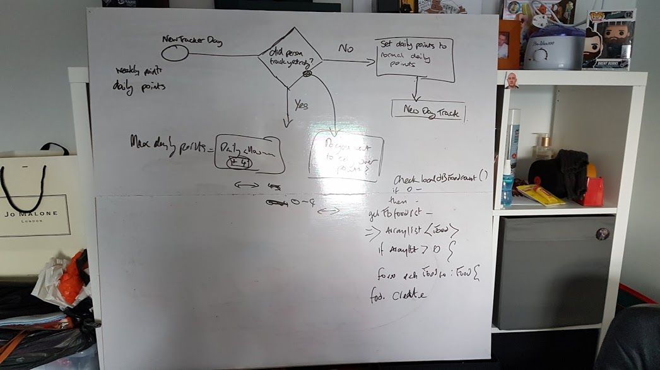

Figure . Roll Over Points Alert Design